

Papua New Guinea
6th National Report
to the Convention on Biological Diversity

June 2019

FORWARD

Minister for Conservation, Environment and Climate Change

FORWARD

Managing Director, Conservation and Environment Protection Authority

BACKGROUND SECTION

This 6th National Report includes

Background Section: Outlining the Process that was taken to develop the 6NR
Section 1 Information on Targets being taken at National level
Section 2 Implementation Measures Taken, Assessment of their effectiveness. Associated Obstacles, Scientific and Technical Needs to achieve the Aichi Biodiversity Targets
Section 4 National Contributions towards achieving the Aichi Biodiversity Targets (combined with Section 3)
Section 6 Contribution of Local Communities to ABT Achievement
Section 7 Updated Country Profile

6th National Report Process
The 6th National Report was nested within the lead agency of the Conservation and Environment Protection Authority, which is based in Port Moresby.

Consultation
An initial inception workshop to facilitate the participation by key staff from National Government Agencies, University and other stakeholders from Industry was held at the CEPA office. It became apparent that this was also a socialisation of the ABT. The Aichi Biodiversity Targets most relevant to agencies were separated out into Sections 2 & 4 with question/prompts as per the Technical Guidance to assist in the writing process by agency expertise. Data in the form of reports, papers was collated by the lead author In this way each ABT was populated as per the online reporting template The relevant ABTs (Section 4) were redistributed to key persons in line agencies for comments, and input which were then incorporated into a series of drafts. Concurrently all mapping options available on the UNEP and UNBiodiversity Lab site and available within PNG were collated along with other graphics and images.

Timeline of Papua New Guinea 6th National Report Document
2018 | September | Inception |  | Line Agencies
2018 | November | ABTs Draft | Review | Line Agencies
2018 | December | Section 4 Draft | Technical Review | Marion Marigo UNDP Technical Specialist, Sixth National Reports to CB, New York, NY
2019 | March | 6NR/ABTs Draft | Review | Line Agencies
2019 | April | 6NR Draft | Review | CEPA
2019 | June | 6NR Final Draft | For Endorsement | CEPA

David K Mitchell CEnvP – Ecology Specialist, Eco Custodian Advocates lead writer.

Acknowledgement of other contributions by;
Birte Komolong PhD, Program Director Agriculture Systems PNG National Agriculture and Research Institute, Sir Alkan Tololo Research Centre, Bubia.
Mr. Stanley Oa, Principal Agriculture Land Use Officer, Department of Agriculture and Livestock
Mr. Ted Mamu, JICA Technical Coordinator CEPA-JICA Biodiversity Project
Ms. Rose W. Alphonse Senior Policy Analyst, Policy and International Branch Conservation and Environment Protection Authority
Linus Digim’rina PhD, Head of the Division of Anthropology, Sociology and Archeology, University of Papua New Guinea
Colin Filer PhD, Associate Professor, Crawford School of Public Policy, Australian National University. College of Asia and the Pacific
Mr. Gerard Natera, GIS Manager, Conservation Environment Protection Authority
Mr. Nate Petersen GIS and Conservation Information Manager, The Nature Conservancy, Australia

Direction was given at 6NR Preparation Workshop in Samoa in September attended by the lead writer and Gerard Natera of CEPA which clarified the process.

Consulted
Focal Points for the Cartagena Protocol, the NBSAP review, the FAO International Treaty on Plant Genetic Resources for Food and Agriculture, representatives at the CBD COP 14 Sharm El-Sheikh, Egypt 2018 and from previous CBD COPs were consulted.

UPNG, ANU (Australian National University) NARI (National Agriculture and Research Institute) NAQIA National Agriculture Quarantine Investigation Authority).

Sectors; Forestry, Fisheries, Agriculture, Climate Change, LNG, Education, Private Sector, environmental NGOs.

Included data and reports from these sectors (outlined in SECTION 2) including regional reports by SPREP, SPC, JICA, WB, FAO and others.

In the absence of a collated list of National Targets the Aichi Biodiversity Targets were reported against (SECTION 4)

Wherever available data on gender, marginalized, minority, youth, elderly, physically challenged and at risk groups was included, however little disaggregated data and reporting exists.

CONTENTS

FORWARD | Minister for Conservation, Environment and Climate Change | ii
FORWARD | Managing Director, Conservation and Environment Protection Authority | iii
BACKGROUND |  | iv
CONTENTS |  | vi
SECTION 1 | Information on Targets being taken at National level | 1
SECTION 2 | Implementation Measures Taken | 2
SECTION 4 | National Contributions towards achieving the Aichi Biodiversity Targets
 | Aichi Biodiversity Target 1 Biodiversity awareness | 33
 | Aichi Biodiversity Target 2 Biodiversity values integrated | 38
 | Aichi Biodiversity Target 3 Incentives reformed | 42
 | Aichi Biodiversity Target 4 Sustainable production and consumption | 45
 | Aichi Biodiversity Target 5 Habitat loss halved or reduced | 51
 | Aichi Biodiversity Target 6 Sustainable management of aquatic living resources | 57
 | Aichi Biodiversity Target 7 Sustainable agriculture, aquaculture and forestry | 63
 | Aichi Biodiversity Target 8 Pollution reduced | 74
 | Aichi Biodiversity Target 9 Invasive alien species prevented and controlled | 82
 | Aichi Biodiversity Target 10 Ecosystems vulnerable to climate change | 86
 | Aichi Biodiversity Target 11 Protected areas | 94
 | Aichi Biodiversity Target 12 Reducing risk of extinction | 105
 | Aichi Biodiversity Target 13 Safeguarding genetic diversity | 114
 | Aichi Biodiversity Target 14 Ecosystem services | 118
 | Aichi Biodiversity Target 15 Climate resilience | 123
 | Aichi Biodiversity Target 16 Nagoya Protocol on access and benefit-sharing | 129
 | Aichi Biodiversity Target 17 National biodiversity strategies and action plans | 131
 | Aichi Biodiversity Target 18 Traditional knowledge | 132
 | Aichi Biodiversity Target 19 Sharing information and knowledge | 135
 | Aichi Biodiversity Target 20 Mobilization of resources (Financial) | 141
SECTION 6 | Contribution of Local Communities to ABT Achievement | 146
SECTION 7 | Updated Country Profile | 148
ACRONYMS |  | 152

SECTION 1

Papua New Guinea is still in the process of revising its NBSAP (2007) and as a consequence has not formally socialized the Aichi Biodiversity Targets within a revised NBSAP post 2010 with defined National Targets that reflect the local context.

Therefore the 6th National Report to the Convention on Biological Diversity will report against the Aichi Biodiversity Targets.

SECTION 2

This Section outlines the Implementation Measures Taken, Assessment of their effectiveness. Associated Obstacles, Scientific and Technical Needs to achieve the Aichi Biodiversity Targets. It also outlines references used and available that inform this.

 Aichi Biodiversity Target 1 Biodiversity awareness

For Aichi Biodiversity Target 1 extensive awareness has been achieved through the teaching of the formal education subjects of Environmental Studies and Community Living from elementary to grade 5. This is reinforced by the participation by students across the country, along with various sectors and agencies, at themed events of the UN recognized World Environment Day (June 5th). This has impact, however no systematic listing of these activities, their participants or the resultant impacts are readily available. It is assumed however that with such input into education and awareness that it impacts on individual behavior in relation to environmental matters and that this is cumulative within our society.

The Department of Education Gender Equity in Education Policy (NDOE, 2003) recommends that no student in the education system of Papua New Guinea will be disadvantaged on the basis of gender and hence supports opportunity to learn for all.

References
Environmental Education
- NDoE. 2015. National Education Plan 2015-2019: Quality Education for all. PNG Department of Education, Port Moresby
- NDoE. 2004. Environmental Studies: Lower Primary Syllabus, Department of Education, Port Moresby
- http://education.gov.pg/quicklinks/primary-syllabus/lower/syllabus-lower-primary-environmental-studies.pdf
- Papua New Guinea University of Natural Resources and the Environment
- http://www.unre.ac.pg/
- UNDP. 2014. National Human Development Report Papua New Guinea UNDP Port Moresby

World Environment Day
A cross section of examples from different sectors involvement and publicity are;
National Capital District Governor
- http://sivarai.ncdc.gov.pg/world-environment-day-2018-governor-parkop-and-ncdc-take-action-in-cleanathon-and-walk-for-life/
Bank of South Pacific - Nature Park
- http://www.bsp.com.pg/About-Us/Community-Contributions/Go-Green-Campaign/World-Environment-Day.aspx
Legend FM radio
- https://www.legendfm.net/blog/world-enviroment-day-2018-observed
Post Courier Newspaper
- https://postcourier.com.pg/today-world-environment-day/
EMTV Commercial Television Station
- https://emtv.com.pg/sir-julius-chan-backs-parkop-on-tree-planting-for-world-environment-day/
UNDP
- http://www.pg.undp.org/content/papua_new_guinea/en/home/presscenter/pressreleases/2017/06/05/undp-urges-png-to-protect-its-biodiversity-on-world-environment-day-june-5.html
PNG LNG
- https://pnglng.com/Newsroom/Media-Release/ExxonMobil-PNG-Commemorates-World-Environment-Day

Obstacles
There is a lack of collation of awareness activities across sectors within a centralized database, that can be analysed to inform follow-up action i.e. environmental focused examination questions in National Education System analysis, questionnaires of participants following awareness activities, or critical assessment of any visible lasting improvements in the localised environment as a result of awareness activities. The future place of environmental education will however likely loose its current level of prominence with the education system from 2019 transitioning to a Standard Based System, within which the teaching of Environmental Studies will be subsumed into Science and Community Living into Social Science. The impact of no longer having a workbook labeled Environmental Studies, nor a dedicated subject period each week is yet to be determined. No baseline data is in place on student attitudes and capability in environmental perception. Therefore as a consequence, to determine future trends in the level of understanding and attitudes towards the environment, and environmental issues will be problematic in the formal education sector. Whilst the informal sector is in the main a combination of individual actions that vary by theme, by sector, by participant, that are not usually evaluated for their effectiveness or impact.

Scientific, Technical and Cultural needs
To measure the effectiveness and impact of awareness that is occurring through 1) formal education 2) observance in PNG of UN International Days 3) events 4) media 5) other means, that has a physical or attitudinal/behavioral impact would benefit from supporting a focused research effort.

 Aichi Biodiversity Target 2 Biodiversity values integrated

National Accounting
Within the National Accounts of Papua New Guinea the value of biodiversity (natural and agricultural) and those of the environment are not included and accounted. Though major developments require Environmental and Social Impact Assessments, the potential and resultant impacts upon biodiversity values and associated cultural values are not accounted.

As recently as 2015 UPNG Environment Professors Mowbray & Kaluwin stated that ‘to ignore consideration of ecosystem services, [and] not to internalise these values or assets of natural capital is to invite unsustainability’.

Sub-National Accounting
Across Papua New Guinea 75-80% of the population is sustained primarily at the local level of production of the subsistence farmer/fisher. The environmental costs incurred from the exploitation of the environment at this level, are often conceptually considered by the individual when making natural resource management decisions. For example if an area of primary forest is converted to garden the value of the loss of what the forest provides is mentally calculated to determine if the trade-off is justified or is by necessity, despite the longer term costs.

This report has drawn from efforts in sustainable land-use at the subnational level of New Britain Island and the adjoining Bismark/Solomon Seas through bottom up planning at the Local level Government that informs Provincial Planning by factoring in potential cost benefits of future development options. In this process the environmental features and services that the New Britain stakeholders valued were factors considered in the analysis.

References
- United Nations Committee of Experts on Environmental-Economic Accounting. 2017. Global Assessment of Environmental-Economic Accounting and Supporting Statistics 2017
- Hurney, M. 2017. The Human and Economic Cost of Child Undernutrition in Papua New Guinea. Save the Children Australia
- Lipsett-Moore, G., Peterson, N., Butler, J., Wise, R., Apelis, C., Meharg, S., Kalit, K., James, R., Hamilton, R., Masike-Liri, B., Allan, J., Hayes, D., Cheok, J., Seeto, T. and Fischer, M. 2017. Ridges to Reefs Assessment for New Britain, PNG: Planning for Responsible, Sustainable Development. TNC Pacific Division Report No. 2/10. 83pp
- Dunstan, P., Hayes, D., Fischer, M., Moeseneder, C., Skewes, T., Butler, J., Wise, R. & Peterson, N. 2017. CTI Marine Values Framework: PNG Implementation. CSIRO Oceans and Atmosphere Report. CSIRO. Australia
- http://www.stockholmresilience.org/research/research-news/2016-06-14-how-food-connects-all-the-sdgs.html
- Mowbray, D. & Kaluwin, C. 2015. Sustainable futures for PNG; Teaching sustainability and sustainable development at the University of Papua New Guinea. PNG Update, 18-19 June 2015. Development Challenges in the LNG Era, 2015 PNG Update, 18-19 June 2015 Development Challenges in the LNG Era, Strategies to convert the resource boom into sustainable development, UPNG Port Moresby.
http://devpolicy.org/Events/2015/2015-PNG-Update/Presentations/Day-2/Education-and-human-development_paper_Mowbray-Kaluwin.pdf
- Wise, R.M., Butler, J.R.A., Skewes, T., Bohensky, E. and Peterson, N. 2014. The future economics of marine ecosystem services in Kimbe Bay, Papua New Guinea: implications for Locally Managed Marine Areas. Report prepared for the Department of Sustainability, Environment, Water, Population and Communities
- Butler, J.R.A., Peterson, N., Wise, R.M., Apelis, C., Masike-Liri, B.M., Meharg, S., Bohensky, E.L., Vaghelo, D.M., Paisparea, F., Lipsett-Moore, G., Skewes, T.D., Hayes, D., Fischer, M., Dunstan, P., Suruman, B. 2017. Seascapes Planning in the Bismarck Sea, Papua New Guinea: A Guidance Document. PNG CEPA, TNC, and CSIRO.
- Clayton. M. & Sekhran, N. 1996. Integrated Environmental and Economic Accounting in Papua New Guinea. Chapter 19 in Sekhran, N. & Miller. S. (Ed.) 1996. Papua New Guinea Country Study on Biological Diversity. DEC. Port Moresby
- Anderson, T. 2015. Land and Livelihoods in Papua New Guinea. Australian Scholarly.
- Anderson, T. 2006. On the economic value of customary land in Papua New Guinea', Pacific Economic Bulletin, Vol.21:1, pp. 138-52.
- Skewes, T., Wise, R.M., Dunstan, P., Hayes, D., Fisher, M., Moeseneder, C., Butler, J., & Peterson N. 2017. An ecosystem values framework to support decision makers in the Coral Triangle . CSIRO Oceans and Atmosphere Report. CSIRO. Australia.
- https://png-data.sprep.org/dataset/ecosystem-values-framework-support-decision-makers-coral-triangle
- Dunstan, P., Hayes, D., Fischer, M., Moeseneder, C., Skewes, T., Butler, J., Wise, R. & Peterson, N. 2017. CTI Marine Values Framework: PNG Implementation. CSIRO Oceans and Atmosphere Report. CSIRO. Australia
- https://png-data.sprep.org/dataset/cti-marine-values-framework-png-implementation
- Bandara, P.M.N. 2016. Corporate Social Responsibility Disclosure Practices in Papua New Guinea Advances in Economics and Business 4(2): 63-75
- Bensolo, K. & Neale, E. 2015. Papua New Guinea Mapping REDD+ Finance flows 2009-2014. Forest Trends REDDX Report.
- Conservation International. 2012. PNG LNG Offset Delivery Plan: Recommendations. Washington DC.
- PricewaterhouseCoopers LLP. 2010. Biodiversity offsets and the mitigation hierarchy: a review of current application in the banking sector. Business and Biodiversity Offsets Programme, UNEP Finance Initiative
- Bartelmus P., Lutz, E. & Schweinfest, S. 1992. Integrated Environmental and Economic Accounting - A Case Study for Papua New Guinea. The World Bank Environment Working Paper No. 54
http://documents.worldbank.org/curated/en/364841468739232622/pdf/multi-page.pdf
- http://www.hrpub.org/download/20160229/AEB1-11804557.pdf

Obstacles
Shortly after the Rio Earth Summit (UN Conference on Environment and Development 1992) there was discussion during a Biodiversity Country Study in PNG 1994, calling for National Environmental Accounting in the National Income Accounts. Yet the determination and inclusion of environmental costs of the country’s development path from Independence has been neglected.

Despite direction within StaRS (2014/15) that a proper valuation of ecosystems including irreversible damages created by growth are to be determined, there is no evidence of this being implemented.

The Conservation Act 2000 outlines a requirement for large-scale developments to have an Environmental Impact Assessment to identify, minimize and mitigate potential environmental impacts. The Act refers to loss of beneficial values that are to be compensated, but is silent on determining and calculating these costs in monetary terms. As a result, the environmental cost of riverine or deep-sea tailings disposal of mine waste, the impacts of logging, commercial agriculture, industrial or major infrastructure developments are not explicitly determined in PGK (Kina).

There are also cumulative environmental costs of development, such as resulting from major roads or the impacts of urban growth centres, that are rarely factored into to determine the long term environmental costs.

Community level natural asset valuation
Under the PNG Valuer General’s Department is the Compensation Schedule for Trees and Plants, all Regions (2013). The rates within the schedule are used as a guideline for paying compensation for the value of trees and plants destroyed or damaged, especially by developers. The values within this schedule however are not the replacement value, nor clearly calculated as to reflect a market value, but appear to be arbitrary. This schedule therefore requires full review by a horticulturalist to determine the true market/replacement values and therefore influence fair accounting.

Scientific, Technical and Cultural needs
Papua New Guinea would benefit by a resource economic evaluation of its environment/ecosystems that factor in environmental, socio-cultural and economic costs in the immediate to long term, both local and cumulative. This needs to be mainstreamed for all forms of ‘development’ or environmental change. Such would require a high level of expertise to be developed within our tertiary institutions with subjects across different faculties to fulfill this need within the context of the complex diversity of Papua New Guinea.

References
- DOL. 2013. Valuer-General’s Compensation Schedule for Trees and Plants ll Regions. Office of the Valuer General, Department of Lands, Port Moresby
http://www.oktedi.com/images/CommunityRelations/Part7/7.6%20PNG%20Valuer-General%20Rates%202013.pdf
- http://www.mra.gov.pg/Portals/2/Publications/Newsletter/2011/Mineral%20Tok%20July-Aug%202011.pdf
- https://www.qgis.org/en/site/

 Aichi Biodiversity Target 3 Incentives reformed

The outcomes of this Aichi Target were assessed in relation to the rules governing international trade, most of which were set up at the World Trade Organisation’s inception in 1995. Papua New Guinea joined the WTO in 1996 (WTO 2018)

References
- https://www.wto.org/english/thewto_e/countries_e/papua_new_guinea_e.htm
- OBG. 2018. Papua New Guinea Tightens fishing regulations in move towards sustainability. Oxford Business Group.
- United Nations Conference on Trade and Development (UNCTAD) & the Department of Trade and Industry. 2016. Papua New Guinea Trade Policy Framework.
- Papua New Guinea Trade, Tariffs and Import Summary
- https://www.wto.org/english/res_e/statis_e/daily_update_e/tariff_profiles/PG_E.pdf
- https://www.businessadvantagepng.com/trade-rules-favour-powerful-countries-but-papua-new-guinea-should-push-for-influence-says-wto-director/
- Bowman, C. n.d. Managing the Challenges of WTO Participation; Case Study 33, The Pacific Island Nations: Towards a Shared Representation.
https://www.wto.org/english/res_e/booksp_e/casestudies_e/case33_e.htm

 Aichi Biodiversity Target 4 Sustainable production and consumption

Papua New Guinea since Independence in 1975 has increasingly depended upon the non-renewable resource sector for its macroeconomic income. The value of the country’s exports based on this sector far outweigh all imports, therefore this paradigm is counter to this Aichi Biodiversity Target.

A high natural birth rate leading to a rapidly increasing population leads to increased consumption. The sustainable development strategy StaRS was launched in 2014 and it raised questions in how best to attain responsible sustainable development in Papua New Guinea. It stated that an open market, demand driven, growth based paradigm has led to a massive explosion of population and a high appetite of resources to sustain it. Stabilisation of the population is seen as a requirement to achieve this Aichi Biodiversity Target.

Many of the large companies operating within PNG measure and aim to reduce their operational footprint by critically assessing and reducing; energy use, water use, emissions and waste with resultant benefits across the triple bottom line of environment, social and economic cost. This is evident within their reports, which are publically available.

References
Sustainable Development
- http://www.planning.gov.pg/images/dnpm/pdf/StaRS.pdf
- SPC. 2018. Pacific Islands Ridge-to-Reef National Priorities – Integrated Water, Land, Forest and Coastal Management to Preserve Biodiversity, Ecosystem Services, Store Carbon, Improve Climate Resilience and Sustain Livelihoods. SPC/GEF-R2R/RPSC 2. Report
- Mowbray, D. 2016. The History of Sustainable Development in Papua New Guinea: Changes, challenges and lessons learned from 1975 to 2016 and beyond.
http://devpolicy.org/Events/2016/PNG-Update/1c_Mowbray_paper.pdf
- Mowbray, D. and Kaluwin, C. 2015. Sustainable Futures for PNG Teaching Sustainability and Sustainable Development at the University of Papua New Guinea in 2015 PNG Update Development Challenges in the LNG Era Strategies to convert the resource boom into Sustainable Development
http://devpolicy.org/Events/2015/2015-PNG-Update/Presentations/Day-2/Education-and-human-development_paper_Mowbray-Kaluwin.pdf
- Mitchell, D.K., Wolnicki, M. and Keako, M. 2015. Conservation and Environment Protection Authority Land Use Planning Workshop: “Collaborative and coordinated protected area land use planning approaches for sustainable development”. Port Moresby 9-12 June 2015
- CEPA. 2015. A Framework for the Sustainable Development Master Plan for the Interim Protection Zone, Brown River catchment area, Papua New Guinea. Planning 4 Sustainable Development Ltd, Report for the Conservation and Environment Protection Authority, Port Moresby

Obstacles
Though there are production figures for export commodities from the non-renewable and renewable sectors and of imports, there is a lack of determination of the sustainability of this through to 2050 and 2100.

Determining the sustainability of the subsistence sector with increasing intensification and support through informal sector cash generation activities is not known at the local or national level.

StaRS 2014/15 describes innovative green growth, that follows a path of responsible natural resource use, that does not degrade the environment. Yet both the cash economy and the subsistence/informal cash economy continue on paths of environmental degradation.

Scientific, Technical and Cultural needs
In planning for the country’s future there is a need to project the production life and value of all known current mineral and hydrocarbon resources, which must factor in environmental costs as per Aichi Biodiversity Target 2. There is also a need to determine the sustainability and carrying capacity of the subsistence agriculture/fishery sectors with increasing pressures from population needs and climate change impacts within Aichi Biodiversity Targets 6 and 7. This will require these sectors to dedicate effort in applied research and to inform the government and public sectors in planning, research needs, and extension needs.

 Aichi Biodiversity Target 5 Habitat loss halved or reduced

Most focus is upon the predominant habitat or ecosystem type found in Papua New Guinea which is on tropical rainforest, this being highly biodiverse. Data on rainforest cover and change is available from spatial portals both within the country (PNGFA-CCDA) and internationally (UNEP, University of Maryland). Other habitat change is not so well researched, however changes within mangroves and other ecosystems can be broadly determined through interpretation of increasingly available high-resolution satellite imagery.

Reference
- Bryan, J., Shearman, P., Aoro, G., Wavine, F. & Zerry, J. 2015. The current state of PNG’s forests and changes between 2002 & 2014. Chapter 1 in Bryan, J.E. & Shearman, P.L. (Eds) 2015. The State of the Forests of Papua New Guinea 2014: Measuring change over the period 2002-2014. University of Papua New Guinea, Port Moresby.

Obstacle
Focus is often on rainforest loss without critically assessing the loss of each ecosystem that is habitat for a different association of species.

As PNG grows its cash economy, the renewable resource sector is being exploited to decrease the country’s macroeconomic dependency upon hydrocarbon extraction and export. The primary obstacle to this Aichi Biodiversity Target is that as Papua New Guinea develops its commercial agriculture sector, predominantly oil palm, this requires the conversion of grassland if under RSPO or forest for a non RSPO compliance market. Whilst concurrently the intensification of the subsistence agriculture sector upon which the majority of the rural population depend for their livelihood is altering the forest through a shortening fallow. This rotational forest fallow is not an obstacle, but to reduce the footprint of this anthropogenic habitat is perhaps unrealistic with an increasing rural population.

Scientific, Technical and Cultural needs
There is a need to define ecosystems (as per ABT 10) and habitats across PNG and to then determine the rates of alteration of each of these.

The subsistence and small-scale agriculture plantation sectors would benefit from applied research in the development of agroforestry, multi-tiered agriculture and permaculture for the ongoing sustainability of each farming system.

Reference
- PwM & TI-PNG. 2014. Why the Clearance Authorities are legally invalid and should be cancelled. Submission to the PNG Forest Authority. Partners with Melanesians, Transparency International (PNG)

 Aichi Biodiversity Target 6 Sustainable management of aquatic living resources

Available data within the PNG National Fishery Authority has informed the reporting of this Aichi Biodiversity Target. The northern EEZ of PNG is a migratory route of a multispecies Tuna fishery which demands robust data in its management and in informing high level discussions in regional negotiation for catch sustainability and quotas. The bêche-de-mer artisanal fishery is monitored and managed however there are issues, which have led to extended closures to enable stock recovery. Other commercial species have management plans and production figures whilst some provincial markets have been surveyed for marine produce.

References
- http://www.fisheries.gov.pg/
- Teh, L., Kinch, J. Zylich, K. & Zeller, D. 2014. Reconstruction Papua New Guinea’s Marine Fisheries Catch. Working Paper Series 2014-09, Fisheries Centre, University of British Columbia
- Brouwer, S., Pilling, G., Hampton, J., Williams, P., Tremblay-Boyer, L., Vincent, M., Smith, N. & Peatman, T. 2018. The western and central Pacific tuna fishery: 2017. Overview and status of stocks, SPC.
- OBG 2018 Papua New Guinea Tightens fishing regulations in move towards sustainability. Oxford Business Group.
- NFA. 2015. Challenges to EU Market Access. Ad Hoc Expert Group Meeting on Trade in Sustainable Fisheries UNCTAD/Commonwealth Secretariat 29 September- 1 October 2015 Room XV, Palais de Nations, Geneva Switzerland.
- Purdy, D.H., Hadley, D., Kenter, J.O. & Kinch, J. 2017. Sea Cucumber Moratorium and livelihood diversity in Papua New Guinea. Coastal Management
- DEC. 2010 PNG Marine Program on Coral Reefs, Fisheries and Food Security 2010-2015. Department of Environment and Conservation, Port Moresby
- Gehrke, P.C., Sheaves, M.J., Boseto, D., Figa, B.S. & Wani. J. 2011. Fisheries & Climate Change Chapter. 10 Vulnerability of freshwater and estuarine tropical Pacific to Climate Change.
- McLeod, E., Moffitt, R., Timmermann, A., Salm, R., Menviel, L., Palmer, M. J., Selig, E. R., Casey, K. S. & Bruno, J. F. 2010. Warming Seas in the Coral Triangle: Coral Reef Vulnerability and Management Implications, Coastal Management, 38:5, 518 -539
- WCS. 2019. WCS Papua New Guinea. 2018 Annual Report

Obstacles
In this sector emphasis is often on the tuna fishery as it is the main source of macro-economic income that supports the NFA (National Fishery Authority) though they also contribute in the management of other coastal fisheries. The bêche-de-mer fishery has been a boom bust fishery due to years, which exceed the Total Allowable Catch by the cumulative purchases of exporters, despite a management plan that is informed by increasingly robust monitoring of stocks across many provinces. This fishery also suffered from Illegal Fishing within the PNG EEZ by vessels from within South East Asia.

Scientific, Technical and Cultural needs
There is a need to increase efforts by NFA in coastal fisheries, both subsistence and artisanal in sustainable management and catch. There is an opportunity to build on local customary management that is reinforced by formalised management plans and locally enforced penalties.

 Aichi Biodiversity Target 7 Sustainable agriculture, aquaculture and forestry

Agriculture
The sustainability of Palm Oil, Coffee and Cocoa in PNG was the subject of a comprehensive report produced in 2016.

In addition the commercial plantation agriculture sector in PNG is dominated by oil palm nucleus estate and associated block/smallholders that are currently predominantly, RSPO (Round Table Sustainable Palm Oil) compliant. This accreditation and that of ISO informs the current sustainability of the industry.

Despite the presence of an objective to enhance and intensify agricultural (subsistence &/or smallholder) production systems under the Agriculture Systems Strategic Programme within DAL, there is no intensive applied research to actually determine the main limiting factors of each farming system to be addressed in order to achieve this. However PNG in 2015 initiated a Food Security and Livelihood Monitoring System mVAM (Vulnerability Analysis and Mapping) which is a joint initiative initially of the United Nations World Food Program (UNWFP), with the PNG National Disaster Office (PNG-NDO), which later engaged with the Department of Agriculture and Livestock (PNG-DAL) and the National Statistical Office (PNG-NSO). The most recent survey, the 4th was done in Nov-Dec 2017. Within this a Food Insecurity Experience Scale (FIES) is used to track progress in attaining the Sustainable Development Goal SDG 2 with a target of Zero Hunger.

The MASP (Mapping Agriculture Systems Project) is a database that represents the spatial distribution of indigenous agricultural systems that includes food-cropping systems, within the rural sector. It is a reliable database which includes information on a variety of agricultural (and non-agricultural) activities which yield livelihood and income for rural populations engaged in each food-cropping system, and the production of export crops by smallholders in an integrated farming system (Filer 2015).

Forestry
From 2013-2018 PNG developed an accurate, reliable, cost-effective and transparent, MRV (Monitoring & Measurement, Reporting and Verification) system through a PNG Satellite Land Monitoring System. The data within this system is Quality Control and Quality Assurance (QC/QA) verified to provide accurate information in historic land-use change. A land-use change assessment for 2000-15 using Collect Earth was completed in 2016.

A PNG Terra Lab was set up with high-speed connectivity in 2015 enabling this to be publically available as a map based land-use information Web-Portal.

The methodologies for all the NFI (National Forest Inventory) components were documented mostly in manual format, tree inventory, non-tree plant biodiversity, ornithology, entomology and soil.

Botany
There are over 2,000 tree species in PNG with their accurate identification being one of the major challenges for implementing the NFI. A PNG2species Identification Manual with training for predominantly PNGFA staff was done across the country in 2014-15. In 2019 The Trees of Papua New Guinea Volumes 1-3 by Conn and Damas was released.

Biodiversity
Training on biodiversity survey including non-tree plant diversity, ornithology and entomology was done in 2015 within which five participants were considered capable to conduct NFI ornithological survey independently.

The National Forest Monitoring System (NFMS) consists of a monitoring function, to assess the implementation and impact of national policies and measures for REDD+, and a MRV function to estimate and report GHG emissions/removals in the LULUCF sector. The Satellite Land Monitoring System (SLMS) produces Activity Data, using Terra PNG operated by CCDA, and Collect Earth (point sampling) operated by PNGFA.

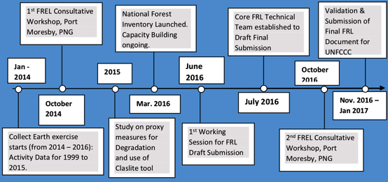
Forest Reference Level development timeline GovPNG 2017

There is much information available online on Papua New Guinea Forest Reports from the Barnett Enquiry, ITTO, FAO, ODI, UPNG, Certification, SABLs, REDD, reports from Global Witness, Oakland Institute, Oxfam, Greenpeace and PNG activists. These give a series of reports of the past and recent developments in the forest sector raising many concerns.

References
Sustainable Development
- DNP&M. 2015. National Strategy for Responsible Sustainable Development. 2nd Edition. National Department of Planning & Monitoring, Port Moresby
http://www.planning.gov.pg/images/dnpm/pdf/StaRS.pdf
- Baloiloi, M. 2016. StaRs- Papua New Guinea’s National Strategy for Responsible Sustainable Development. 2016 PNG Update

Agriculture
- Bito, B. & Petit, N. 2016. Towards Sustainable Agriculture Commodities in Papua New Guinea - the case of Palm Oil, Coffee & Cocoa. Final Report. Forest Carbon Partnership Activity & UNDP.
- RSPO. 2007. RSPO principles and criteria for sustainable palm oil production. Including indicators and guidance. October 2007. RSPO (Roundtable on Sustainable Palm Oil).
- Arif, M.J. 2017. RSPO Principles & Criteria. Public Summary Report. Main Assessment Hagita Oil Mill. New Britain Palm Oil Limited, Milne Bay Estates ControlUnion
- Nelson P.N., Webb M.J., Orrell I., van Rees H., Banabas M., Berthelsen S., Sheaves M., Bakani F., Pukam O., Hoare M., Griffiths W., King G., Carberry P., Pipai R., McNeill A., Meekers P., Lord S., Butler J., Pattison T., Armour J. & Dewhurst C. 2010. Environmental sustainability of oil palm cultivation in Papua New Guinea. ACIAR Technical Report No. 75. Australian Centre for International Agricultural Research: Canberra
- WFP-DAL-NDC-NSO 2018. Papua New Guinea, mVAM Food Security and Livelihood Monitoring System. Report 4, March 2018
http://vam.wfp.org/sites/mvam_monitoring/papua_new_guinea.html
- https://docs.wfp.org/api/documents/WFP-0000069090/download/
- WFP-DAL-NDC-NSO 2018. Papua New Guinea, mVAM Food Security and Livelihood Monitoring System. Report 3, July 2017
- WPF-NDS 2017. El Nino Food Security Impact in Papua New Guinea, Follow-up Survey, November/December 2016
- https://docs.wfp.org/api/documents/WFP-0000021122/download/
- https://documents.wfp.org/stellent/groups/public/documents/ena/wfp291158.pdf
- WPF-NDS 2016. El Nino Food Security Impact in Papua New Guinea, 2015-2016 El Nino.
- https://documents.wfp.org/stellent/groups/public/documents/ena/wfp289927.pdf
- http://www.nari.org.pg/agriculture-systems-improvement
- http://www.nari.org.pg/sites/default/files/publications/Reports/annualreport.2016.pdf

Forestry
- Conn, B.J. & Damas, K.Q. 2019. Trees of Papua New Guinea. Vol. 1-3 Xlibris, Australia.
- GovPNG 2017. Papua New Guinea’s National REDD+ Forest Reference Level; Modified Submission for UNFCCC Technical Assessment in 2017
https://redd.unfccc.int/files/png_frl_resubmission_modified_201700710_final.pdf
- FAO-UNDP-UNEP 2017. UN-REDD Program, Papua New Guinea National Program, Final Report
- McDonnell, S., Allen, M. & Filer, C. (Eds.) 2017. Kastom, property and ideology: Land transformations in Melanesia, ANU Press, The Australian National University, Canberra, Australia. Chapter 7. Gabriel, J., Nelson, P.N. Filer, C. and Wood, M. 2017. Oil Palm Development and Large- Scale Land Acquisitions in Papua New Guinea. 205-250
- Global Witness. 2014. ‘The People and Forests of Papua New Guinea under Threat: The Government’s Failed Response to the Largest Land Grab in Modern History.’ London: Global Witness.
- Nelson, P.N., Gabriel, J., Filer, C., Banabas, M., Sayer, J.A., Curry, G.N., Koczberski, G. & Venter, O. 2014. Oil Palm Deforestation in Papua New Guinea. Conservation Letters 7(3) 188-195
- University of Maryland: Department of Geographical Sciences. Global Forest Change
- Hansen, M.C., Potapov, P.V., Moore, R., Hancher, M., Turubanova, S.A., Tyulavina, A., Thau, D., Stehman, S.V., Goertz, T.R., Kommareddy, A., Egorov, A., Chini, L., Justice, C.O., & Townshend, J.R.G. 2013. High-Resolution Global Maps of 21st Century Forest Cover Change. Science. Vol. 342, Issue 6160 pp. 850-
http://earthenginepartners.appspot.com/science-2013-global-forest
- https://pngforests.com/
- https://pngforests.com/barnett-inquiry-3/

Aquaculture Fisheries
- Coates, D. 1989. Fish fauna of the Sepik and Ramu River floodplain regions: Summary of information on fish ecology, identification of vacant niches and categories of species suitable for stocking. A report prepared for project PNG/85/001 Sepik River Fish Stock Enhancement Project FAO
- ABD. 2014. State of the Coral Triangle in Papua New Guinea. Asian Development Bank. Manila.
- https://png-data.sprep.org/dataset/breaking-down-poverty-environment-relationship-papua-new-guinea-conceptual-framework
- https://png-data.sprep.org/dataset/intensification-agricultural-systems-papua-new-guinea

Obstacles
Agriculture
Papua New Guinea does not dominate the production share in any commercial agriculture crop (although it is emerging as a major vanilla producer) and is therefore impacted by fluctuations in world prices which variably influence each crop’s economic viability and hence sustainability of production. This has influenced industry to maintain quality in order to gain country and brand recognition. There are challenges in gaining and maintaining high levels of accreditation with which to gain premium prices.

Collation of information of subsistence agriculture production levels and trends presents a major challenge due to the informal nature of this sector across challenging environments.

Forestry
Determining change in rainforest from all causes and separating the impartial interpretation of objective data from subjective reaction has affected this sector. Compliance within logging operations is poorly monitored and enforced.

Aquaculture
Gaining production data in a sector that is predominated by inland ponded fish farming often in isolated areas is difficult to obtain.

Scientific, Technical and Cultural needs
Agriculture
An analysis of the current and projected agronomic sustainability of all cropping systems across all sites that factors in all variables is required. This can be built upon past applied research e.g. PNGRIS, MASP but will require a concerted effort based on applied scientific fieldwork and follow-up analysis.

Forestry
A full review of the extraction practices in the forest industry that takes into account illegal logging is needed to determine the sustainability or not of current practices and on what rotational basis. The impacts of logging on surrounding ecosystems needs to be evaluated. This will be comparative to an ecological ‘baseline’ that is determined in the process of developing a logging plan.

Aquaculture
The ongoing production levels of fish farming projects and the incidence of stock escape into surrounding rivers and lakes is required across the entire country.

References
- Global Witness. 2018. A major Liability: Illegal logging in Papua New Guinea threatens China’s timber sector and global reputation. London
- Lawson. S. 2014. Illegal logging in Papua New Guinea. Chatham House

 Aichi Biodiversity Target 8 Pollution reduced

Data on all aspects of pollution are poorly reported and what data is available is of variable reliability and quality. For domestic pollution regional reports and local project reports have therefore been sourced to gain information. Data is also not disaggregated by impact by gender or sector of the community.

There is currently no regular collated data at the domestic national, subnational or localized level of the volume and location of waste generated and disposed across Papua New Guinea apart from major developments with Environmental Permit requirements. This also applies to determining the domestic localized and cumulative impacts of pollution on the environment. To determine therefore if and by how much, pollution is being reduced is therefore not possible apart from some specific examples.

Reports on pollution in Papua New Guinea are also quite limited. Most data that is available is from Environmental Reports generated by Mining, LNG and agro-industry as a requirement of their Environmental Permits issued and monitored by CEPA. This represents the only trend data available as these reports (quarterly, half yearly or annually), which become a series across the life of each development. Also some data from activist organisations relating to these development activities is in the public domain.

Without systematic ongoing monitoring, trends are difficult to gauge. This applies to all types of resultant pollution impacts on the environment from major urban centres, though to village communities.

Localized fires from the activities of subsistence gardening and grassfires for hunting are a part of the localized anthropogenic impact upon local ecosystems that is a cause of air pollution. These are spatially represented on a UPNG portal site.

Whilst at the household level, where firewood has been used for millennia as a fuel for cooking, the resultant daily localised level of air pollution is known to impact the health of especially women and children, but the extent and severity is not known. It also needs to be realized in the absence of awareness, that women most often manage household waste without resource support, compounding their effort in maintaining a safe healthy environment for their families.

References
- Richards, E. 2015. Cleaner Pacific 2025: Pacific Regional Waste and Pollution Management Strategy 2016-2025. SPREP Samoa

Where available case studies have been used along with sections from Environmental Reports.

- ExxonMobil-PNG. 2018. PNG LNG Environmental and Social Report – Annual 2017
- ExxonMobil-PNG. 2017. PNG LNG Environmental and Social Report – Annual 2016
- Ernst & Young. 2017. Papua New Guinea Extractive Industries Transparency Initiative (PNG EITI). Report for 2016
- Barrick. 2015. Barrick Porgera Annual Environment Report 2014 POR ENV 1/15
- Barrick Niugini Limited. 2016. Porgera Joint Venture Annual Environment Report 2015 POR ENV 1/16
- Ok Tedi Mining 2017. Annual Environmental Report 2016. ENV 170319
- Ok Tedi Mining 2016. Annual Environmental Report 2015. ENV 160624
- Ok Tedi Mining 2014. Annual Environmental Report FY14 ENV 140923
- Hettler, J., Irion, G. & Lehmann, B. 1997. Environmental impact of mining waste disposal on a tropical lowland river system: a case study on the Ok Tedi Mine, Papua New Guinea Minerealium Deposits 32: 280-291.
- Newcrest Mining Limited 2016. Sustainability Report 2015
- Newcrest Mining Limited 2015. Sustainability Report 2014 Disclosures on Management Approaches
- Anon. 2014. North-East Shipping Management Plan. North East Shipping Management Group
- https://png-data.sprep.org/dataset/marine-pollution-pacific
- ExxonMobil-PNG. 2012. PNG LNG Environment and Social Report First Quarter 2012
- Dold, B. 2014. Submarine Tailings Disposal (STD) A Review. Minerals 4, 642-666
- Hughes, D.J, Shimmield, T.M. Black, K.D. & Howe, J.A. 2015. Ecological impacts of large-scale disposal of mining waste in the deep sea open Scientific Reports 5 Article number 9985
- ADB. 2012. PNG: Maritime and Waterway Safety Project. Scope and Technical Report.

Obstacles
The highly visible impact of mine riverine tailings disposal has in some ways concentrated pollution concerns in this sector, possibly detracting due consideration towards a systematic quantitative analysis of all pollutant types and their causes across the country.

Currently there is no systematic measurement of the volume, extent or composition of pollution in Papua New Guinea apart from developments that require environmental monitoring such as mines, LNG and agro industry. Without this information it is difficult to prioritise and strategically tackle each pollution concern.

Determining the extent and impacts of landfill and effluent disposal on local, riverine inshore and marine systems is lacking by the government along with resultant impacts on its citizens.

There is no systematic monitoring of air pollution in urban growth centres and no vehicle emission standards set.

Similarly there is no systematic monitoring in the food chain for heavy metal accumulation measured against health standards from all known pollution sources. Nor for any other pollution induced or exacerbated health related concerns.

The government agencies, some of which in the past were monitoring and reporting environmental pollution, no longer have the capacity or recurrent allocation of resources required to fulfill this role. There is also a lack of political support to proactively react to increasing pollution concerns.

Scientific, Technical and Cultural needs
There is a need to have PNG determined environmental standards and to systematically monitor pollution. Determining sources of pollution in major growth centres, large village communities and within the natural environment from all sources is needed. This will require a broadening of technical training within PNG universities to support future pollution research, standards, monitoring and compliance that are put in place.

Using the example of airborne pollution in the nation’s capital Port Moresby, air pollution is noticeable as a haze that is a combination of dust, vehicular exhaust, the burning of fuel wood, hard rubbish and plastic. Therefore determining a monitoring protocol on the chemical and particle composition of this air pollution would inform future pollution control measures in this city and other population growth centres across the country.

 Aichi Biodiversity Target 9 Invasive alien species prevented and controlled

Data on invasive species is from the National Agricultural Quarantine Inspection Authority and their reports. Information on passenger arrivals and shipping volumes is available from PNG Customs, PNG Ports Corporation and the National Airports Corporation.

References
- http://www.naqia.gov.pg/quarantine/Quarantine%20in%20png.html
- http://www.naqia.gov.pg/quarantine/Animals.html
- http://www.naqia.gov.pg/quarantine/Plants.html

Scientific, Technical Cultural needs
Though NAQIA has a proactive presence at the main points of entry into the country the reporting of interception of invasive species is not complied into a document that is extant and readily available.

 Aichi Biodiversity Target 10 Ecosystems vulnerable to climate change

There is no definitive map of the ecosystems of Papua New Guinea. In the absence of this however the country has been categorized into a mosaic of vegetation community types and marine association types through research and ground studies from before independence in 1975 till now. These have been refined and adjusted over time. Examples of ecosystems vulnerable to climate change have been drawn from in this report.

Ecoregions are proposed defined areas across the country, many by international environmental NGOs and picked up by government agencies. These broad-scale definitions however mask the variance of ecosystems that exist within the high biodiversity country of PNG.

Even in the absence of clearly defined ecosystems there has been no concerted research into understanding deeper ecological change across the PNG mosaic of ecological systems. However there are peer review papers on specific ecosystems. Altitudinal transects, forest monitoring plots and intensive half-hectare forest monitoring plots have been established that will inform understanding change through future trend data.

References
- World Bank 2011. Vulnerability, Risk Reduction, and Adaptation to Climate Change, Papua New Guinea.
http://sdwebx.worldbank.org/climateportal/countryprofile/doc/GFDRRCountryProfiles/wb_gfdrr_climate_change_country_profile_for_PNG.pdf
- Shearman, P. & Bryan, J. 2011. A bioregional analysis of the distribution of rainforest cover, deforestation and degradation in Papua New Guinea Austral Ecology 36, 9-24
https://onlinelibrary.wiley.com/doi/pdf/10.1111/j.1442-9993.2010.02111.x
- Hope, G. 2014. The Sensitivity of the High Mountain Ecosystems of New Guinea to Climatic Change and Anthropogenic Impact. Arctic, Antarctic, and Alpine Research, 46:4, 777-786,
- Robiansyah, I. 2018. Assessing the impact of climate change on the distribution of endemic subalpine and alpine plants of New Guinea. Songklanakarin J. Sci. Technol. 40 (3): 701-709.
- Bourke, R.M. 2018. Impact of Climate change on agriculture in Papua New Guinea, in Quartermain, A.R. (Ed.) Climate Change: Our Environment, Livelihoods and Sustainability. Climate Change Conference. 2018. University of Goroka, Papua New Guinea, pp.35-50
https://www.researchgate.net/publication/327930392_Impact_of_climate_change_on_agriculture_in_Papua_New_Guinea
- Maiguo, E., Keenan, E. & Nitschke, C. 2013. Assessment of Vulnerability and Impacts of Climate Change on Forests in Papua New Guinea in 7th Huon Seminar, Achieving Vision 2050 Through Higher Education, Research, Science and Technology, Papua New Guinea University of Technology, PNG.
http://www.unitech.ac.pg/sites/default/files/publication_pdf/HS7-2013-19.pdf
- Polhemus, D.A. 2007. Climate Change in New Guinea and its potential effects on freshwater Ecosystems. in Leisz, S.J. & Burnett, J.B. (Ed.) 2007. Climate Change and Biodiversity in Melanesia, Bishop Museum
https://www.researchgate.net/publication/237706137_CLIMATE_CHANGE_IN_NEW_GUINEA_AND_ITS_POTENTIAL_EFFECTS_ON_FRESHWATER_ECOSYSTEMS

Obstacles
Papua New Guinea is a highly ecologically diverse country however various experts both terrestrial and marine have delineated various broad-scale EcoRegions. Such categorization has influenced analysis and oversimplified the complex diversity that exists. Alternatively many ecosystems are defined by plant community or marine association type, which however often are made up of different aggregations of species. There is clearly a need to define at a recognizable scale, ecosystems that transcend beyond the political boundary of Papua New Guinea and which extend across the island of New Guinea and the length of the Solomon chain of islands.

Although there are broad scale predictions and trends from climate change of temperature increase, sea level rise, intensity and frequency alteration of rainfall, cyclones and drought events, there remain unknowns. Unpredictability and variance of these events and the cumulative impacts on species and their interrelationships and unknown tipping points of dramatic ecosystem change leads to high levels of uncertainty. Determining vulnerability is therefore much influenced by perception of visible change or interpretation of data time series.

Scientific, Technical and Cultural needs
There is a need to define terrestrial ecological systems in a collaborative effort between PNG, Indonesia and the Solomon Islands for an agreed conformity that will allow comparison across the region.

In regards to the subsistence ecosystems, Filer (2015) considers that the MASP (Mapping Agriculture Systems in PNG) database provides the best available source for a systematic survey of local ecosystems defined by a combination of political and biological criteria, as a set of ‘social-ecological systems’ rather than a set of biological communities with human interference treated as an ‘external’ variable. And that the database also provides a set of scientific, rather than political, criteria for grouping traditional communities together on the basis of their ‘culture of cultivation’ including the role of traditional communities and groups in the development, management and understanding of these food-cropping systems.

References
- Burke, L., Selig, E. & Spalding, M. 2002. Reefs at Risk in Southeast Asia. World Resources Institute, Washington, D.C.
- Spalding, M.D., Fox, H.E., Allen, G.R., Davidson, N., Ferdana, Z.A., Finlayson, M., Halpern, B.S., Jorge, M.A., Lombana, A., Lourie, S.A., Martin, K.D., McManus, E., Molnar, J., Recchia, C.A. & Robertson, J. 2007. Marine ecoregions of the world: a bioregionalization of coastal and shelf areas. BioScience 57(2): 573-583.
- Green, A., Kertesz, M., Peterson, N., Retif, S., Skewes, T., Dunstan, P., McGowan, J., Tulloch, V. & Kahn, B. 2014. A Regionalisation of Papua New Guinea’s Marine Environment. A technical report prepared for Papua New Guinea’s Department of Environment and Conservation 1
- Green, A.L. & Mous, P.J. 2008. Delineating the Coral Triangle, its Ecoregions and Functional Seascapes. Version 5.0. The Nature Conservancy Coral Triangle Program Report 1/08, 44 pp. Weblink: https://www.conservationgateway.org/Files/Pages/delineating-coral-triangl.aspx

 Aichi Biodiversity Target 11 Protected areas

Formally recognized protected areas are listed with the national PNG agency of the Conservation and Environment Protection Authority. In 2019 a Protected Areas Register with associated data for each PA has been established within CEPA. A METT (Management Effectiveness Tracking Tool) analysis of these protected areas was also completed and reported to the authority in 2017. Combined these represent the most definitive current record of protected areas as reported to the CBD in this report.

Many of the customary ‘protected’ areas, both terrestrial and marine, that are not formally recognized, such as sacred ‘tambu’ sites, some of which cover extensive areas i.e. mountain summits have not been accounted. It is considered that as custom is dynamic, the future use of these areas is subject to change, however such areas have been recognized within the draft of a Protected Areas Bill (2018)

References
- SPREP Pacific Islands Protected Area Portal.
https://www.sprep.org/attachments/VirLib/PNG/marine-protected-areas-png.pdf
https://pipap.sprep.org/content/papua-new-guinea-reports-and-papers-related-conservation-and-protected-areas
- CEPA. 2018. Ramsar National Report to COP13
https://png-data.sprep.org/dataset/papua-new-guineas-ramsar-national-report-cop-13
- CEPA. 2014. Policy on Protected Areas. Conservation and Environment Protection Authority, Port Moresby.
- Duguman, J. (Ed.) 2006. Chatterton, P., Yamuna, R., Higgins-Zogib, L., Mitchell, N., Hall, M., Sabi, J. & Jano, W. 2006. Papua New Guinea Assessing the management effectiveness of Papua New Guinea’s protected areas using WWF’s RAPPAM methodology
https://www.sprep.org/attachments/VirLib/PNG/assessing-management-effectiveness-png-protected-areas-2006.pdf
- Leverington, F., Peterson, A. & Peterson, G. with Jano, W., Sabi, J. & Wheatley, A. 2017. Assessment of management effectiveness for Papua New Guinea’s protected areas 2017. Final Report. SPREP, Apia, Samoa.
- Leverington, F., Peterson, A. & Peterson, G. with Jano, W., Sabi, J. & Wheatley, A. 2017. The PNG-METT: A method for assessing effectiveness in Papua New Guinea’s protected areas. Final Report. SPREP, Apia, Samoa.
- CEPA/JICA. 2017. Report for Inaugural Launch for the Renovated Facilities in Varirata National Park: Wrap up of Work from 2015-16 by CEPA-JICA Project, Conservation and Environment Protection Authority –Japanese International Cooperation Agency, Port Moresby
- CEPA. n.d. Varirata National Park Management Plan 2018-2023 Working Draft. Conservation and Environment Protection Authority, Port Moresby.
- JICA. 2014. Environment is JICA’s priority. Pacific Business Review 14 March 2014 14-15.
- Conservation International. 2012a. Creating the YUS Conservation Area in Papua New Guinea. Technical Report to KfW (Report No. 8) January to June 2012. CI Arlington, Virginia.
- Conservation International. 2012b. Creating the YUS Conservation Area in Papua New Guinea. Technical Report to KfW (Report No. 9) July to December 2012. CI Arlington, Virginia.
- Wells, Z., Dabek, L. & Kula, G. 2011. Draft Steps to a PNG Conservation Area and Lessons Learned: the case of the YUS Conservation Area
- Beehler, B. & Kirkman, A. (Ed.) 2011. Lessons Learned from the Field, Achieving Conservation Success in Papua New Guinea. Conservation International-Woodland Park Zoo-Tree Kangaroo Conservation Program.
- DEC. 2009. Supporting Country Action on the CBD program of Work on Protected Areas. Department of Environment and Conservation, Port Moresby
- https://png-data.sprep.org/dataset/png-mett
- Dudley, N. (Ed.) 2008. Guidelines for Applying Protected Area Management Categories. Gland, Switzerland: IUCN.
- GML. 2015. Road Map for Potential World Heritage Nomination: Kokoda Track and Owen Stanley Ranges. GML Heritage Pty. Ltd

Obstacles
Maintaining a protected areas register up to date has been a major challenge in PNG along with a clearly defined map of all PA boundaries. This has a flow on effect in maintaining up to date information on various website and portals by CEPA and hence other agencies that reflect the current PAs in the country.

Marine Protected Areas many of which are customary LMMA (Local Marine Managed Areas)
are very dynamic in their extent.

Altering the status and boundaries of PAs to consistently reflect the on-ground reality is challenging.

Scientific, Technical and Cultural needs
An up to date electronic and hard copy register of customary and sacred sites, with associated PIC (Prior Informed Consent) and IPR (Intellectual Property Rights) provisions that are effectively a form of conservation across PNG is urgently needed. As culture and sacredness are dynamic in a changing society the accumulation and maintenance of this information is a major undertaking.

References
- Adams, V.M., Tulloch, V.J. & Possingham, H.P. 2017. Land-sea conservation assessment for Papua New Guinea A report on the work undertaken to fulfil the terms of the project Review and Integration of the Terrestrial and Marine Program of Works on Protected Areas
https://www.researchgate.net/publication/316622317_Land-sea_conservation_assessment_for_Papua_New_Guinea/download
- http://www.pg.undp.org/content/dam/papua_new_guinea/docs/Publications/GEF%20Publications/3.%20Land-sea%20Conservation%20Assessment%20PNG_Low_res.pdf

 Aichi Biodiversity Target 12 Reducing risk of extinction

The IUCN Red list of Threatened Species for Papua New Guinea is used to determine the changes in status of species which occur on the list. Some of these species are the focus of environmental effort through community-based conservation, including protected areas, management and species ‘recovery’ plans. Reports of these have been referred to in assessing this Aichi Biodiversity Target.

Although some data suggests different threat levels, there is a lack of gender disaggregated data on threats to species or on positive management by gender. These influences can be suggested based on the roles of gender in the use and management within the complex mosaic of subsistence and cash economies of the country.

References
- https://www.iucnredlist.org/
- Threatened species in each country Table 5
- Red List Category summary country totals (Animals) Table 6a; (Plants) Table 6b
- Species changing IUCN Red List Status (2014-15, 2015-16, 2016-17, 2017-18) Table 7
- Total endemic and threatened endemic species in each country (Vertebrates) Table 8a; (Invertebrates) Table 8b; (Plants) Table 8c
- Rodrigues, A.S.L., Brooks, T.M., Butchart, S.H.M., Chanson, J., Cox N., Hoffmann, M & Stuart, S.N. 2014. Spatially Explicit Trends in the Global Conservation Status of Vertebrates. PLoS ONE 9(11): e113934. doi:10.1371/journal.pone.0113934
- Kula, G.R. & George, I. 1996. Protected Fauna of Papua New Guinea. Conservation and Environment Protection Authority. Port Moresby
- https://png-data.sprep.org/dataset/png-mett
- https://png-data.sprep.org/system/files/Protected%20Fauna%20of%20Papua%20New%20Guinea.pdf
- https://www.tenkile.com/
- TCA. 2016. 2016 Annual Report Celebrating 15 years. Tenkile Conservation Alliance
- TKCP. 2017. Tree Kangaroo Conservation Program Annual Report 2016. Seattle Washington
- https://www.worldatlas.com/articles/threatened-native-plants-of-papua-new-guinea.html
- Burgess, E. A. & Lilley, R. 2014. Assessing the Trade in Pig-nosed Turtles Carettochelys insculpta in Papua, Indonesia. TRAFFIC. Petaling Jaya, Selangor, Malaysia
- Georges, A., Doody, S.J., Eisemberg, C., Alacs, E.A. & Rose, M. 2008. Carettochelys insculpta Ramsay 1886 – Pig-Nosed Turtle, Fly River Turtle. Conservation Biology of Freshwater Turtles and Tortoises. Chelonian Research Monographs, No. 5
- Rhodin, A. G. J. & Genorupa, V. R. 2000. Conservation Status of Freshwater Turtles in Papua New Guinea. Chelonian Research Monographs 2:129–136.
- Richards, S.J. and N. Whitmore (Eds.) 2015. A rapid biodiversity assessment of Papua New Guinea's Hindenburg Wall region. Wildlife Conservation Society Papua New Guinea Program. Goroka, PNG.
- Whitmore N. (Ed.) 2015. A rapid biodiversity survey of Papua New Guinea’s Manus and Mussau Islands. Wildlife Conservation Society Papua New Guinea Program. Goroka, PNG.

Obstacles
Annual PNG IUCN red lists of threatened species need to be user friendly to inform decision makers. In this process there is a lack of socialization of this process through a lack of participation, due in part due to a lack of capacity of local PNG expertise in IUCN red list species assessments.

This has the effect of a lack of threatened species management or recovery plans based on IUCN red list status or cultural significance, which is quite evident.

Whilst there is also a lack of any countrywide assessments in determining species of socio-cultural importance, that can inform localized and national management plans from a social perspective.

Scientific, Technical and Cultural needs
There is both an opportunity and a need to recognize and to urgently collate local indigenous environmental anthropological knowledge and to develop this as a PNG strength, to be recognized in the teaching and research at our local Universities.

 Aichi Biodiversity Target 13 Safeguarding genetic diversity

Papua New Guinea became a signatory in 2015 to the International Treaty on Plant Genetic Resources for Food and Agriculture (FAO, which came into force 2004) and information was drawn from the first report to the treaty.

Reports to the FAO by NARI are the most reliable on agricultural genetic resources in country along with some details within NARI annual reports. There is a lack of information on the main forms of livestock of pigs and chickens.

References
- http://www.fao.org/plant-treaty/en/
- http:/www.nari.org.pg
- NARI. 2018. NARI 2017 Annual Report, National Agriculture Research Institute, Papua New Guinea.
- Ebert, A.E. & Waquinabete, L.M. 2018. Conserving and sharing taro genetic resources for the benefit of global taro cultivation: A Core Contribution of the Centre for Pacific Crops and Trees. Biopreservation and Biobanking Journal Vol. 16(5)
- Chair, H., Traore, R.E., Duval, M.F., Rivallan, R., Mukherjee, A., Aboagye, L.M., van Rensburg, W.J., Andrianavalona, V., Carvalho, de. M.P., Soboria, F., Pana, M., Komolong, B., Lawac, F. & Lebot, V. 2016. Genetic Diversification and Dispersal of Taro (Colocasia esculenta (L.) Schott). PLOS One. doi: DOI:10.1371/journal.pone.0157712
- Komolong, B. n.d. First Report on Compliance of ITPGRFA, NARI, Bubia, Papua New Guinea
- Kambuou, R., Okpul, T. & Hunter, D. 2012. Papua New Guinea: a much neglected hotspot of crop wild relative diversity. Crop Wild Relative Newsletter, Vol. 8. 39-42
https://www.bioversityinternational.org/fileadmin/user_upload/online_library/publications/pdfs/Papua_New_Guinea_a_much_neglected_hotpsot_of_crop_wild_relative_diversity_1925.pdf
- FAO. 2009. Country Report on the state of plant genetic resources for food and agriculture Country Report of Papua New Guinea
http://www.fao.org/docrep/013/i1500e/Papua%20New%20Guinea.pdf
- SPC 2006. Regional strategy for the ex situ conservation and use of crop genetic diversity in the Pacific island region. The Global Crop Diversity Trust
- https://www.sprep.org/att/IRC/eCOPIES/pacific_region/162.pdf
- Anon. 2004. Monitoring the Implementation of the Global Plan of Action on Plant Genetic Resources for Food and Agriculture in Papua New Guinea through the National Information Sharing Mechanism on PGRFA
- Godden, D., Kennedy, J. & Kambuou, R. 1997. Economic modeling of plant germplasm collections in Papua New Guinea. 41st Annual Conference of the Australian Agricultural and Resource Economics Society Gold Coast, Queensland 22-24 January 1997
- https://ageconsearch.umn.edu/bitstream/136014/2/AARES.970a.pdf
- Kambuou, R.N. 1995. Papua New Guinea: Country report to the FAO international technical conference on plant genetic resources

Obstacles
Much emphasis has been on ex situ maintenance of agricultural plant varieties with selection in research plantings, gene-banks and through the potential use of biotechnology. This has not been adequately supported with recurrent funding to become an effective approach in maintaining these collections.

However with some erosion, plant genetic resources are being maintained through custom and subsistence gardens as the food and livelihood of this rural village based sector. There is no national strategy to record and maintain plant varieties and associated traditional agronomic knowledge in situ with IPR (Intellectual Property Rights) protection of this knowledge held by subsistence farmers.

Scientific, Technical and Cultural needs
There is an urgent need and huge potential if investment is made in an intensive national program to ethically record the ethno-botany of plant resources, both wild and propagated for all language groups and clans/tribes across PNG. This would include the traditional agronomic and social status of food varieties, DNA sequencing and chemical/nutritional composition. This would require a multidisciplinary approach and defining an appropriate means to maintain this as living knowledge through in situ support.

 Aichi Biodiversity Target 14 Ecosystem services

The status of this Aichi Biodiversity Target is drawn from various reports. As ecosystems have not been systematically defined across Papua New Guinea there has been no systematic definition of relative ecosystems services that they contain beyond generalization as per the Millennium Ecosystem Assessment terminology. The current emphasis is on the ecosystem services of carbon sequestration with extensive research on tree species and forest types led by the PNG Forest Authority and the Forest Research Institute. Other ecosystem services such as catchment maintenance for downstream fresh water provision is still under development. There has been recent work at the subnational level in ecosystem services evaluation on New Britain. Though the utilisation of ecosystem services is variable by gender, this has not been systematically researched.

References
- Skewes T., Lyne V., Butler J., Mitchell D.K., Poloczanska E., Williams K., Brewer D., McLeod I., Rochester W., Sun C. & Long B. 2011. Melanesian coastal and marine ecosystem assets: assessment framework and Milne Bay case study. CSIRO Final Report to the CSIRO AusAID Alliance. CSIRO Marine and Atmospheric Research, Brisbane
- Butler, J.R.A., Skewes, T., Mitchell, D., Pontio, M. & Hills, T. 2014. Stakeholder perceptions of ecosystem service declines in Milne Bay, Papua New Guinea: Is human population a more critical driver than climate change? Marine Policy. 46:1-13
https://www.sciencedirect.com/science/article/pii/S0308597X13002947
- Crane, M.D. 2015. Payment for Ecosystem Services Options and Opportunities for New Britain Island Papua New Guinea. Conservation and Environment Protection Authority, Port Moresby
- http://www.pg.undp.org/content/papua_new_guinea/en/home/library/payment-for-ecosystem-services-options-and-opportunities-for-new.html
- https://www.millenniumassessment.org/en/index.html

Obstacles
Spatial planning of Natural Resource Management through a process led by customary resource owners with technical support in an ecosystem service approach is still an emerging best practice.

Scientific, Technical and Cultural needs
With customary ownership and user rights held by clans and tribes over natural resources, their full participation, education and empowerment is essential in how to utilize science to value-add to experiential customary management in dealing with contemporary issues.

References
- MEA. 2005. Ecosystems and Human Well-being; A Framework for Assessment. Millennium Ecosystem Assessment. Island Press.
- Busilacchi, S., Butler, J.R.A., Rochester, W. & Posu, J. 2018. Drivers of illegal livelihoods in remote transboundary regions: the case of the Trans-Fly region of Papua New Guinea. Ecology and Society 23(1):46. https://doi.org/10.5751/ES-09817-230146
https://www.ecologyandsociety.org/vol23/iss1/art46/
- Drew. J.A., Amatangelo, K.L. & Hufbauer, R.A. 2015. Quantifying the Human Impacts on Papua New Guinea Reef Fish Communities across Space and Time. PLoS ONE 10(10): e0140682. https://doi.org/10.1371/journal.pone.0140682
https://journals.plos.org/plosone/article?id=10.1371/journal.pone.0140682

 Aichi Biodiversity Target 15 Climate resilience

In developing climate resilience there is first a need to have an understanding of the likely changes, variance, frequency and intensity of various factors that influence future climate patterns in the coming generational lifetimes. When this is better known a pro-active response can be more reliably progressed to try and cope with anticipated climate change, weather extremes and unpredictability.

The CCDA Climate Change Development Authority is the line agency with an active program that is moving with the changes taking place. Some climate science is being published and there are guiding policies that are being refined within line agencies within PNG that can inform progress towards achieving this Aichi Biodiversity Target. However this is an emerging issue that is intensifying with dire consequences. With atmospheric carbon now at 415ppm and the current average increase of near 2ppm each year, PNG is already experiencing changes in weather patterns from the consequences of this that are not well understood.

References
- OCCD. 2013. Climate Compatible Development Policy 2013-2015. Office of Climate Change and Development. Port Moresby
- CCDA 2017 Papua New Guinea ‘s National REDD+ Forestry Reference Level: Submission for UNFCC Technical Assessment. Climate Change Development Authority. Port Moresby
- UNFCC 2017. Report of the technical assessment of the proposed forest reference level of Papua New Guinea submitted in 2017. FCCC/TAR/2017/PNG.
- CCDA/PNGFA 2017. UN-REDD Program: National Programme Final Report. Climate Change Development Authority – Papua New Guinea Forest Authority, Port Moresby
- Smith, I., Moise, A., Inape, K., Murphy, B., Colman, R., Power, S. & Chung, C. 2013. ENSO related rainfall changes over the New Guinea region. 2013 American Geophysical Union
- Gehrke, P.C., Sheaves, M.J., Boseto, D., Figa, B.S. & Wani. J. 2011. Fisheries & Climate Change Chapter. 10 Vulnerability of freshwater and estuarine tropical Pacific to Climate Change.
- McLeod, E., Moffitt, R., Timmermann, A., Salm, R., Menviel, L., Palmer, M.J., Selig, E.R., Casey, K.S. & Bruno, J.F. 2010. Warming Seas in the Coral Triangle: Coral Reef Vulnerability and Management Implications, Coastal Management, 38: 5, 518 -539
- https://png-data.sprep.org/dataset/pacific-country-report-sea-level-climate-their-present-state-papua-new-guinea-june-2006
- http://ctatlas.reefbase.org/pdf/IUCN%20Red%20List%20Data%20for%20Corals%20in%20the%20Coral%20Triangle.pdf

Obstacles
A major issue is the increasing unpredictability of weather patterns that are occurring and how to proactively prepare and respond to this. Many of the weather recording stations across the country no longer maintain this function resulting in a lack of reliable real time data and some data series being truncated. To then inform, educate and prepare our remote communities across the country of localised weather and climate changes is an ongoing challenging task.

Scientific, Technical and Cultural needs
Reestablishing an extensive weather network that reliably collects data across the country, especially in locations where earlier data series existed is important to inform what changes are occurring. In the interim understanding both incremental changes e.g. temperature increase and the extremes that are likely to occur can be shared. As ecosystem changes become apparent these too can be shared so that strategies of climate resilience can be maintained as an ongoing discussion.

 Aichi Biodiversity Target 16 Nagoya Protocol on access and benefit-sharing

Papua New Guinea is not a signatory or party to the Nagoya Protocol, nor the Nagoya -Kuala Lumpur Supplementary Protocol on Liability and Redress.

However the reports of the agencies within which this target would be progressed were the primary source for determining the current status. Those which primarily lead in genetic resources are CEPA, NARI (National Agricultural Research Institute), KIK (Kokonas Indastri Koporesen), CIC (Coffee Industry Corporation), CB Cocoa Board, OPRA (Oil Palm Research Association), DAL (Department of Agriculture and Livestock), NAQIA (National Agriculture and Quarantine Inspection Authority), the PNG FAO office, the PNG Institute of Medical Research, Medical Research Institute, Binatang Research Institute. Whist those which lead in Traditional Knowledge are the National Museum & Art Gallery, the National Cultural Commission and the PNG UNESCO Office. Whilst the universities of UNRE, PNGUT, UoG, PAU are more crosscutting.

Within the PPA (PNG Policy on Protected Areas (2014)) the Nagoya Protocol is listed as one of the International Agreements to be acceded, and within the PAIP (Protected Areas Implementation Plan 2018-2028) the Ratification of the Nagoya Protocol is an Activity under the second Goal; Livelihoods of the communities are sustained by 2020.

Also under the PPA (2014), elements of Nagoya Protocol on ABS are deliberated on briefly under Pillar 2, on Community support and awareness. It recognizes the importance of collaborative research programs and sharing of information amongst stakeholders (ABS on research and development). The same section also recognizes the importance of Traditional Ecological Knowledge and sustainable cultural uses and practices.

References
- DEC. 2005. Papua New Guinea’s National Biosafety Framework: Draft. Department of Environment and Conservation, Port Moresby
- Kambuou, R., 2013. Plant genetic resources of Papua New Guinea: some thoughts on intellectual property rights. Chapter 8 in Whimp, K. & Busse, M. (Eds.) 2013. Protection of intellectual, biological & cultural property in Papua New Guinea. ANU Press, Canberra.
- Towards Access and Benefit-Sharing Best Practice; Pacific Case Studies, Professor Daniel Robinson of UNSW
- https://pharmacy.utah.edu/ICBG/pdf/The_PNG_ICBG_Recognized_for_Best_Practices.pdf.

Obstacle
Political will, will determine if this initiative will be supported.

Scientific, Technical and Cultural needs
There is a perception that genetic resources are there for the common good, especially those in collections held in institutions. However, each variety needs to be traced back to its origin to determine the custodians of the species/variety and link it to their customary name and customary agronomic knowledge and hence formally establishing their intellectual property rights over them. This also includes the knowledge and use of traditional medicines, perfumes, preservation of seeds for agricultural purposes and ceremonial events the majority of which have not been documented and protected

This is especially the case when genetic resources are used/bred to improve the productivity of varieties as in food crops or have an economic benefit from agronomic, horticultural, floricultural species. Papua New Guinea being the center of diversity of domesticated food crops and endemic wild species of agricultural crops and over 2700 orchid species (10-13% of the world total) that are potentially hybridized, with subsequent loss of genetic rights.

Although PNG as a member of APEC has participated in High Level Policies Dialogue on Agricultural Biotechnology (HLPDAB) since its inception in 2001 Papua New Guinea has not progressed to put in place any laws, regulations, policies or institutional strategies.

Whether or not Papua New Guinea is a signatory, it will have to comply with legislation from provider countries of borrowed specimens, scientific journals (that may require proof that a specimen was obtained legally), and other institutions

References
- Ebert, A.E. & Waquinabete, L.M. 2018, Conserving and sharing taro genetic resources for the benefit of global taro cultivation: A Core Contribution of the Centre for Pacific Crops and Trees. Biopreservation and Biobanking Journal Vol. 16(5)

 Aichi Biodiversity Target 17 National biodiversity strategies and action plans

The Papua New Guinea NBSAP was endorsed in 2007 and is under revision in 2018-19. Although in place, implementation of the NBSAP (2007) has not been proactively tracked due a lack of socialization across CEPA and within other implementing agencies and stakeholders.

As the PNG NBSAP 2007 was not consistently utilised actively as a guideline for conservation actions, much of the resultant implementation of its targets has been passively incidental. The PNG NBSAP was developed pre Aichi Biodiversity Targets (2010), and it was not subsequently revised to incorporate these, resulting in a disconnect between the PNG NBSAP and many aspects of the ABTs.

References
- Government of Papua New Guinea. 2007. Papua New Guinea Biodiversity Strategy and Action Plan
https://www.cbd.int/doc/world/pg/pg-nbsap-01-en.pdf

There is a PNG NBSAP review in the PNG 5th National Report to the CBD.
- Government of Papua New Guinea. 2017. Papua New Guinea’s Fifth National Report to the Convention on Biological Diversity
https://www.cbd.int/doc/world/pg/pg-nr-05-en.pdf

Obstacle
Political will is needed to drive this process of revision.

Scientific, Technical and Cultural needs
CEPA has endorsed a Policy on Protected Areas (2014), which was the basis of developing a PAIP (Protected Area Implementation Plan). This however did not progress through the development of a strategy hence missing a step. Discussion is required to factor in recent thinking on how to best achieve conservation in the PNG context.

 Aichi Biodiversity Target 18 Traditional knowledge

Papua New Guinea is a nation with a high number of diverse living languages with associated traditional knowledge that is linked to localized environments. Though the languages are catalogued much of the traditional knowledge is not, being held orally by custom.

Traditional Knowledge in relation to biodiversity and the environment is recognized by recently developed policy. Within the Policy on Protected Areas (2014), Pillar 4 emphasises that the PNG Protected Area network is to be relevant to the PNG people by building upon traditional management and traditional ecological knowledge. Whilst the Climate Compatible Development Policy (2013-2015) promotes appropriate community-based adaptation measures, in particular with the use of traditional knowledge.

Within the Protected Areas Bill drafted between 2016-2018 it has been included that Protected Areas will be selected where possible, to be culturally relevant and to provide protection to places of cultural and historic importance, including tambu areas of significance to customary landowners.

The assessment of this Aichi Biodiversity Target is in the context of the implementation of these overarching documents and in other assessments.

The Protected Area Implementation Plan PAIP (2018-2028) charts a course for CEPA to document traditional knowledge, sustainable cultural uses and traditional ecological and sustainable cultural practice based PA planning/management for all PAs by 2025.

Within PNG a Community Conservation Area (CCA) best fits the IUCN PA Category V which is described as an important landscape and/or seascape created by interactions with people through traditional management practices and maintaining it for traditional or semi-traditional use.

References
- Anon. n.d. The Languages of Papua New Guinea. An Ethnologue Country Digest
- Anon. 2016. Preliminary guide regarding diverse conceptualization of multiple values of nature and its benefits, including biodiversity and ecosystem functions and services (deliverable 3 (d)), Plenary of the Intergovernmental Science-Policy Platform on Biodiversity and Ecosystem Services
- Loh, J. & Harmon, D. 2014. Biocultural Diversity Threatened Species endangered Languages WWF Netherlands, Zeist, The Netherlands
- Manrubia, S.C., Axelsen, J.B. & Zanette, D.H. 2012. Role of Demographics and Conflict in the Population-Area Relationships for Human Languages PLOS | one (LANGUAGE MAP)
- Quinn, N. (Ed.) 2001. Aquatic Knowledge and Fishing Practices in Melanesia. Port Moresby: Uramina Nelson. p. 140.

Obstacles
Since traditional knowledge and harvesting/hunting/gleaning practices are passed orally from one generation to the next, little written documentation concerning this knowledge exists, with the very real consequence that most of this knowledge is at great risk of being lost. Also compounding this, is that ecological, economic, social and cultural conditions are constantly evolving across the many cultures of the country leading to further erosion of traditional knowledge and in some instances its perceived value.

The constitution and the report of the Constitutional Planning Committee (CPC) emphasises the importance of Papua New Guinean ways, but the CPC Report acknowledges that some of these ways constrain our vision of freedom, liberation and fulfillment. PNG‘s legal environment also accepts customary laws that may be discriminatory or oppressive in the light of modern thinking on human, and especially women‘s, rights. Women face culturally-rooted gender inequalities and discriminative traditional practices while also bearing the burden of excessive workloads. Such customs are being progressively challenged through awareness and advocacy programs.

Scientific, Technical and Cultural needs
Because of the value of traditional knowledge in formulating future conservation efforts, its documentation, archiving, and storage facilitated by institutions such as, the National Library/Archives, the National Museum and Art Gallery, is urgent. Such knowledge needs to remain in the consciousness of the people and to achieve this demands innovation in recording and socializing it. To achieve this across the diversity of cultures and languages of the country is a huge challenge.

Many best practices will need to be applied that respect the custodians of this knowledge such as that all information regarding traditional knowledge concerning resource conservation practices should be used in a way that is endorsed by the custodians of this information. Under such arrangements, the custodians of traditional information are its owners with recognized Intellectual Property Rights and access/use rights where this information is sensitive or not in the public domain.

Support must be provided to reform discriminatory customary laws and practices if PNG is to meet its UN CEDAW (Convention on the Elimination of All Forms of Discrimination against Women) commitments.

References
- UNDP REDD+ 2017. Situation Analysis and Recommendations for Improving Gender Inclusiveness and Participation in Papua New Guinea’s National REDD+ Strategy and Policies
- UN-WB-ADB-AusAID-GovPNG. 2012. Papua New Guinea: Country Gender Assessment 2011-2012
- JICA. 2010. Country Gender Profile: Papua New Guinea

 Aichi Biodiversity Target 19 Sharing information and knowledge

Within this reporting period online portals have been developed and are in the public domain. These are either spatial with interactive maps, with or without supporting information or as a database of reports, papers, maps and shape files. National policy in data/statistics sharing has also been developed.

References
- http://www.planning.gov.pg/
- DNP&M 2017. Papua New Guinea Strategy for the Development of Statistics 2018-2017 Vol. 1. Department of National Planning and Monitoring, Port Moresby
http://www.planning.gov.pg/images/dnpm/pdf/latest_pub/PNGSDS-Policy-Vol-1.pdf
- PNG CEPA Conservation and Environment Protection Authority Web site created July 2018.
http://www.pngcepa.com/

Obstacles
Papua New Guinea is a highly biodiverse tropical country. The sheer volume and variance of existing biodiversity data that exists and is continually being accumulated, makes the review and collation of this information for PNG quite challenging.

Despite several portals becoming available on aspects of the environment the platform for a database of biodiversity information, the National Biodiversity Information System (NBIS) is still under development.

Many of the PNG biodiversity collection vouchers/specimens that exist in country or in overseas institutions are not in an electronic database, nor with images. Though a huge commitment is needed to digitize these, many museums and herbaria are now progressively digitizing their collections, some of which contain PNG specimens, often with open access facilitating the opportunity for online research. Also there remain specimens of new species held in overseas museums, which are yet to be described. Additionally there are many uncovered species yet to be collected across many taxa, and a lack of local specialist field taxonomists with sufficient support to continue such a task.

Scientific, Technical and Cultural needs
Much thought and discussion has gone into a National Biodiversity Information System (NBIS) within CEPA. When in place the NBIS needs to be linked to PNG biodiversity information held overseas that is collated within existing databases, such as in digitized museum collections. PNG Institutions and applied researchers will benefit from the development of Data Sharing Agreements with overseas Institutions for the open sharing of existing biodiversity data, including data that is not in the public domain and to contribute to the NBIS. In this way PNG expertise can access in country, all available electronic information to readily develop biodiversity knowledge and management planning more effectively.

References
- Mitchell, D.K., Ewai, M, Conn, B., Gamui, B. and Sabi, J. 2013. Biodiversity Survey and Data Capture, Data Analysis and Species Information Management Methods and Approaches for Application in Papua New Guinea. Cairns 2-4 July, Community-based Forest and Coastal Conservation and Resource Management Project. PNG Department of Environment and Conservation
- Mitchell, D.K., Ewai, M, Gamui, B. and Sabi, J. 2013. Biodiversity Survey and Data Capture, Data Analysis and Species Information Management Methods and Approaches for Application in Papua New Guinea. Goroka, Community-based Forest and Coastal Conservation and Resource Management Project. PNG Department of Environment and Conservation

Aichi Biodiversity Target 20 Mobilization of resources

The methodology for this section is taken from the known Programs and Projects mobilized through International Donors.

The references are a non exhaustive list of major funds, grants and loans to PNG or a wider region with a PNG component.

References

GovPNG Budget Allocations
- Independent State of Papua New Guinea. 2017. 2018 Budget estimates for Statutory Authorities Provincial Governments Debt Services and Trust Accounts for the year ending 31st December 2019. Volume 2d
http://www.treasury.gov.pg/html/national_budget/files/2018/Volume%202d.pdf
- Independent State of Papua New Guinea. 2017. 2018 Budget estimated of Revenue and expenditure for National Government Departments for the year ending 31st December 2019. Volume 2a
http://www.treasury.gov.pg/html/national_budget/files/2018/Volume%202a.pdf

GEF Small Grants Program 1994-2020
- http://www.pg.undp.org/content/papua_new_guinea/en/home/operations/projects/environment_and_energy/undp-gef-small-grants.html

GEF 4
- GEF Project Identification Form
https://www.thegef.org/project/pas-community-based-forest-and-coastal-conservation-and-resource-management-png
http://www.pg.undp.org/content/papua_new_guinea/en/home/operations/projects/environment_and_energy/community-based-forest-and-coastal-conservation-and-resource-man.html

GEF 5
- UNDP. 2017. R2R Strengthening the Management Effectiveness of the National System of Protected Areas. UNDP GEF PIMS 5261 Atlas Award 00090694 and Project ID 00096337. Project Document
https://info.undp.org/docs/pdc/Documents/PNG/150821%20-%20PIMS%205261_Prodoc_PNG_WPZ_rev%20Final%20Approved.pdf
- UNDP-GEF. 2011. Implementation of the Arafura and Timor Seas Regional and National Strategic Action Programs (ATSEA-2); Second Phase of the Arafura Timor Seas Ecosystem Action (ATSEA) Program. Atlas Award 00096036 and Project ID 5439 Project Document.
PAPUA NEW GUINEA: UNDAF 2012-2015 (extended to 2017) Outcome 10: Environment, Climate Change and Disaster Risk Management
https://www.thegef.org/project/implementation-arafura-and-timor-seas-regional-and-national-strategic-action-programs
- R2R- Pacific Islands Ridge-to-Reef National Priorities – Integrated Water, Land, Forest and Coastal Management to Preserve Biodiversity, Ecosystem Services, Store Carbon, Improve Climate Resilience and Sustain Livelihoods
https://www.thegef.org/project/r2r-pacific-islands-ridge-reef-national-priorities-%E2%80%93-integrated-water-land-forest-and
- 2014. Ratification and Implementation of the Nagoya Protocol in the Countries of the Pacific Region PROJECT 5634
https://www.thegef.org/project/ratification-and-implementation-nagoya-protocol-countries-pacific-region

GEF 6
- Strengthening capacity in the agriculture and land-use sectors for enhanced transparency in implementation and monitoring of Nationally Determined Contributions (NDCs) under the Paris Agreement in Papua New Guinea PROJECT 9833
https://www.thegef.org/project/strengthening-capacity-agriculture-and-land-use-sectors-enhanced-transparency-0
- 2016. Sustainable Financing of Papua New Guinea’s Protected Area Network PROJECT 9536
https://www.thegef.org/project/sustainable-financing-papua-new-guinea%E2%80%99s-protected-area-network
- 2015. Development of Minamata Initial Assessment in Papua New Guinea PROJECT 9188
https://www.thegef.org/project/development-minamata-initial-assessment-papua-new-guinea

ADB
- 2017. Building Resilience to Climate Change in Papua New Guinea. Sovereign (Public) Project 46495-002
- 2012-. Maritime and Waterways Safety Project. Sovereign (Public) Project
- 2010-. TA 7753-REG Regional: Strengthening Coastal and Marine Resources Management in the Coral Triangle of the Pacific (Phase 2) Sovereign (Public)

WB
- 2010. Improving rural incomes and livelihoods in Papua New Guinea.
http://www.projects.worldbank.org/P110959/png-productive-partnerships-agriculture?lang=en
http://documents.worldbank.org/curated/en/562941468186867370/pdf/94902-2010Agu4-P110959-Papua-New-Guinea-Improving-rural-incomes-Box-385437B-PUBLIC.pdf

FAO
- FAO-GovPNG. Country Programming Framework for Papua New GUINEA 2018-2022
http://www.fao.org/3/CA2219EN/ca2219en.pdf
- FAO in Papua New Guinea Project List
http://www.fao.org/papua-new-guinea/programmes-and-projects/project-list/en/

USAID
- PACAM 2017
https://pg.usembassy.gov/u-s-government-awards-4-new-biodiversity-grants-papua-new-guinea/
- 2018. Papua New Guinea (PNG) Biodiversity Program, INITIAL ENVIRONMENTAL EXAMINATION (IEE)
https://ecd.usaid.gov/repository/pdf/51792.pdf

JICA
- JICA Activities in Papua New Guinea, Major Projects
https://www.jica.go.jp/png/english/activities/index.html

Kokoda Initiative
- Kokoda Initiative Annual report 2014-2015. GovPNG-Australian Government
https://www.environment.gov.au/heritage/publications/kokoda-initiative-annual-report-2014-15

SECTION 4 National Contributions towards achieving the Aichi Biodiversity Targets

1. 2. 
Conserve Sustainable Use

Aichi Biodiversity Target 1 Biodiversity awareness

Status of awareness to conserve biodiversity
Progress towards target but at an insufficient rate
Status of awareness on sustainable use of biodiversity
No significant Change

Level of confidence of the above assessment
Based on limited evidence

Confidence level is based on visibility of public reporting
An inadequate monitoring system in place

Environmental Awareness and attitudes are not monitored in PNG to gauge impacts of environmental messaging.

Outline
Biodiversity in PNG is gradually being eroded with the main drivers of current biodiversity loss linked to the rapidly increasing population whose wellbeing and daily subsistence is reliant upon the surrounding environment and by the extractive industries that are fueling the maco-economy of the country’s development. There is a wide variance across the different parts of the country and within PNG society, in their appreciation of the environment and the services that it provides along with an understanding of the intensity and implications of the abovementioned impacts.

Where population density is high and biodiversity and ecosystem services are limited the environmental impacts are high. This occurs in parts of the PNG highlands and some small islands where arable land is limited. These communities are facing loss of agriculture productivity and biodiversity, with forest fallows decreased to the point where they become grassland fallows with subsequent loss of soil fertility, erosion and landslides.

Also almost a quarter of Papua New Guinea’s current macro-economic income is dependent upon large mines, many of which have low-grade ore deposits, many with resultant processed waste which is dumped into rivers and/or the ocean. Riverine disposal causes downstream environmental impacts and in the example of the Ok Tedi Mine this has impacted and will continue to impact over the next 200+ years the ecology of the Fly River, its associated adjoining floodplains, estuary and the marine associations in the Torres Strait.

The extraction and commercial export of round logs (A long overdue log export ban is set for 2020) is degrading tropical rainforest through extensive logging access tracks, and altered forest with the opening of the canopy, and incidences of the colonization of invasive species. Some clear felled logging is now also taking place with the potential intent of mono-cultural agricultural development, especially oil-palm for the non RSPO compliant market, e.g. China.

Biodiversity Awareness
The majority of the rural population of Papua New Guinea, estimated at 75-80%, by virtue of their dependence upon subsistence agriculture, have developed a localised perception and knowledge and appreciation of their customarily owned and managed environment. This is driven by their essential basic needs; to have reliable food security, materials for housing, water and fuel to cook. These are sourced from the land and/or sea resource base that each clan/tribe and household have ownership or access rights to, either directly, through customary ties or through trade. Much environmental knowledge is therefore utilitarian and not a deep knowledge of biodiversity.

Conservation Awareness
Within the diversity of customs across the many communities that makes up Papua New Guinea society over many generations, there has been a respect of elders, respect of traditional knowledge and respect of the environment. Much of this was ecologically sound, i.e. tambu areas serving as refugia, ‘conservation’ of biodiversity. However in many communities this respect has been eroded. The ‘tragedy of the commons’ where resources are exploited across the entire expanse of the clan/tribe’s resource base, before someone else exploits it, is now more often the norm. The needs of an increasing population has led to increasing pressures on natural resources through increased exploitation.

Also within urban areas the environment is often utilised to supplement cash income.

The points of Conservation Awareness now are often through the education of students who grow up with and often become advocates of what they have learnt, the media, environment campaigns and events. However the transformation of awareness/awareness messages into attitudinal change in many instances has not occurred. For example messages and campaigns to keep the nation’s capital Port Moresby clean, have had limited impact, as people continue to throw rubbish. And it is a similar situation for all provincial urban centres.

Awareness Effectiveness
The effectiveness of these campaigns has not been researched to determine the short or long-term behavior changes of individuals or their communities or environmental benefits.

Within the PNG NBSAP 2007 a National target under the Education and Public Awareness Section was to review and enhance national curricula which emphasises biodiversity contributions to
1. local and national welfare,
2. the health of ecosystems, and
3. tie ecological, economic, and social themes together to ensure that students of all schools receive formal instruction on the nature and value of biodiversity, and on the interrelationship between biodiversity and the environment.

Success
Environmental Studies in Curriculum
Papua New Guinea has gone through a period of progressive environmental curriculum from 1994 to 2018 that included the subjects of Environmental Studies and Community Life from Elementary Prep - Grade 1 to Grade 5. From Grade 6 - 8 and 9-12 at high school, topics of Environment are taught within the subjects of Science and Geography whilst Custom is taught within Social Science.

This has led to an entire generation of students who have a formal education in environment and its links to custom, which has raised their understanding
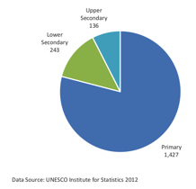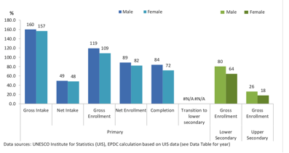
In 2012 the number of students in the Primary School Grades was 1.4 million. The ratio of girls to boys being 100:109 Gross Enrolment, 100:109 Net Enrollment and 100:117 at Completion. This ratio widens in upper grades to 100:125 in Lower Secondary from which the numbers of students dropped off dramatically and the gender ratio widened further in upper secondary to 100:144. Reaching girls in early years of their education opportunity is therefore important whilst efforts are made to encourage girls to remain at school.

In 2015 Free Education to grade 12 was introduced by the PNG National Government which resulted in more students attending school. Though this gave more opportunity for children of low income families to attend school the increased influx of students led to a higher student to teacher ratio, exacerbated by the limited teaching resources that are available.

Environment Education in Tertiary Institutions
There are several tertiary universities across Papua New Guinea which have courses and a range of qualifications in various aspects of the environmental and sustainable development sciences.

University qualifications in Natural Resources offered at PNG Institutions.
 | UNRE | PNGUT | PAU | UPNG | UOG
Diploma | *Sustainable Tropical Agriculture  *Sustainable Livestock Production  *Sustainable Fisheries and Marine Resources  *Sustainable Tropical Forestry | Forestry *
Advanced Diploma | *Sustainable Tropical Agriculture  *Sustainable Livestock Production  *Sustainable Fisheries and Marine Resources  *Sustainable Tropical Forestry
Degree | *Sustainable Tropical Agriculture  *Sustainable Livestock Production  *Sustainable Fisheries and Marine Resources  *Sustainable Tropical Forestry | BSc  *Forestry  BSc  *Agriculture  *Environmental Science + Biology  *Environmental Science + Chemistry  *Environmental Science + Physics  *Environmental Science + Mathematics | BSc | BSc  *Environment + Geography | BA  Environmental Studies
Honors | *Sustainable Tropical Agriculture  *Sustainable Livestock Production  *Sustainable Fisheries and Marine Resources  *Sustainable Tropical Forestry | BSc (Hons) |  | BSc (Hons) | BA (Hons)
Masters |  |  |  | MSc
PhD |  |  |  | PhD

The University of Papua New Guinea has also finalised course programs for a Postgraduate Diploma and a Master’s degree in Conservation Management in partnership with EMPNG (ExxonMobil-PNG) as part of EMPNG’s biodiversity offset program, and the Mama Graun Conservation Trust Fund. Two conservation certificate courses were delivered in 2017, with the first involving 25 participants from the Kokoda Initiative. The first four scholarships for the new Master’s degree in Conservation Management were awarded in December (EMPNG 2018).

Awareness
There are two main focuses in awareness in PNG
- To gain an appreciation and respect of the environment.
- To care for the environment and become proactive in this.

Within and across PNG there is much awareness on the environment. This is often centered on World Environment Day, June 5 where the yearly theme of the UN is led by CEPA, this is sometimes extended to include World Oceans Day, June 8. Some organisations also celebrate World Wildlife Day, March 5.

Environment Days
At the World Environment Day (WED) 2018 with the theme ‘Beat Plastic Pollution’ the National Minister for Environment, Conservation and Climate Change asked for WED to become a public holiday in 2019. (The National Newspaper June 6 2018). World Environment Day is recognized in schools across PNG and is the most celebrated UN day that reaches the most remote parts of the country each year for well over 20 years. This has led to a generation of students who have participated in this awareness event under several different themes. This would reach 1 million plus students through all grades each year.

Much awareness is centered on the nations capital city of Port Moresby with the participation of agencies based there along with companies. This includes but is not limited to UNDP, JICA, SPREP, World Vision, UPNG, Eda Ranu, PNG Power, ExxonMobil-PNG, Steamships, Laba Holdings, the PNG Sports Federation and others. This usually involves posters and various activities on the day that relate to the theme. This awareness in Port Moresby would reach 250,000+ people.

Within the grounds of UPNG, Port Moresby is the Nature Park where in 2017 19,000 students were given environmental education and in this year 150,000 people visited the park which also has animal exhibits. It has received ZAA (Zoos and Aquarium Association) accreditation) the first in a Pacific Island Nation to do so.

Whilst in the northern city of Lae, UNITECH, PNG Biomass, Steamships, Dulux and others take part in activities that would reach 50,000+ people. Located at the PNGUT Lae, the Rainforest Habitat has potential.

Other Urban Provincial Centres also celebrate World Environment day and cleanups at various times. The Bank of South Pacific (BSP) has a ‘Go Green’ Campaign with various activities such as cleanup and campaign branded giveaways.

World Oceans Day and Coral Triangle Day are to some extent celebrated by government agencies, the National Maritime Safety Authority (NMSA) through posters, the PNG Surf Association and others.

There is other ‘passive’ awareness through various environmental/recycled bags to replace single use plastics in stores. Also most accommodation chains in Port Moresby have environmental ‘friendly’ options for travellers to consider.

Awareness in major population centres is often on, town and or/coastal cleanup, to have an inviting environment, with the purpose of creating a positive attitude of people towards their surroundings. This is targeted at a cross section of the urban community. Some of these cleanup activities have also generated data on the volume, types and localities of rubbish collected to inform future planning. However the problems of rubbish remain. Though land allotments are serviced by paying for rubbish collection the surrounding squatter settlements which are a consequence of PNG urbanization usually dispose of solid waste by burning and/or dumping in drains/waterways.

It is evident though that much of the environmental awareness is targeted at school students, which are a major proportion of the country’s population, i.e. 50% of the population is less than 19 years of age

Constraints
Awareness is often focused where resources are available and supported. Reaching rural communities is logistically complex and their level of understanding of contemporary issues is often limited because of this. Levels of literacy also is a contributing factor.

Moving forward
The education syllabus is transitioning in 2018 to Standards Based Outcome, with an emphasis on Science, Technology, Engineering and Mathematics. The subjects of Environmental Studies and Community Life will be absorbed into Science/Geography and Social Science. Teaching in local language with bridging to English in Grade 3 will also cease with English as the language of instruction in all grades. Spoken literacy of local languages has already dropped from 80% to <50% in a single generation and is likely to be further eroded due to this change in the alteration of formal education. Also without a dedicated subject on environment the effects of this on students empathy and knowledge of the environment will need careful monitoring.

The ongoing development and distribution of teaching materials that support environmental education would be a positive initiative.

World days that focus on an element of the environment remain an effective environmental awareness approach and with increased internet access across PNG the theme and web based support materials can be accessed in a timely manner.

The local development of interactive learning e-based environmental resources is an opportunity that educators and activists would benefit from through well directed support.

Sustainable Development Goals
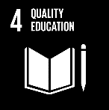
4.7 The Papua New Guinea formal education system up to 2018 promoted sustainable development through all grades through subject recognition in the syllabus of Environmental Studies and Community Living. This was in fulfillment of the Goals and Directive principles of the PNG Constitution that recognise equal opportunities, environmental custodianship and building upon PNG ways.
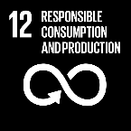
12.8 Through Environment Day awareness across the country information is available to students and communities on annual environmental themes.

1. 
Aichi Biodiversity Target 2 Biodiversity values integrated

Status of biodiversity value integration
Moving away from target

Level of confidence of the above assessment
Based on limited evidence

There is little evidence that indicates that biodiversity values are integrated into National Accounts.

Subsequently there is no monitoring system in place

The Valuation of Biodiversity has not been accounted.

Outline
Within Papua New Guinea near 40% of its people live in cash poverty. In cities this can be absolute with high unemployment, whilst in rural areas individuals, clans/tribes and communities often have high levels of socio-cultural and environmental ‘capital’ or ecosystem system services to draw upon. However even in rural areas some small clans/tribes with limited resources within a community may be in food security poverty. For their livelihood and well-being the majority of Papua New Guineans, 75-80%, rely principally upon their available ecosystem resource base from customary agriculture/fishery hunting/gleaning and/or small-scale cash cropping/artisanal fisheries. They are however often cash poor. Through experiential learning each culture of PNG has developed its own ways of utilizing and managing the local environment, their agriculture system, crops and customary agronomic practices. Maintaining customary knowledge and planting materials are an important foundation of village life and approach to maintaining the wellbeing of its people. Should the local environment be over-utilised or collapse from other causes such as pollution or impacts of climate change, the communities’ reliant upon it will face absolute poverty.

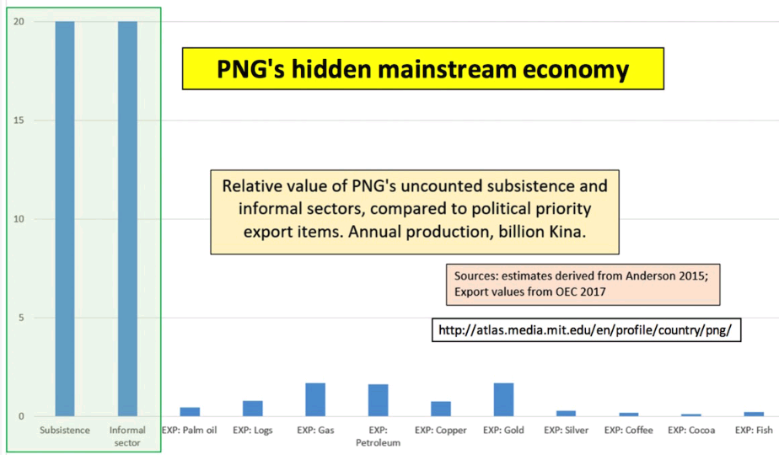
Suggested Hidden Economy (ACT Now 2018)

ACTNOW an activist organization in PNG has a suggested valuation of the Subsistence and Informal Economy which is given as PGK40 billion (Anderson 2015) which far outweighs the formal economy which is given predominance.

Currently the values of biodiversity and ecosystem services are not known explicitly. Though the rural people themselves have a generalized understanding of its value based on their a day-to-day reliance, based on their efforts, and the harsh reality of the costs when their system of production fails in times of natural disaster, drought, flood or frost.

StaRS
Within StaRS (2014/15) the PNG government recognized that the idea of ‘integrated environmental and economic accounting is a crucial consideration in development policymaking, on the basis that growth in GDP can be misleading if the natural and environmental capital base on which GDP growth depends is being carelessly exhausted’. It however saw ‘green accounting’ as an experimentation to define best practice without then progressing to environmental accounting. Also despite recognizing the value of a paradigm shift of PNG to an inclusive green growth policy, the (7) instruments with which to progress this have not been implemented.

Implicitly however major resource development projects as per the Environment Act (2000) require an environmental and social impact assessment to mitigate impacts upon the environment, biodiversity and ecology.

Government Agency Application
There is currently no systematic valuation of biodiversity or of ecosystems. A current proxy are maps that indicate areas of biodiversity importance. Still used are the internally generated Conservation Needs Assessment (CNA 1994), the Plan of Work Protected Areas (PoWPA) Terrestrial (2008), Marine (2015) and Ridge to Reef (R2R 2018). CEPA in 2019 is guided by the map of biodiversity areas of interest ABT11, whilst externally Critical Habitat, as defined by the International Finance Corporation’s Performance Standard 6 (IFC PS6) criteria is also used. The latter triggered a biodiversity offset requirement by the developers of the ExxonMobil-PNG LNG project.

Success
Major Developments in PNG require under the Environment Act (2000) that an Environmental Impact Assessment is submitted to CEPA. The EIA and associated documentation is then open for public comment and is evaluated by a reputable independent assessor who delivers their assessment to CEPA before the EIA is considered for approval by the CEPA Environment Council. Upon approval the development is issued an Environmental Permit with regular reporting requirements as set out by CEPA.

Environmental Accounting at Provincial Level
At the sub-national (local level government) level a comprehensive Marine and Coastal Values Framework (Skewes et al., 2017) was developed that can be applied to existing and new natural resource, ecological and socio-cultural data to comprehensively value ecosystem features and cultural assets. This process included four value categories and 18 value types as per the figure below. The value categories and metrics are based on best practice approaches for environmental valuation and is capable of integrating a broad range of environmental, socio-cultural and resource-use data. These values can be applied at all scales, but is particularly useful for information targeted at the local level government scale.
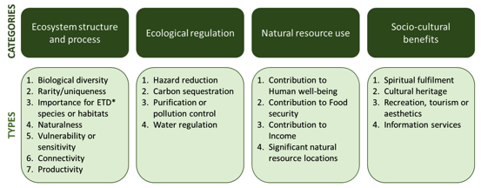
Value categories (attributes & benefits) expressed within the Marine and Coastal Framework (Skewes et al., 2015)

This initiative set out to build a comprehensive Marine and Coastal Values Database for New Britain Island (East New Britain and West New Britain Provinces) as a resource to contribute to the sustainable development of the Bismarck Sea “Seascape”. The database was populated using the approach developed as the Marine and Coastal Values Framework. Resource use and ecosystem attributes data collected from various sources was entered into a database using the framework to construct the Values Database ready for use as spatial maps and in a GIS program (QGIS), so that it has the potential to be utilized and inform marine and coastal management and decision making in New Britain and the Bismarck Sea seascape.
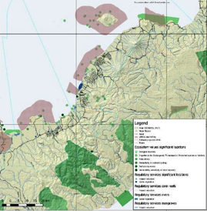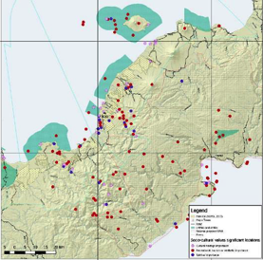
Left Ecosystem and Regulatory values East & Central Nakanai Right Socio-Cultural Values WNB (Skewes etal 2015)

Biodiversity Offset
There has been discussion in Biodiversity Offset initiated during the PNG-LNG project construction phase which has been applied by this development and which has informed ongoing discussion, and CEPA has progressed in 2019 to a draft policy on Biodiversity Offset. Some level of biodiversity ‘accounting’ is required to understand what losses are to be offset. This is expanded upon further in ABT14.

Constraints
Lack of Environmental/Biodiversity Value Accounting
Papua New Guinea does not have a National environmental-economic accounting framework in place nor the determined values required to effect this.

Papua New Guinea has not participated in the SEEA (System of Environmental-Economic Accounting) implementation strategy, which indicates that it has not reached a point of determining environmental cost-benefits of its current development policies by using this framework or currently does not have the political will to do so.

Currently ecosystem and biodiversity values (nor social/customary costs) are factored as a part of national accounting in the development ‘equation’. The environmental, social, cultural and future financial costs of development are not systematically determined in PNG at either the local or national level.

There is currently no systematic data on biodiversity values that could be represented spatially. The data that does exist is on forest types, informed by satellite image interpretation, survey plots and economic tree species transects. Eco-regions within the surrounding seas informed by satellite image interpretation, marine surveys including economically important species such as tuna and bêche-de-mer.

Moving forward
There is an urgent need to determine how to value all aspects of the PNG economy. It is to verify or otherwise the value of the ‘hidden’ economy, by valuing the subsistence economy, the informal sector, the cash economy and to determine costs to the environment, cultural erosion and social costs as the result of subsistence and economic development. The cost of the loss of traditional knowledge in relation to formal education also could be a factor requiring inclusion. In this way a cost-benefit analysis can be made of PNG’s development pathway since independence, that can be assessed. This will then inform the new paradigm of responsible sustainable development (StaRS) that is meaningful for Papua New Guinea’s future development.

Sustainable Development Goals

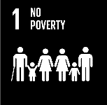
  - The people of PNG still maintain rights over their customary land, which underpins the livelihood of 75-80% of the total population.

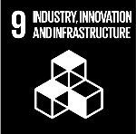
9.4 There are current upgrades of hydropower supplies and conversion from diesel to LPG for power generation.

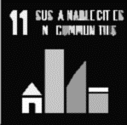
11.3 PNG through the bank BSP has initiated low interest long term loans for low income earners in Port Moresby to potentially own a home rather than to live in a settlement.
11.7 Public space in Port Moresby has been enhanced such as Ela Beach sporting facilities and play areas for children.
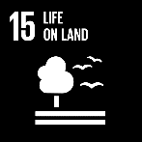
15.9 The idea of subnational accounting has been piloted.

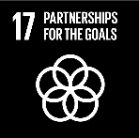
17.4 StaRS has put forward a new paradigm for sustainable green development as a Strategy of the government.

1.  2.
Harmful incentives eliminated Conservation

Aichi Biodiversity Target 3 Incentives reformed

Status on the elimination of harmful incentives
On track to achieve target
Status of resultant conservation
No significant change

Level of confidence of the above assessment
Based on partial evidence
Based on limited evidence

Documentation indicates that reforms have been made.
No monitoring system in place to determine the impacts of these reforms.

Reformation of incentives can be monitored by noting the Trade Agreements that Papua New Guinea enters into.

Outline
Formal Economy
Papua New Guinea ranks 90th of the world’s 221 exporting economies at USD 8.2 Billion in 2016, heavily dependent on the nonrenewable mining (2.37B) and hydrocarbon sectors (3.12B). The current known reserves of these non-renewable resources is 30-40 years of further extraction. The main renewable resource exploited is the rainforest through round logs (0.6B). All of these economic activities are dominated by foreign ownership.

PNGs main export destinations are Australia (2.6B Japan 1.8B China 1.5B and other Asia 1.2B). This mineral and now additional hydrocarbon dependency has been the situation in Papua New Guinea for the last 30 years and is projected so for a further 30 years, essentially two generations.

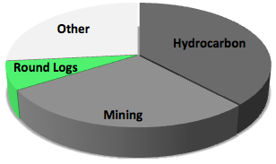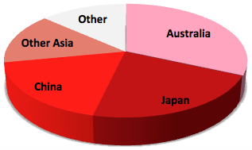
PNG Exports commodity by value PNG Exports Destination by value

Export commodities trends EITI 2017

Free Trade Agreements
PNG has entered free trade agreements that give its products preferential market access. These include the
- PNG – European Union Economic Partnership Agreement (EPA) with simplified rules of origin for processed fish and duty-free market access for export tuna. In late 2018 the UK indicated that it will honor this agreement after Brexit
- The South Pacific Agreement on Trade and Economic Cooperation (SPARTECA) with duty-free market access to Australia and New Zealand.
- The Pacific Island Countries’ Trade Agreement (PICTA) with countries across the Pacific and
- The Melanesian Spearhead Group Trade Agreement (MSGTA) which facilitates free-trade in this sub region.

In 2018 PNG has initiated discussions with China for a free-trade agreement and in November 2018 PNG is host to the APEC (Asia Pacific Economic Cooperation) meeting, where other free trade agreements are likely to be discussed. Significantly for PNG the forestry sector has been proposed for accelerated tariff reduction under the EVSL (Early Voluntary Sector Liberalisation). The APEC meeting could be instrumental in addressing major tariff and non-tariff market access barriers in PNGs major export markets to larger economies. Papua New Guinea was the first among Pacific island countries to sign a cooperation agreement on the Belt and Road.

Tariffs
Also in 2018 PNG has amended its tariff regime to enable local manufacturers to compete with imports. Levy increases have changed the gradual import duty cuts under the Tariff Reduction Program (TRP) that was instituted on the advice of the World Bank in 1999. These tariffs on food and consumer goods aim to benefit agriculture and agro-industry which has declined due to dependency on the nonrenewable sector. Tariffs as excises on fuel are aimed to put imports on a more level footing with domestic production.

There is however a risk that without dedicated and efficient reporting and compliance in place that biodiversity will be negatively impacted as a result of these development incentives.

With protection, PNG agroindustry will likely become more competitive on the export market. This is a strategy by the government to increase macroeconomic income from the sustainable natural resource sector i.e. agriculture, to lessen the country’s reliance on the mineral/hydrocarbon sector. How this balances the use of land between subsistence agriculture/small scale and commercial agriculture and maintaining the natural environment is not yet determined.

The quantified impacts of this have also not been determined.

Success
Development towards reform in the Custom Tariff (2019 Budget) (Amendment) Bill 2018 along with Free Trade agenda discussed at the APEC 2018 in Port Moresby.

Constraints
Lack of Financial Benefits from Protected Area
Within the Policy on Protected Areas (2014) Pillar 5 calls for the sustainable and equitable financing for protected areas. One of the major strategies being developed by CEPA under GEF6 (Global Environment Facility, Period 6) is the establishment of a PNG Biodiversity Trust Fund, initially as a sinking fund to support the management of PAs and to incentivise the development of sustainable livelihood strategies for participating communities as per Pillar 2 of the PPA (2014). Discussions are currently underway on options to capitalize the Biodiversity Trust Fund, such as through green taxes, payments for biodiversity offsets and ecosystem services to achieve the required long-term financial stream required to support the PNG Protected Area network.

Management of the formal protected area network of PNG has not been effective due to a lack of financial support for both site management and national oversight (PNG-METT 2017) It was recognized that each Protected Area required and annual budget for its development and implementation of management plans including capital and recurrent expenditure. The aim also is to improve the accountability of the management of protected areas with a greater level of confidence of conservation objectives being achieved. In this way communities see conservation as development.

Moving forward
The subsides or tariffs that remain which have a negative effect on the PNG environment need to be identified and critically assessed.

Sustainable Development Goal
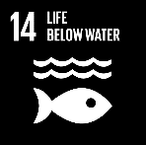
14.4 Policy reforms have been put in place to combat IUU fishing that has included the development of a new tuna management plan; developing a coherent scheme for fisheries monitoring, control and surveillance and a new more transparent vessel licensing system
14.6 Fair Trade Agreements are being pursued with simplified rules of origin for processes fish and duty-free market access for export tuna


Aichi Biodiversity Target 4 Sustainable production and consumption

Status of sustainable production and consumption
Moving away from target

Level of confidence of the above assessment
Based on partial evidence

Within the cash economy the extractive industry is not sustainable. Whilst within the subsistence / informal economy food security is more tenuous with the pressures of an increasing population and unpredictability of climate change impacts.

Monitoring related to this target is partial (e.g. only covering part of the area or issue)

Outline
PNG the Duel Economy
Papua New Guinea has a duel economy: the subsistence-informal sector that directly supports 75-80% of the population and the cash reliant sector at 20%. The ongoing sustainability of the subsistence-informal sector is not monitored, although urban drift may be an indicator (natural birth rates and in-migration census figures) of stress within it. The stressor of people per arable square kilometre within a subsistence farming system has a baseline in 1990-96 under the ‘Mapping Agricultural Systems Project’ (MASP) that can also be used to intimate if this is the likely situation. Indicators of land-use change, forest loss/degradation are currently being determined primarily for REDD+ that is outlined further in Aichi Biodiversity Target 7, data which can also be interpreted to determine the sustainability of ecosystems.

Outline:
Bio-capacity decreasing
The bio-capacity of Papua New Guinea is steadily decreasing due mainly to a rapidly increasing population with a cumulatively increasing ecological footprint. Additionally as climate change impacts increase, the resilience of many ecosystems to both incremental change and perturbations is expected to also decrease, exacerbating the loss of bio-capacity.

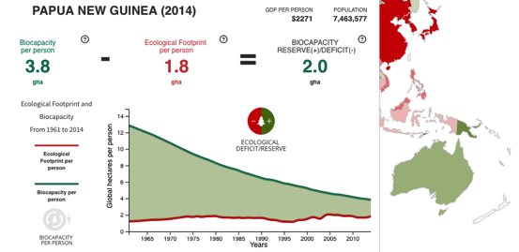
The human footprint is variable across the country and is evident in populated areas and areas of economic development. The map below is of the change of the terrestrial footprint of PNG and neighboring areas for comparison at a world scale from 1993-2009.
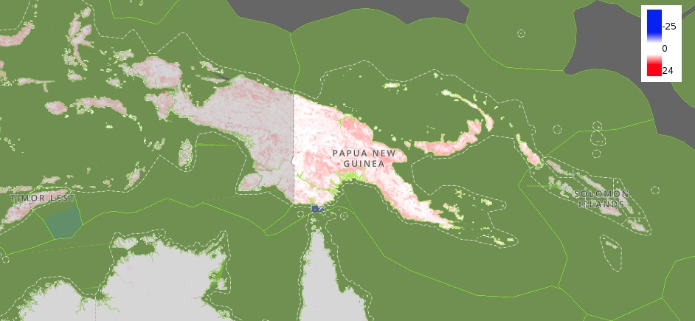
World Scale Human Footprint Change 1993-2009 (UNBiodiversity Lab 2018)

Subsistence/Informal Sector Economy Reliance
In Papua New Guinea 75-80% of its people live in a subsistence agriculture and informal sector income economy. So when the cumulative impacts of population pressure, climate change and other impacts exceed the threshold of safe ecological limits of the resource base, there are serious livelihood and wellbeing concerns. As a country this threshold is projected to be exceeded near 2035, as per the graph on bio-capacity above. However on a localized level in some parts of the country, the sustainable threshold of subsistence production has already been exceeded. This becomes noticeable in a subsistence agriculture reliant mode of production when the population exceeds 500 people per arable square kilometer.
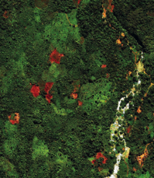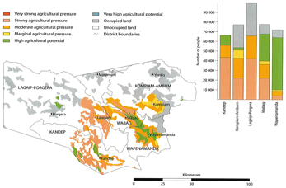
Left: Subsistence agriculture mosaic of forest, secondary regrowth/grass, garden and villages (light orange near river) East New Britain. SOF 2015
Right: subsistence agriculture systems under pressure Enga Province. Many of these areas have high populations exceeding 500-600 people per arable square kilometer. Hanson etal., 2001

The groundbreaking work of the Papua New Guinea Rural Development Handbook 2001 was the culmination of over a decade of work in an Australian-PNG institutional collaboration. It sets out the status and interaction of population, land, agriculture and income by province and by district. It becomes quite apparent at the district and even sub-district level where agriculture systems are under pressure and hence also sustainability, such as the example of the Enga Province above. Of note the Governor of this province has supported the priority of Education over the last 15 years.
Severe Food Insecurity December 2017 IFF 2018

There are signs that subsistence agriculture production is no longer sustaining the local populations that depend upon it especially if there are perturbations in the weather patterns that it can impact upon it.

It is often thought that the incidence of food poverty is usually low due to widespread subsistence agriculture and access to land under the customary land system that still prevails in many parts. However the incidence of food poverty was estimated to be around 26.5% per cent of the PNG population in 2009/10.

While the incidence of basic needs poverty was estimated at 24% of the population in urban areas, it reached 38% of the population in rural areas. Unexpectedly, in rural areas, where access to customary land should lead to lower incidence of food poverty, the rate of food poverty was estimated at 28.5% of the population compared to 14.4% of the population in urban areas (UNDP HDR 2014).

Formal Economy
Whilst in the formal economy of Papua New Guinea there is a heavy reliance upon exports of the non-renewable resources of hydrocarbons and minerals, which are being depleted apace. Though there is a strong balance of payments or exports over imports, PNG in this period has increased its national debit to GDP from 16.3% in 2011 to 33.5% in 2016. Of the renewable resource base, rainforest logs are also being exploited (Trading Economics 2018).

Success
National Population Policy 2015-2024
The government of PNG has recognised that the population growth rate and distribution of PNG’s population has become more unsustainable. With the population doubling approximately every 27 years, pressure on the available natural and human resources continue to increase dramatically as well as the need for increased demographic investment and service delivery. This is considered a major stumbling block for the achievement of responsible sustainable development.

In response to this situation within this reporting period the National Government launched the country’s third National Population Policy 2015-2024 (NPP): Promoting a Viable Population and Environment with the Paradigm of responsible Sustainable Development. A general principle of the policy recognises that all couples and individuals have the basic right to decide freely and responsibly the number, spacing and timing of their children and to have the information, education and means to do so and bases the implementation of the policy on the concept of a willing partnership between citizens, NGOs, the private sector, international agencies and government

The second policy goal of the NPP is, to revitalize and accelerate the demographic transition in order to prevent the presently too high rate of population growth that becomes an impediment to the achievement of responsible sustainable development.

Whilst goal three aims to improve the understanding and awareness of the interrelationships between population growth, development, and the environment among various groups, through targeted population education, advocacy and awareness programmes. With the emphasis target groups being youth, women, policy makers and NGOs/churches.

It is through the next National Population and Housing Census that the effectiveness of interventions and initiatives driven by this policy will be determined. Held near every 10 years, the last such census was held in 2011 and was published in 2014 by the National Statistical Office.

Papua New Guinea Development Strategic Plan 2010-2030
Through the implementation of the Papua New Guinea Development Strategic Plan (2010-2030) it is envisioned by the government that PNG can become a prosperous, middle income country by 2030. As with most such documents it recognises that the directives and goals of the Constitution form the broad objectives of Papua New Guinea’s Development Strategic Plan. To promote growth and reduce poverty the plan focuses on the following strategic areas;
- Land reform, with emphasis on the Land Development Program to improve the existing administration of customary and alienated land, including dispute resolution, and in strengthening the PNG institution of Incorporated Land Groups.
- The energy reform goal is for households to have access to a reliable and affordable energy supply.
- Rural development at the district and local level, promoting cooperative societies in all rural areas as an effective mechanism for developing agriculture and fisheries enterprise, and the establishment of micro-finance banking agencies in all districts by 2030.
- Agriculture and livestock sectors responsive to international and domestic markets for a diverse range of products. Strategies include land reform and improvements in productivity, extension services, use of new high yielding varieties of coffee, cocoa and copra, improvement of roads and general infrastructure to improve farmers’ access to markets, adoption and implementation of the International Codex food safety and fair trade standards.
- Forestry focused on a sector that is sustainable and highly profitable, promoting sustainable forest management through reforestation and afforestation programs, preventing the felling of primary forests, and pursuing downstream processing of forest products.
- Energy and minerals focused on doubling -mineral exports, while minimizing the adverse impact on the environment.
- Environment sector focused on promoting a sustainable environment balance between material wealth and a cleaner environment, economic incentives must be in place to deter pollution. Pollution taxes and transferable pollution permits will be used to fund clean production methods and technologies. Customary practices for enhancing and preserving the environment will also be strengthened as well as the monitoring and evaluation mechanisms in order to protect the environment.
- Climate change focused on adapting the domestic impacts of climate change and contribute to global efforts to abate greenhouse gas emission. To this end, a national greenhouse gas emissions tax and permits incentive will be introduced to serve as a catalyst to promote the development of a low carbon society.
- Natural disaster management focused on managing the risk of natural disasters. focusing on implementing and enforcing building standards for the construction of infrastructure in disaster prone areas, promoting awareness, establishing an effective emergency line, improving the capacity of monitoring and evaluation mechanisms of early warning.

PNG has mapped and updated its forestry resource base data through a Japanese funded Capacity Development for Operationalization of PNG National Forest Resource Information Management System for Addressing Climate Change (2014-2019) (JICA 2017).

Agricultural area potential was initially mapped using PNGRIS (PNG Resource Information System 1987-2002) that included soils, updated census agricultural activities, and inclusion of farming systems data. There are many natural constraints on agriculture potential however across the country. On a localized scale however pockets of arable land occur.
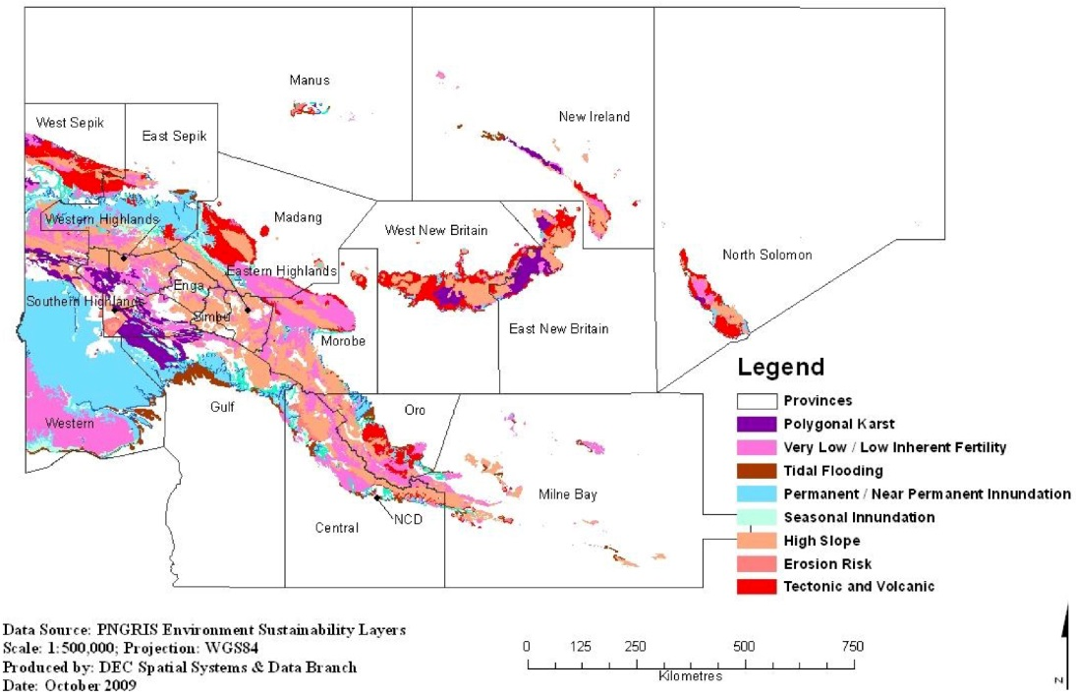
Sustainable Agriculture Constraints from PNGRIS 2009 (pre EEZ map)

Constraints
From 2010-2018 the Papua New Guinea Development Strategic Plan (2010-2030) has seen little progress in its implementation apart from the increased development of future mines, LNG projects and major infrastructure projects in the country. Translating policy into a sustainable paradigm change has not occurred.

Unsustainable Commercial Logging
Within the forestry sector the ban on commercial export of round logs is set for 2020. Repeat harvesting within the 35 year cutting cycle prescribed by the PNG Logging Code of Practice (1996) was widespread inside PNG’s older logging concessions. In the Wawoi Guavi concessions of Western province, re-entry logging was observed only 15 years after the first harvest, 20 years sooner than ought to have been the case. A key priority for forest management in PNG is immediately excluding logged forests from re-entry logging in too short a time period (Shearman etal., 2015)

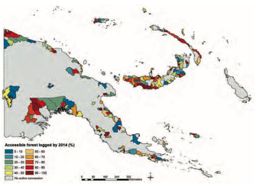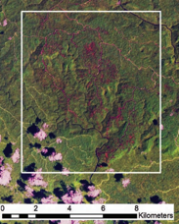
Percentage of commercially accessible forest already logged 1972-2014
Area West New Britain unlogged 1989, logged 2003 same area in 2015 areas logged red.

Based on the findings of Shearman etal., (2015) at the University of Papua New Guinea Remote Sensing Centre (UPNG RSC) within PNG’s logging concessions there is an estimated average of 88.1-98.6 million m³ of timber remaining. In order to maintain logging concessions for timber production into the future and respect the 35 year cutting cycle, annual timber production in PNG needs to be at least 1.6 to 1.8 times lower than current production levels to be sustainable.

Moving forward
There is a need for political will to support a sustainable future for the country. There is a need for improved due process, surveillance and compliance in the exploitation of resources to improve sustainable use. Accreditation of sustainable practice and chain of supply within markets are positive steps that can be taken.

Sustainable Development Goals
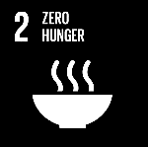
2.4 Food production systems research by NARI through introduction of disease resistant varieties of staple crops and agronomic improvements has and continues to contribute to food security

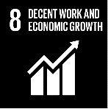
8.4 The PNG government facilitates development of the SME (Small to Medium Enterprise) sector.

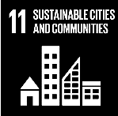
11.3 The government has facilitated opportunities for low income earners home ownership in Port Moresby through long term land/loan options along with the opening up of residential land.

14.4 For the Tuna fishery policy reforms have been put in place to combat IUU fishing that included the development of a new tuna management plan; developing a coherent scheme for fisheries monitoring, control and surveillance; a new, more transparent vessel licensing system.
14.7 Although PNG has low tourism numbers, dive tourism, surfing, leisure cruise and expeditionary cruises are actively promoted by the TPA Tourism Promotion Authority
15.1 The area and diversity of terrestrial ecosystems formally conserved is gradually increasing.
15.2 Forests are under pressure from a range of developments and from climate change effects. This target is being achieved negatively.

Aichi Biodiversity Target 5 Habitat loss halved or reduced

Status on the reduction of habitat loss
Moving away from target

Level of confidence of the above assessment
Based on partial evidence

Figures of forest loss and degradation are becoming more accurate.

Monitoring related to this target is partial (e.g. only covering part of the area or issue) often centred on rainforest with less emphasis on all other habitat types. It also relates to which definition of habitat is taken i.e. the environment within which a species or group of species lives or a specific kind of environment. In the absence of knowledge of the habitat requirements of the majority of species within PNG the latter definition is used.

Monitoring of environmental change is increasingly based upon satellite interpretation and ground truthing with drone capability.

Outline
PNG a Developing Nation with rapid Population Growth
Papua New Guinea is a developing country with a rapid annual population growth rate since 2000 of 3.1% (NSO 2018). There are subsequently pressures on the environment and the country’s resources to maintain the living standards of its people. Attaining this Aichi Biodiversity Target is therefore quite challenging under the country’s current actual economic development path in the formal and transitioning subsistence sectors of PNG. The most noticeable and debated change is the rate of loss of and degradation of primary rainforest. The pressures being extractive commercial logging, conversion of forest to commercial agriculture in plantations and the intensification of subsistence agriculture and smallholder cash cropping. Also grasslands are being converted to commercial agriculture as they are viewed as having a low biodiversity value in comparison. Natural environments where there are population growth centres are also at risk of alteration.

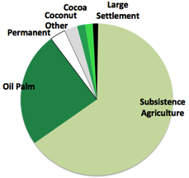
Forest Loss to Cropland Type 2000-2013 PNGFA 2017
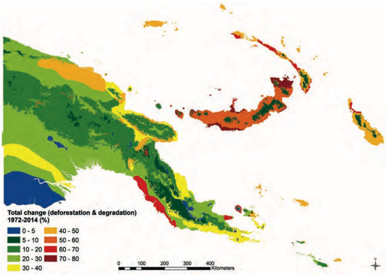
Rainforest Change (Deforestation and forest degradation) 2002-2014 in Papua New Guinea’s bioclimatic regions Shearman etal, 201*

Papua New Guinea is highly mountainous in the interior with the higher risk areas of habitat change and loss from commercial development consequently occurring in the arable and accessible lowland areas. Logging occurring on slopes to 30 degrees and commercial agriculture on slopes to 20 degrees.
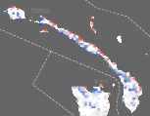


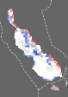
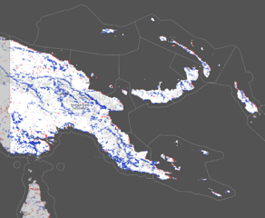

Papua New Guinea Tree Canopy Change Red loss and Blue gain (source UNEP)

Some reports indicate that tree canopy cover is stable and in some areas increasing which without ground truthing is complex to verify and explain.
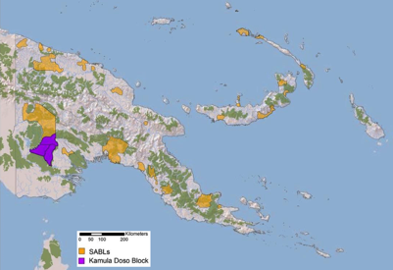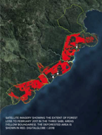
SABLs over intact Forest Landscape 2013 (USAID WCS) SABL forest loss on the south coast of New Britain Island.

The government promoted the establishment of SABLs (Special Agriculture Business Leases) within which areas of clear-fell logging were permitted for broad-scale agriculture development. In many instances due diligence in the process of verifying the viability of these development schemes and the lack of transparency and due diligence in the access over customary lands led to an enquiry into SABLs that is still being undertaken by the Department of Lands. These are still being evaluated, a process hampered in many instances by the apparent loss of documentation.

Fire
Most of the fires across PNG occur in non-forest vegetation in areas of savannah, although fires often creep into rainforest on the edges. Many landscapes where fire occurs have likely evolved with the human influence of burning. Burning also occurs within areas of subsistence agriculture with cut vegetation burnt off as a cultural agronomic practice.
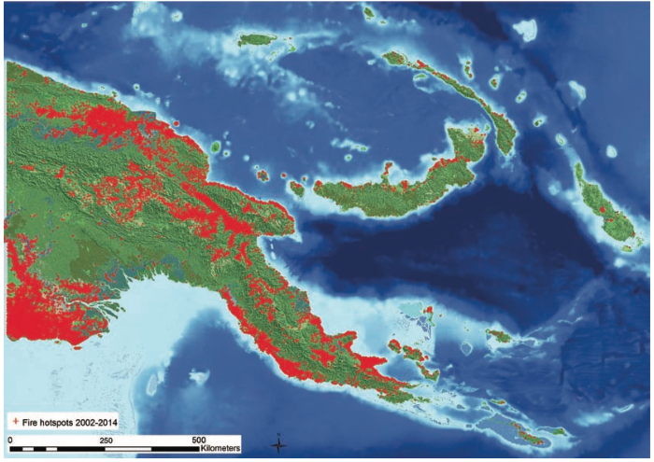
Location of fire hotspots in PNG 2002-2014

Success
StaRS, the National Strategy for Responsible Sustainable Development and its associated Green Growth Framework provides the overarching framework to guide these discussions and what can be done to reduce the future impact of agricultural commodities on forest cover in PNG. StaRS is the road map for mainstreaming sustainable development into development policy and actions, and establish PNG as a global leader in promoting a responsible sustainable development paradigm. However realizing this paradigm shift will require significant national commitment as well as ongoing support from development partners. This paradigm development shift in outlined in greater detail in Aichi Biodiversity Target 7.

Agriculture Sector
Palm Oil
Currently there is a recommendation to develop a National Policy For Sustainable Palm Oil (2016) that is supported by the mapping of appropriate areas for expansion and off limit areas, to help guide future expansion. Also for a Multi-stakeholder Palm Oil Platform to be established in order to strengthen coordination in the sector and help in both developing and overseeing policy implementation.

Cocoa/Coffee
The coffee and cocoa sectors represent the 2nd and 3rd most significant agriculture crops in terms of their economic importance to PNG. They have industry strategic plans in place, developed by their commodity boards, that detail the future direction of these sectors. Contrary to palm oil, coffee and cocoa expansion plans are mostly focused on increasing productivity and the rehabilitation of existing blocks/plantations. This sector therefore currently does not pose a major threat to habitat loss.

Biodiversity Offset
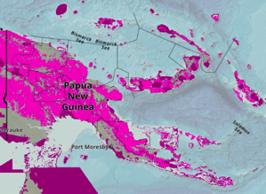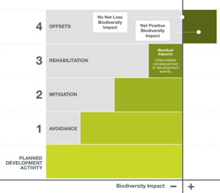
Globally Critical Habitat: International Finance Corporation’s Performance Standard 6 (IFC PS6) criteria. Right: Mitigation Hierarchy (CI 2013)

During the construction phase of the PNG-LNG project an Environmental Mitigation Hierarchy was followed and the concept of Biodiversity Offset for the resultant footprint was advanced in PNG. As this development fell within Globally Critical Habitat it triggered biodiversity offset requirements under the International Finance Corporations Performance Standard 6 (IFC PS6). Therefore a Biodiversity Offset Delivery Plan was developed as part of the PNG-LNG Biodiversity Strategy to address biodiversity impacts that could not be managed through mitigation (EMPNG 2014). This offset being additional to and complimentary to the PNG-LNG environmental program.
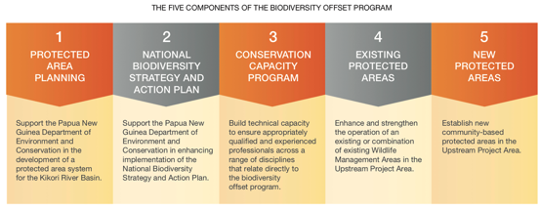
(ExxonMobil-PNG 2014)
This example of collaborative innovative implementation of biodiversity offset was timely to assist in broadening the concept of offset in the PPA (Mitchell etal., 2014). As a result these discussions on offset also informed discussion through CEPA at this time, in the consultations with stakeholders that led to the Policy on Protected Areas (2014). It was seen in Pillar 5 of the policy that the development and implementation of a Biodiversity Trust Fund was needed to support the Protected Area Network through mechanisms such as biodiversity and ecosystem services offsets, Payment for Environmental Services (PES), green contributions such as levies and taxes, and donations and philanthropic contributions. The Policy developed CEPAs thinking in that where existing industry proposals for resource extraction or development coincide with and conflict with Conservation Priority Areas, negotiations will be needed. If the area is developed, biodiversity offsets will be required in similar ecosystem or habitat types. In the case of new industry proposals, careful consideration will be required and approval given only where no net environmental harm can be ensured.

Constraints
With an increasing population the subsistence agriculture sector it has been calculated that gardening has led to forest degradation in 8.2% of the forests of Papua New Guinea outlined in ABT 7. With land-use intensification and decreasing fallow periods, the sustainable forest fallow is lost through succession to a grass fallow. Other areas of forest are brought into the garden production cycle or felled for small scale cash cropping.

Definition of Forests by PNG
In this period the PNGFA (PNG Forest Authority) has altered its definition of forests in 2014. This must be factored when comparing previous forest cover, and hence its ongoing sustainability with current forest cover. This redefinition occurred in the determination of the Forest Reference Level (FRL) to UNFCCC rather than the structure of forest as reported to FAO i.e. the national forest cover in PNGs FRL submission (76.2%) is smaller than that reported in the Global Forest Resources Assessment 2015 report (83.8%).

The government capacity and coordination to support the sector is limited with; a lack of coordination between government departments and agencies, a lack of dialogue and transparency between the different stakeholders engaged in agricultural commodities, low capacity in government departments to enforce existing legislation and an agriculture budget representing less than 2% of public spending (2016).

Oil Palm Futures
Oil-palm in PNG was 100% RSPO compliant however recently an uncertified palm oil sector has emerged which is focused on increasing production through expansion of its area under cultivation and represents the most significant threat to levels of forest cover. The current area estimated under production at 1,500km² is set to increase by 10-fold to 15,000km² by 2030 according to government plans. The large-scale development of uncertified palm oil could significantly impact on existing certified producers as well as the long-term profitability of the sector as investors seek to follow global market trends towards sustainable production for high value European and US markets.

Currently with several SABLs (Special Agriculture Business Leases) and/or FCAs (Forest Clearance Authority) licences issued or in process of issuance for the conversion of rainforest to commercial agriculture, the ongoing loss of habitat within a developing nation such as PNG is counter to this Aichi Biodiversity Target.

Moving forward
Good quality monitoring is now available which can inform adaptive management into future habitat use.

Sustainable Development Goals
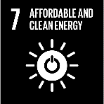
7.1 Energy and renewable energy is accessed by few of the urban majority.

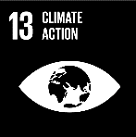
13.1 Few have enhanced capacity against natural hazards and the unpredictability of weather due to climate change.

14.5 Coastal and marine habitats remain poorly represented within the protected area network.

15.1 The area and diversity of terrestrial ecosystems formally conserved is gradually increasing.
15.2 Forests are under pressure from a range of developments and from climate change effects. This target is being achieved negatively.


Aichi Biodiversity Target 6 Sustainable management of aquatic living resources

Status of the sustainable management of aquatic living resources
Progress towards target but at an insufficient rate

Level of confidence of the above assessment
Based on partial evidence

The level of confidence is from Management Plans and Reports that are readily available.
Monitoring related to this target is partial (e.g. only covering part of the area or issue)

The marine sector of Papua New Guinea supports a dual economy of a subsistence/artisanal fishery and commercial fisheries. Little is known of the extent, impact and value of the subsistence fishery with no monitoring of the sustained marine catches/gleaning for subsistence and some sporadic data on marine sales in targeted markets. Commercial fisheries are better known with catch, and export data. Certified Tuna entering the market will also be a new data source in future.

Outline
Fisheries
The PNG National Fisheries Authority has developed several fishery management plans which are as follow:
National Beche-de-Mer Fisheries Management Plan (2016)
National Tuna Fishery Management and Development Plan (2014)
Barramundi Fisheries Management Plan (2004)
National Shark Longline Management Plan (2002)
Torres Strait and Western Province Tropical Rock Lobster Fishery Management Plan (1984 updated 2018)

In addition there is a Trial Fishing Policy (2001), which is a guideline for the precautionary investigation of potential commercially viable fisheries that are not currently exploited e.g. live fish for food trade.

These plans have been implemented to varying degrees of monitoring and compliance.

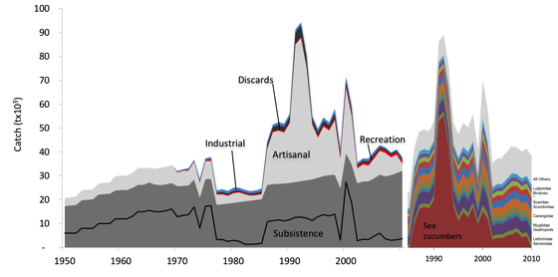
Left: Papua New Guinea Total Catches 1950-2010 Right: Top 10 Taxa Teh etal., 2014

The Subsistence Fishery is quite significant and underpins the coastal communities of Papua New Guinea and the Sea Cucumber/ bêche-de-mer fishery had a major impact from 1985 until 2010 when this fishery collapsed driven by exporters, that led to overfishing by coastal village communities on their customary reefs. A major concern is the amount of rejected harvest, either due to undersize or poor processing.

Given this, a cautious approach to calculating sustainable catch rates should be adopted. That said, subsistence and artisanal fisheries are, by nature, difficult to manage and regulate. Experience to date suggests that sustainable management of these fisheries is best achieved through a combination of agency regulation, community-based awareness programs, and local skills development programs in fishing communities. Such programs should be designed to engage and then empower the communities in a manner that allows them to monitor and manage their own local fisheries in a sustainable manner. (ADB 2014)

Significant loss of coastal fisheries is evident along PNG’s coastline. Marine resources in provinces that have depended heavily on them to sustain livelihoods have come under increasing stress because of fish catches that exceed sustainable levels, destructive fishing methods, and use of outboard engine-powered crafts to access distant or protected fishing grounds.

Community level Marine Management
There are several communities around the country who have established either CMMAs Customary Marine Management Areas or LMMAs Locally Managed Marine Areas. Much effort has been made in the Bismark Seascape through the Coral Triangle Initiative and other major programs involving either or both international and local environmental NGOs. In this seascape LMMAs and CMMAs are practiced within the customary fishing grounds of communities of Manus, New Britain, and New Ireland. Between 2016-18 WCS reported that 22 LMMAs with a combined area of 120km² were established by communities. With the assistance of the National Fishery College, WCS has deployed 18 inshore fish aggregating devices (FADs) in the waters of these LMMAs. Whilst in the Solomon/Coral Sea Ecoregion there are CMMAs in Milne Bay and Central. The PNG CLMA (PNG Centre for Locally Managed Marine Areas) based out of Port Moresby is an umbrella organization that has facilitated discussion with other stakeholders in the development of mainstreaming community-driven fishery management initiatives.

Bêche-de-mer
Bêche-de-mer is an artisanal coastal village fishery which was overfished due to a combination of consistently exceeding the Total Allowable Catch (TAC), wastage of undersize take, poor quality product and IUU (Illegal, Unreported and Unregulated) take by Asian based vessels. This fishery was therefore closed in 2006 to allow stocks of this multiple species fishery to recover. NFA monitored stock recovery in different provinces through evaluating species numbers within permanent transects. A seasonal harvesting season was opened in 2017 under a revised gazetted Management Plan 2016.

This allowed for a TAC per province that if exceeded in a season would lead to a lowering of the TAC in the subsequent season. The plan included the banning of illegal fishing techniques and a schedule of harvestable size limits by species. It does not however consider monitoring the greater impact to the marine ecology through decreasing the presence of sea cucumbers in the system.

Though exporter licence applications are to be screened by a PMAC (Provincial Management Advisory Committee), which makes recommendations to an NMAC (National Management Advisory Committee) this has not been effectively implemented or enforced.

From research in New Ireland before and after the BDM ban, fishing's contribution to total household income increased from 61% in 2004 to 73% in 2014 with the percentage of female residents living in a household now positively and associated with fishing income with customary management practices contributing to this difference.

Tuna
The main export fishery in Papua New Guinea is tuna, mostly Skipjack near 80%, Yellowfin near 20%, Bigeye and Albacore taken from both the EEZ (Exclusive Economic Zone) and Archipelagic waters. At the beginning of this reporting period in 2015 these were overfished at 80% of utilization rate. The catch is estimated by the NFA at around 500,000 tonnes, which is about 11% of the global catch, and 20% of the Western and Central Pacific Ocean (WCPO) catch. The vast majority of this is destined for European markets, within which PNG has favorable trade agreements allowing reduced tariffs in exchange for meeting certain certification and sustainability requirements. Access to this critical market became endangered after the EU issued a “yellow card” to PNG in June of 2014 over concerns regarding the country’s contribution to the global fight against illegal, unreported and unregulated (IUU) fishing. Throughout 2014 and 2015 the NFA, with input from the EU, implemented a range of policy reforms to improve the legal and administrative capacity to combat IUU fishing. In this response the NFA and PNG government amended the Fisheries Management Act 1998, Fisheries Management Regulation 2000 and other legislation to ensure PNG met its obligations under international law. These included the development of a new tuna management plan; developing a coherent scheme for fisheries monitoring, control and surveillance; a new, more transparent vessel licensing system. In October 2015 the EU lifted its yellow card status for PNG (OBG 2018), with PNG able to show it was in full compliance with EU fish handling and traceability certification standards.

The members of the Nauru agreement agreed collectively to operate tuna fisheries in a sustainable manner, which includes taking unilateral action to conserve over-fished big-eye tuna. These actions include a variety of management practices including the closures of high seas pockets, seasonal bans on use of fish aggregating devices, satellite tracking of boats, in-port trans-shipment, 100% observer coverage of purse seiners, closed areas for conservation, mesh size regulations, tuna catch retention requirements, prohibitions against targeting whale sharks, shark action plans and hard limits on fishing efforts as mandated by the vessel day scheme (VDS).

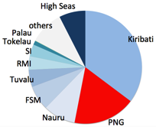
WCPO Purse Seine Tuna Catch 2014 WB nd WCPO Fish Stocks in the Water WB nd

The World Bank Report on Tuna stated that the above figure depicts assessments of the current status of the natural resource stocks, but does not indicate if this status is sustainable under current rates of fishing pressure, or if they will increase or decrease in the future if current rates of fishing pressure are maintained.

The VDS limits the total number of days fished in the PNG EEZ each year, as established according to the 2004 base level, in order to limit catchment to sustainable levels based on quota from studies by Secretariat of the Pacific Community SPC. The VDS fishing day quotas allocated to PNG are reallocated by NFA.

In 2017 near 80% of fish caught by PNG-based fleets were being processed in other countries however the PNG government is leveraging the limited day quotas available by granting priority to companies which have established onshore processing facilities or plan to do so in the future. Fish subsidies were cancelled requiring permits at full cost with those processing onshore given a rebate. These are important changes for PNG in establishing itself as a downstream processing centre within the region with tuna processing hubs in the areas of Malahang near Lae and the Pacific Marine Industrial Zone in Madang. These canneries are operated by RD Fishing and Canning (located in Madang), Frabelle Fishing Corporation (Lae), South Seas Tuna Corporation (Wewak) and International Food Corporation (Lae) with annual export revenues of USD200m The NFA expects a total of PGK350m (USD119.5m) in foreign direct investment to flow to the construction of five additional processing plants between 2015 and 2020 (OBG 2018).

By law all vessels fishing PNG waters must be equipped with vessel monitoring systems (VMSs), which transmit geographic data in real time to the NFA and are also subject to boarding inspections. In spite of these measures, illegal fishing vessels are still known to often be in violation of other codes such as transparency regarding data on catch tonnage, location, offload and other crucial information. Catch traceability is in need of particular attention. Traceability measures were put in place based on a new catch-documentation scheme, which ensures improved traceability of fishery products through comprehensive record-keeping, enhanced port inspections, a stronger focus on enforcement and better collaboration with other government agencies.

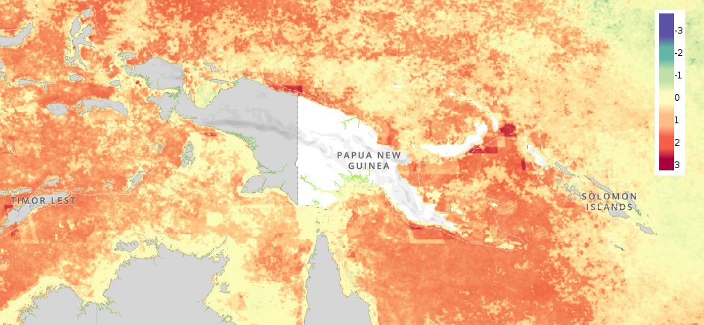
Marine Impacts
Change in Cumulative Human Impact to Marine Ecosystems (UNBiodiversity Lab 2018)

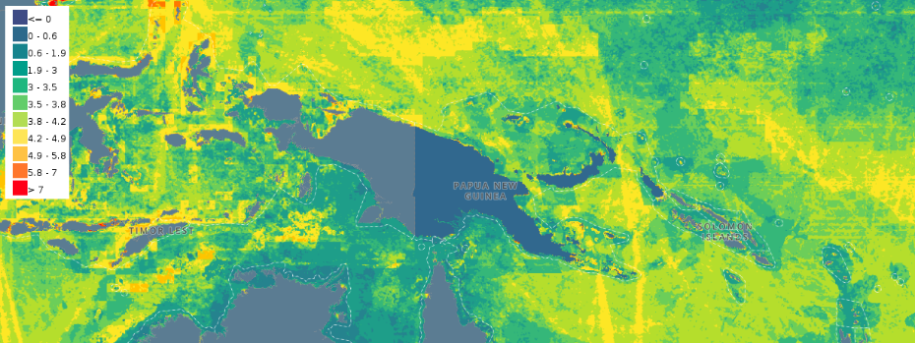
Cumulative Ocean Impact in the Region. (UNBiodiversity Lab 2018)

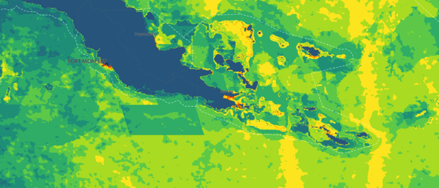
Cumulative impact in the Coral and Southern Solomon Sea (UNBiodiversity Lab 2018)

The Impacts are greatest near urban growth centres and noticeably influenced by the international shipping routes. Except in areas of high population where subsistence fishing takes place the impacts are not great

Success
Maritime Zones Act
Consequent to the country’s Maritime Zones Act (2015) coming into legal effect PNG deposited its charts with the United Nations to become the eighth Pacific Island state to declare information about its territorial sea baselines. Maritime zones and the outer limits of its EEZ, in accordance with the Law of the Sea (UNCLOS). This entered into legal force of on the 1st of May 2017. The final delineated border instruments were submitted in 2019.

Marine Stewardship Council Certification Tuna Fishery
In September 2018 Papua New Guinea received the Marine Stewardship Council (MSC) certification for its tuna fishery. The Fishing Industry Association (FIA) PNG Inc. indicated that PNG has the opportunity to apply for full assessment of MSC certification for tuna caught in PNG waters and processed in PNG tuna canneries through the PNA’s (Parties to the Nauru Agreement (Federated States of Micronesia, Kiribati, Marshall Islands, Nauru, Palau, Papua New Guinea, Solomon Islands and Tuvalu)) Pacifical MSC label. The immediate phase of the MSC assessment would cover the PNG licensed in fleet fishing skipjack and yellow-fin fishery, on anchored fish aggregating devices (FADs) and drifting FADs. Global sourcing will then be considered for assessment and eventually have MSC certification for the prawn fishery. The FIA is finalising the scope of the assessment with the selected conformity assessment body (CAB).

Constraints
Gaining and evaluating data on marine stocks across multiple fisheries disaggregated by the subsistence/artisanal and commercial sectors and by gender participation is a major challenge across PNG.

Improved marine resource management through designation of zoned multiuse National Marine Sanctuaries within the PNG EEZ, currently lacks political will.

Moving forward
The various fishery management plans require evaluation of their effectiveness with revision and adaptive management where this is required. The bêche-de-mer fishery which is a major cash generating fishery for local fishers requires strict compliance in harvesting, maintenance of quality, market licencing and compliance within the TAC if this fishery is to be sustained.

Building on the Maritime Zones Act large areas of the EEZ within PNG need to be considered as zoned protected areas (designated as National Marine Sanctuary under the Policy on Protected Areas 2014). With projected loss of many coral reef ecosystems by 2060 due to the cumulative multiple effects of climate change, the establishment of National Marine Sanctuaries with ongoing monitoring and surveillance of these within the PNG EEZ would be a positive way forward. In addition the current management of pelagic skipjack tuna to ensure food security of PNG coastal communities into the future is vital.

Sustainable Development Goals
1.4 Rights to resources by all within the subsistence fisheries sector is
enhanced by the promotion of C/LMMAs (Customary/Local Marine Management Areas.
1.5 The mainstreaming across coastal and island communities of C/LMMAs, customary closures improve localized marine ecosystem resilience
2.1 Well placed C/LMMAs leads to availability of fish, molluscs inshore during extended periods of rough outer rough
2.2 C/LMMAs, customary closures lead to spill-over of fish, molluscs into inshore areas, that the young, women and elderly can access as a regular source of protein. This overcomes the tragedy of the commons and resource depletion.
8.4 Artisanal fisheries are still to be properly developed with efficient value chain marketing with proper monitoring and surveillance to ensure that ensure sustainability.

12.2 Fisheries management plans are in place and reviewed however these need to be properly and effectively applied.

14.2 Currently only small C/LMMAs are protecting limited areas of marine ecosystems. Large Areas of zoned marine protection within the EEZ are lacking apart from a small designated PSSA (Particular Sensitive Sea Area) at Jomard through the IMO.
14.4 For the Tuna fishery policy reforms have been put in place to combat IUU fishing that included the development of a new tuna management plan; developing a coherent scheme for fisheries monitoring, control and surveillance; a new, more transparent vessel licensing system.
14.7 Although PNG has low tourism numbers, dive tourism, surfing, leisure cruise and expeditionary cruises are actively promoted by the TPA (Tourism Promotion Authority).


subsistence sector commercial sector
Aichi Biodiversity Target 7 Sustainable agriculture, aquaculture and forestry

Status of sustainable subsistence sector production
Moving away from target
Status of sustainable commercial sector production
Progress towards target but at an insufficient rate

There is an assumed (unmonitored) loss of sustainability of the of subsistence agriculture systems with decreasing fallows due to population increase.
Smallholder plantations have been sustainable and the Palm Oil sector has been 100% RSPO, however there are trends that recent Palm Oil Plantations are being developed on cleared forest lands that are not RSPO compliant. The forestry sector has suffered from illegal practices with predominantly round log exports that are

Level of confidence of the subsistence sector assessment
Based on partial evidence
Level of confidence of the commercial sector assessment
Based on limited evidence

Monitoring related to this target is partial (e.g. only covering part of the area or issue) being variable across each sector

Sustainable Agriculture
The subsistence agriculture systems across PNG are not monitored for their productivity and the sustainability of each is not known. However when population exceeds 500 per arable square km or the fallow decreases below 10 years this production system is highly likely to be at or near a sustainability tipping point.

‘Sustainability’ of the major plantation crop of Palm Oil can be determined by the percent of CPO (Crude Palm Oil) exports that are RSPO compliant.

Sustainable Forestry
Each of the following when combined will contribute to an indication of if, future commercial forest cut is sustainable beyond these baselines;
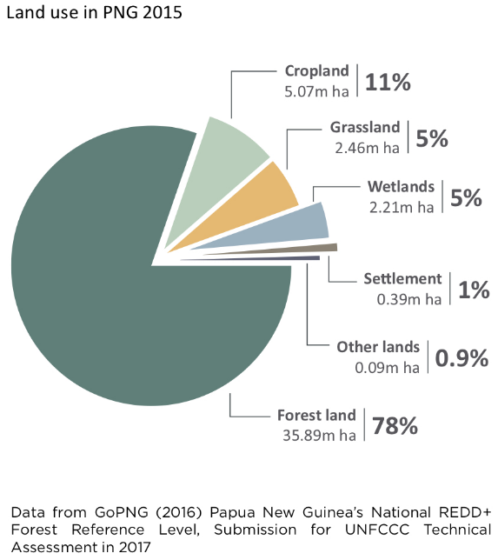
- The Forest Reference Level (FRL) established in 2017 under REDD+
- The National Forest Inventory Baseline (Tree inventory, non-tree plant biodiversity ornithology, entomology and soil) established (CCDA 2017)
- The National Forest Assessment and Land Use Assessment using Collect Earth (FAO) was completed in 2014 and is suitable for LULUCF determination (CCDA 2017).

Aquaculture
This sector is currently a subsistence smallholder activity that has greater opportunity to generate cash when it can upscale with the enablers of a constant supply of fingerlings, feed and access to a ready market. Of the current activities, that are commercial businesses these tend to be monitored by the Fisheries Authority in locations such as the Sirinumu dam.

Outline
Areas of economic growth in PNG have been centred on the major towns, provincial centres and district centres. However the proximity and/or roles of these service centres in serving major mines, hydrocarbon projects, logging operations and agro-developments has also influenced a greater concentration of growth linked to these developments. These developments are driving or adjusting any land-use planning that previously existed in these areas.

Land-uses as in 2015 across PNG are represented in the pie diagram from the FRL (Forest Reference Level) determination. From this it can be seen that the dominant cover of PNG remains as forest, followed by cropland which is both subsistence under-garden, oil palm and other cash crops.

Agriculture
There are two main streams of agriculture in PNG.
A highly diverse range of customary subsistence agriculture systems and/or cash cropping that ranges from small scale village plantings through to nucleus estate plantations.

Subsistence
The sustainability of subsistence agriculture is principally dependent upon the health and fertility of the soil which is gained through the length of bush fallow and/or soil enrichment practices. Subsistence systems are usually practiced without input of imported chemical fertilizer, weedicides and pesticides relying on organic methods and labour, making it sustainable in this regard. Much of the labour input in this sector is disproportionately that of women and girls which also influences what area of land can be sustained under subsistence. As the population increases the pressure on the arable land to continue to remain productive increases but within which, fallow periods decrease, soil fertility declines, weed and pest incursions increase, and yields continue progressively to decline.
Production level of food gardens compared to normal December 2017 IFF 2018

Supply of main staple food crops December 2017 IFF 2018

In areas of gardening on sleep slopes, erosion and landslides occur with high intensity rainfall or during severe earthquakes. Saltwater intrusion occurs on small coralline islands where there is sea level rise and overuse of the underground fresh water lens.

Subsistence agriculturalists who have cleared more primary rainforest, or more regularly cut gardens leading to a succession to grassland, are with each generation altering the environment, reducing the sustainability of the forest fallow system that they rely upon. Hunting also impacts the mammal and bird populations with decreasing intensity with distance from the village.

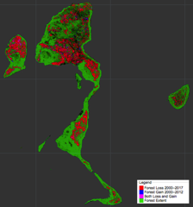
Subsistence farming fallow on Trobriand Island no longer returns to forest
Left: Forest loss in red 2000-2017 Kiriwina islands University of Maryland

On the Trobriand (Kiriwina) Islands, Milne Bay Province there has been a high forest fallow loss between 2000-2017 from Subsistence Agriculture due to population increase, as is evident from the red areas on the adjoining map and picture. The supply of main staple D. alata yam was also less than normal in 2017 from previous Figure from IFF.

Following the agriculture systems research MASP (Mapping Agriculture Systems Project) completed in 1996, areas of arable land utilized for subsistence agriculture were spatially delineated. The area of agriculture has extended in the period since then, but to what extent has not been defined and needs updated research to determine.
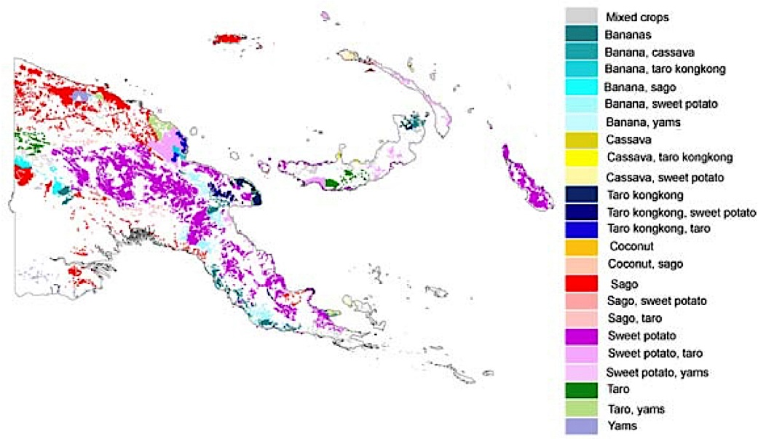
MASP Mapping Agriculture Systems Project 1996

Considering these points the farming systems that 75-80% of the country’s population depend upon are under pressure to consistently supply the food needs of the people who depend upon it.

Cash Crops
The agricultural crops of coffee and cocoa are produced predominantly by smallholder farmers on their customary land base, either additional to subsistence agriculture or as an alternative livelihood strategy. Around 85% of coffee and 95% of cocoa production is produced by smallholders.

The export value of these crops in 2014 was PGK450million and PGK213million respectively.

Near 400,000 households representing over 2.5 million people depend on coffee as a main cash crop and near 150,000 households representing over 0.75 million people in the coastal region of PNG depend on cocoa as a main cash crop.

Through the Productive Partnerships in Agriculture Project (PPAP) the largest ongoing development program in the agriculture sector funded by a World Bank loan and implemented by DAL, CIC and CB 2011-2019 aims to improve the livelihoods of >50% coffee and cocoa farmers and their families. The project has a strong focus on intensifying productivity in existing areas rather than to identify new growth areas.

Many of the smallholder plantings are grown with low levels of external input with agronomic practices of husbandry often a key input.

Plantation Agriculture
The largest plantation crop in PNG is oil-palm with the current main company New Britain Palm Oil with the major shareholder being the Malaysian based Sime-Darby, which in PNG is 100% certified RSPO (Round Table Sustainable Palm Oil).

However some new oil palm developments have been on forested area that has been clear felled. The Bewani Oil Palm Plantation Ltd (BOPPL) in West Sepik covers a SABL of 1,390km² of primary and secondary forest leading to deforestation-linked non RSPO compliant crude palm oil to enter international supply chains from PNG most likely in the Asian market. (Chain Reaction research 2018)

Monoculture agriculture such as oil palm over large expanses of the lowlands has altered the previous ecological balance and reduced the species richness, that was present in these areas, and acts as a barrier to movement of other species across the landscape. High yields are dependent upon on imported fertilizer which is economically sustainable only if prices for the commodity remain strong.

Aquaculture
Within the Papua New Guinea National Aquaculture Development Policy 2004 there are visions that take sustainability and aquaculture appropriate to PNG into account such as
- To establish aquaculture as a viable business industry by facilitating and supporting the private sector to establish economically, socially and environmentally sustainable aquaculture ventures, with NFA facilitating development when appropriate.
- Food security by producing sufficient fish or fish products to feed the people of Papua New Guinea.
- To integrate aquaculture with agriculture by encouraging farmers to adopt subsistence/artisanal aquaculture into their existing agriculture options.

Aquaculture has been and is still predominantly the artisanal and subsistence pond culture of introduced fin fish. These low level input systems are sustainable if returns for labour are favorable.

In 2010 there were an estimated 10,000 inland aquaculture projects in PNG with an estimated value of PGK10 million (NFA 2018).

Forestry
Following the 1989 Barnett Commission of Enquiry into forestry in PNG and subsequent Forestry Act (1991) the process of establishing and implementing a FMA (Forest Management Area) guided by the PNG Logging Code of Practice (1996) was aimed towards sustainable forest use. However the subsequent continuation of TRPs (Timber Rights Purchase) areas, and incidences of FCA (Forest Clearance Authorities) that did not lead to agricultural development has diverged from the intent of sustainable forest use.

Within the current reporting period the Papua New Guinea Forest Authority now has the capability to have a reliable forest and other vegetation types baseline in a spatial format with a high level of resolution based on satellite interpretation and on-ground permanent forest survey plots. This will inform future forest change.
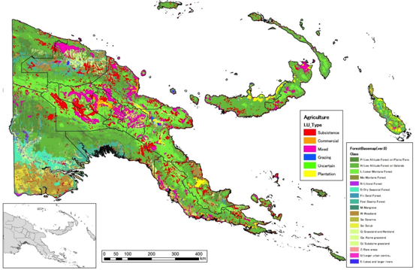
Forest Base Map v1 (PNGFA-JICA 2012)
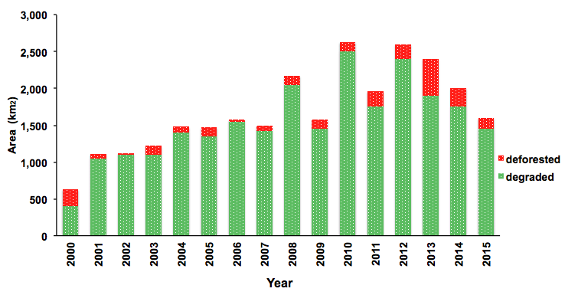
Area of Deforestation and Forest Degradation PNG 2000-2015 (adapted from FRI 2017)

Based on ongoing research it was determined independent of the (UPNG Lab) that a total of 2,615km² of forest was lost (deforested) between 2000-2015. 0.7% of the total forest lost (FRI 2015).

In addition a total of 24,280km² of forest were disturbed (degraded) between 2000-2015 which is 10x higher than the area deforested in the same period. Almost all of this disturbance 98.1% recorded from 2000-2015 were due to logging. In 2015 23.8% of PNG Forests were disturbed with 11.9% commercial logging 7.9% subsistence gardening, fire 3.0%.

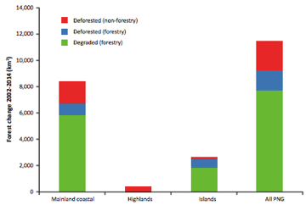
Forest Regional Change 2002-2014 deforestation (forestry and non-forestry) and degradation by forestry activity. Shearman etal., 2005

Other comparative data comes from the 2008, UPNG Remote Sensing Centre (UPNG RSC) published “State of the Forests of Papua New Guinea” report, which described changes in PNG’s forests between 1972 to 2002 at a spatial resolution capable of detecting fine scale and localised changes in PNG’s forests. This report documented the loss of 24% of primary rainforest ecosystems in the period 1972-2002. It was able to accurately quantify the two largest causes of this loss: industrial logging and the expansion of subsistence agriculture into previously uncultivated forests, driven by a rapidly increasing rural population. UPNG RSC undertook to update the State of the Forests Report by measuring the present condition of PNG’s forests, and to map the area that has been logged and cleared since 2002.

In 2014 there were 278,767 km² of closed canopy rainforest in PNG, 13% of which had been logged at least once since 1972. Since 2002, 4.1% of forest was cleared or logged. A total of 3752 km² of rainforest was deforested and 7705 km² of previously unlogged forest was degraded through logging. Overall PNG’s forests were being cleared or degraded at a rate of 0.49 % per year in 2014, a deceleration compared to the 1972-2002 period.

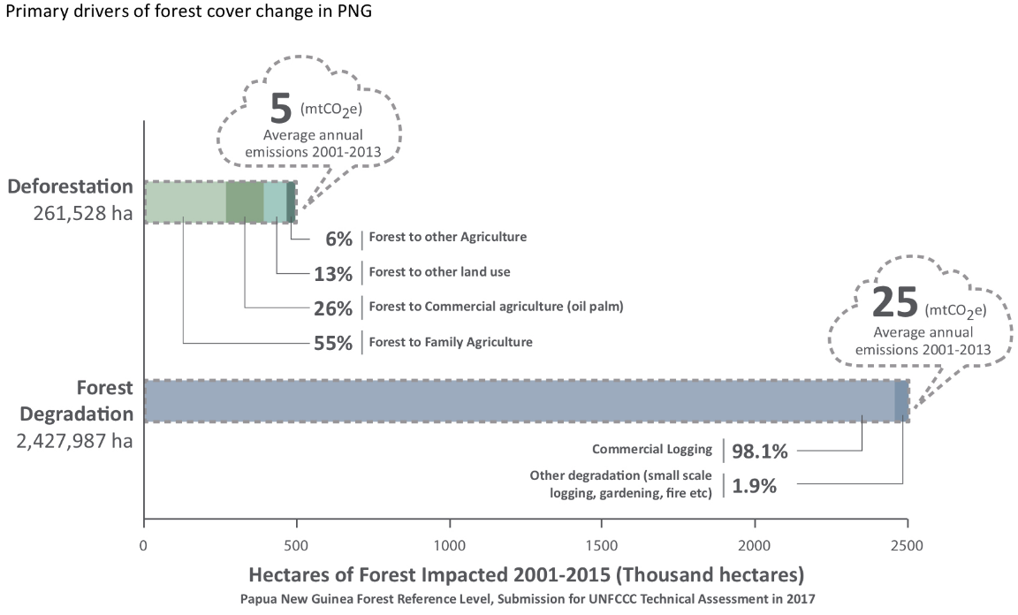
Whilst just over half of deforestation was due to subsistence agriculture/cash cropping. A quarter was due to a recent trend of oil palm destined for the non RSPO compliant market.

Forest degradation which is essentially a non-sustainable practice was almost completely attributed to the commercial logging sector. Degraded forest is less resilient to climate change impacts on plant communities, invasive species and fire.
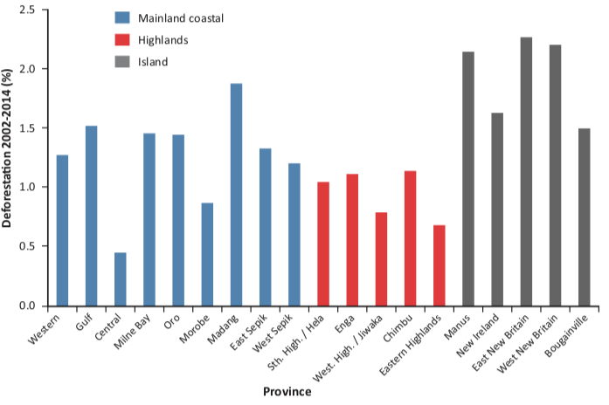
The Provinces with the greatest proportion of forest change (logged or cleared) between 2002 and 2014 were Manus 9.1% of forest, New Ireland 7.6%, West New Britain 7.5%, Gulf 7.7% and West Sepik 6.3% (Shearman etal., 2015).

Success
Policy and Sustainable Strategy
Prior to this reporting period Papua New Guinea developed three main guidelines towards a sustainable development paradigm in the Vision 2050 Policy (2009), the National Strategy for Responsible Sustainable Development (2013/14) and the Development Strategic Plan 2010-2030.

Within these the main basis of change were,
- Vision 2050 with one of the strategic pillars being
- Environmental Sustainability and Climate Change
- Spiritual Cultural and Community Development, and with
- Strategic Planning Integration and Control.
- StaRS (2014/15) a new green paradigm of development.
- The Medium Term Development Plan 2 (MTDP2 2016-2017) based on the sustainable principles of, followed by MTDP3 2018-2022.

PNG also has put in place a bold National Population Policy (2015) “Promoting a Viable Population and Environment within the Paradigm of Responsible Sustainable Development.”

The supporting Policies of the National Population Policy (2015),
- National Climate Compatible Development Management Policy (2014),
- Water Sanitation and Health Policy (WaSH) (2015),
- National Energy Policy (2018-2028)
were adopted by the National Government.

National Strategy for Responsible Sustainable Development for Papua New Guinea StaRS (2014/15)
This strategy is aimed at development with a growth strategy that is built on the principles of green growth and sustainable development built on renewable resources with priority placed on preserving the environment and sustainability using it by adding economic value to it.

The strategy addresses the need to make agriculture, forestry and fisheries more productive and sustainable, while at the same time reducing cash poverty. To enable sustainable growth the policy introduces the Green Growth Framework with three dimensions.

Dimension 1 A National Green Growth Plan to create enabling conditions which includes a shift in government expenditure, more effective enforcement, research and training, resource and land rights, and facilitating the integration of sustainability and equity concerns.

Dimension 2 Mainstreaming mechanisms focused on public environmental expenditure review, strategic environmental assessment, establishment of a Council for Sustainable Development and green accounting.

Dimension 3 Instruments focused on certification of sustainable production and trade, subsidy reforms, payments for ecosystem services, environmental fiscal reforms, green energy investment frameworks and incentives, inclusive green social enterprises and community based organizations, sustainable public procurement, and green innovation.

Lack of Sustainable Growth and Value-adding of Natural Resources
Despite all these policies there has been no recognizable shift towards sustainable modes of growth happening with PNG’s cash economy still very dependent on the export of raw materials by the extractive sector. The population is still growing at rate which doubles each 30-32 years and the country’s food security is declining as a consequence. (Baloiloi 2016)

The people of PNG from clans and tribes to national leaders have come to realize the reality that their resources are finite and decreasing. However in communities there is by necessity, continued exploitation of their environment in order to survive or gain at the expense of sustainable use through perpetuation of the tragedy of the commons. Whilst at the National Government level there is a lack of leadership and commitment to implement the needed changes for oversight of the sustainable use of the country’s natural resources. As a result the promising shift to a sustainable development paradigm that was purported in the StaRS and in some instances reiterated in the MTDP 3, has not gained much ground.

PNG remains an exporter of its non-renewable resources both mineral and hydrocarbons along with its renewable resources i.e. logs, agriculture products and tuna. Though the sustainable use of renewable resources is the purported future direction, PNG remains one of the lead nations in the world for export of rainforest harvested logs 4,000,000 cubic meters (2014). Agriculture commodities are also predominantly exported unprocessed i.e. oil palm oil 98% as crude palm oil, coffee 99+% as green bean, cocoa 99+% bean of which 90% is fine or flavor. At a small scale there are several PNG companies active in downstream processing i.e. producing oil palm cooking oil, coffee as both roasted beans and ground, and cocoa as the first PNG chocolate produced in 2011.

The subsistence and informal sector economy of PNG which is 75-80% of the population draws upon the available environment to develop its social capital e.g. to pay for higher education fees to give the next generation a chance of employment rather than the subsistence life of their parents.

Towards Sustainable Agricultural Commodities in Papua New Guinea
This was informed by a Report Towards Sustainable Agricultural Commodities in Papua New Guinea-the case of Palm Oil, Coffee and Cocoa (2016)

RSPO (Roundtable Sustainable Palm Oil)
The largest plantation agro-industry in PNG is Oil Palm with 93% (2014) certified under the RSPO (Roundtable Sustainable Palm Oil) standards however newly emerged oil palm companies are not seeking certification.

Certified Coffee/Cocoa
Coffee and cocoa in PNG is often of high quality and therefore commands high prices in the world market. Gaining premium prices for organic/conservation/fair trade produce is an emerging opportunity. The YUS TKCP Tree Kangaroo Conservation Program initiated the export of conservation coffee in 2010 from Uruwa Zone, extended to Yopna Zone in 2015 and this continues with support from a GEF5 project through to 2020 whilst another coffee company exports NASAA (National Association for Sustainable Agriculture, Australia) Organic Certified coffee. YUS also initiated sale of conservation cocoa to a local PNG chocolatier in 2014. The Adelbert Cooperative is one of the only groups in PNG working to establish protected areas through the production of environmentally-friendly fair- trade cocoa.

In 2014 five standards certify coffee production in PNG: 4C Association, Fairtrade International, Organic, Rainforest Alliance/SAN and UTZ Certified. All of them operates in PNG. Four Standards certify cocoa production of which 3 operate in PNG: Fairtrade International, Organic, Rainforest Alliance/SAN and UTZ.

General
It has been recognized that there are overarching planning documents needed to guide and advise on the best use of land, especially arable land across PNG. To this aim the National Department of Lands has been discussing land-use for over a decade and is currently refining a National Sustainable Land Use Policy 2014/2018. Also within the National Department of Agriculture and Livestock discussions have been on the development of a National Agriculture Land-use Plan supported by National Agriculture Development Guidelines and a National Agriculture Sector Plan 2019-2029 that is currently in development.

It is also recognized that there is poor inter-sectoral discussion and coordination and that within line agencies such as DAL there are capacity and capability constraints. The coordination between research by NARI (National Agriculture Research Institute), National DAL and Provincial DAL extension agents would benefit by knowing the applied questions that need to be answered in order to maintain ongoing food security across the subsistence farming and marketing systems of the country, and in value adding to smallholder cash cropping, processing and access to premium markets.

Agriculture
Plantation
The largest plantation agro-industry in PNG is Oil Palm which in 2017 was all certified under the RSPO (Roundtable Sustainable Palm Oil) standards however newly emerged oil palm companies are not seeking certification. Some as mentioned in Aichi Biodiversity Target 4 were developed under a SABL (Special Agriculture Business Lease) with a Forest Clearance Authority resulting in the clear-felling of areas of rainforest. A clear shift away from sustainability standards.

Subsistence/Small Holding
Although the Mapping Agricultural Systems Project MASP, documented and mapped subsistence agriculture identifying 287 unique food-cropping systems for the whole of PNG, this foundational work has not led to applied research at the farming system scale to make it sustainable and food production secure. The results of this work was extended to include, land potential, agriculture pressure and potential, income, disadvantaged people in the Papua New Guinea Rural Development Handbook in 2001. A resource that was not used to its full potential.

Aquaculture
Across the country there are small pond fish farms mostly stocked with tilapia or more recently ‘super’ tilapia fish. In many places these have ‘escaped’ into nearby riverine systems where they have changed the localized ecology, often with the loss of native fish species. Agencies who have introduced these species as ‘food security’ for local village communities have not considered the environmental impacts of alien fish species.

Forestry
The PNG Forest Authority with the Department of Environment and Conservation (now CEPA) developed and put in place a Logging Code of Practice (1996). Despite having clear environmental guidelines these have not been conveyed in education programs with landowners where logging is taking place. There is a mixed level of implementation by logging companies and limited compliance monitoring by the Forest Authority.

In 2008 the PNG Minister for Forests, Namah said round log exports would be phased out by 2010. However according to ITTO (2017) Papua New Guinea produced in 2015 about 4.1 million m³ of logs, of which 89% was exported as round logs, 85% of which in 2017 were exported to China. In 2018 the PNG Prime Minister O’Niel, said that round log exports would be banned from 2020. A definitive decision is need by the government.

There are few landowners who have taken on plantation forestry or reforestation as a cash income opportunity apart from the fast turnaround species of balsa which requires a clearly determined market.

Moving forward
Agriculture
The potential for coffee/cocoa certification in Papua New Guinea is much higher than its current level of production (currently below 10% for each commodity). There is an opportunity to improve the current low capacity among smallholders and government to address certification with support in training, farmer organisation and market access.

With the trend in PNG of new oil-palm developments away from RSPO certification there is a need to establish a multi-stakeholder palm oil platform (PNGPoP) that looks at; developing a multi-stakeholder national action plan for the long-term sustainability of palm oil, that monitors and adapts actions that address the root causes limiting the sustainability of the PNG palm oil sector and informs government policy that ensures a strong and coherent legal framework for the sustainability of PNG palm oil.

There is no systematic ongoing Farming System research and extension occurring at this time however there are some individual examples of recording of traditional agriculture and agronomic practices that are important examples of experiential ‘science’ by NARI. This could become the basis of recording such knowledge across all farming systems and languages that would constitute an incredible body of knowledge locally in language and nationally when also documented in English. Also where additional resources have been introduced such as food crop species/varieties these have often had rapid uptake by farmers where their value is apparent.

Sustainable Development Goals
1.4 Women in fisheries and women in agriculture are being more promoted however despite their role as major labour in these forces of production are still rarely given opportunity of greater management from what they produce.
1.5 Within the country’s majority in rural subsistence agriculture the vulnerable remain so through a lack of awareness and empowerment.

2.1 Maintaining a reliable consistent food supply in rural PNG becoming more difficult due to the unpredictability of weather due to climate change and the loss of ecological resilience due to this and pressures from a population that doubles every 30 years.
2.2 Stunting is a major health issue in PNG that is now becoming better known. As a result measures by the IFF in collaboration with agriculture agencies is working to address this.
2.4 Despite the country’s farming systems being known for the last 20 years this has not led to progressive applied Farming System research to improve these. The links between research and subsistence farmers needs remains poor.

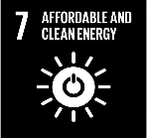
7.1 Small solar systems have become more affordable and as a result a greater amount of household lighting is from photovoltaic systems. In some areas mini-hydro systems have been put in place however the greater potential for this energy source has not yet been realised.

8.4 Papua New Guinea’s macro-economic income remains heavily reliant on the extractive sector. Though the value of the subsistence sector is beginning to be realised and a sustainable development strategy is in place this has not yet been realised in sustainable use and production at any scale
12.2 Natural resources are impacted by an increasing population and climate change making sustainable use a challenge.

14.4 Policy reforms have been put in place to combat IUU fishing that included the development of a new tuna management plan; developing a coherent scheme for fisheries monitoring, control and surveillance; a new, more transparent vessel licensing system
14.7 Species Management Plans are in place however improved data on population, surveillance and compliance remain challenging
15.1 Sustainable forest management remains a challenge and the existing and potential large mines pose an ongoing threat to the major riverine systems, especially from tailings due to the dynamic tropical parameters that exist in PNG. Many waterways have altered detrimentally due to the introduction of alien fish species that were intended as a protein source.
15.2 As the dominant vegetation type in PNG is forest, both the macro and subsistence economies are reliant upon use and or conversion to agriculture.


mining sector others
Aichi Biodiversity Target 8 Pollution reduced

Status of pollution reduction in the mining sector
Moving away from target
Status of pollution reduction in other sectors
Moving away from target

Based on partial evidence

Though the mining sector is very proactive in being compliant with many aspects of pollution management the levels of riverine and deep-sea tailings disposal of many mines is evident within their reports.
Adequacy of monitoring information to support assessment
Monitoring related to this target is partial (e.g. only covering part of the area or issue)

Pollution data is limited to Environmental Reporting from major development projects.

Outline
Papua New Guinea has realised the potential impacts of pollution on its local environments and people, and has therefore through various levels of commitment recognized many International and Pacific Regional Conventions including the:

Stockholm Convention
Basel Convention
Waigani Convention (Signatory)
London Convention 72
INTERVENTION Convention 69
CLC Convention 69 (Denunciation)
FUND Convention 71 (Denunciation)
Noumea Convention

And in addition the;
Montreal Protocol
MARPOL 73/78 (Annexes I/II, III, IV, V),
MARPOL Protocol (Annex VI)
CLC Protocol 92
FUND Protocol 92
Dumping Protocol
Emergencies Protocol

In localizing these into the complex local context, PNG has developed a Policy on Liquid Waste, a draft Chemical Policy and has commenced on an Oil Spill Contingency.

Pollution in PNG has six main potential sources,
- Settled centres; (household, industrial, healthcare waste (HCW), vehicular including e waste)
- Mining with riverine or deep sea tailings disposal,
- Agro industry runoff
- Forest clearance runoff
- Fish processing facilities
- Sea lane pollution

Settled areas
Settled areas whether urban cities, growth centres, towns or urban villages are a major source of pollutants and with a population increase of 2.3% and greater in urban centres, the generation of waste also is increasing.

Solid Waste Pollution
Solid waste of both biodegradable and non-biodegradable in nature is disposed of in landfill (Port Moresby this is in a ratio 40:60) or locally. In traditional society waste was biodegradable and many of the habits of its disposal are applied to the increasing diversity of non-biodegradable waste. Segregation of waste, into biodegradable, recyclable and landfill is limited.

Port Moresby the capital of PNG with a population estimated at 400,000 (2018) has a large solid waste output that is collected by 80 trucks daily. However the household waste from the extensive settlements around Port Moresby with around 40% of the population, are not collected.

Opportunities for commercial recycling are limited. There are currently no facilities to recycle glass, paper products, plastic products, waste oil, rubber or electronic waste, including batteries. Some recycling of aluminium cans and scrap metal occurs. Also there is limited disaggregation of organic waste and other waste unless at the household level. Large amounts of plastic waste are ending up in the coastal areas near towns and major cities. Plastic waste is currently the focus of the government through CEPA. Initially there was a change to the use of biodegradable shopping plastics, which though reducing unsightly macro-plastics, generated and released micro-plastics into the environment.

The Minister for Environment, Conservation and Climate Change in 2018 made a call to ban the use of single use plastics, especially shopping plastics, across the entire country. This was deferred on the request of industry to allow time for a readjustment and transition to this point.

Liquid Waste
Many towns do not have treatment of sewerage, grey water effluent and proper hard waste disposal. In coastal areas this flows into the sea. In 2010 2% of the population of PNG was serviced with sewer connection with a volume of near 30,000 Megalitres per year.

Electronic e Waste
Currently the waste in country generated from disposed electrical and electronic equipment including computers, mobile phones/batteries is not recycled or disaggregated in PNG. There is no countrywide or subnational data on the volume of this waste however there are 2.5+ million mobile phones in urban and rural PNG and an increasing number of computers.

Asbestos
Asbestos-containing materials (ABM) from aging infrastructure remains a hazardous waste stream in PNG with no countrywide or subnational data available on the extent.

Used Oil
There is no national or subnational data on the volume of this waste generated from machinery apart from major private developments such as mines, agro-industry estates which have waste management plans including export for reuse in place. Country compliance under the requirements of the Basel and Waigani conventions needs to be assessed.

Batteries
Primary cell batteries (household use), button cell and Secondary batteries i) wet cell lead acid ii) gel iii) rechargeable (e-Waste) are all having increased use in rural and urban communities (photovoltaic power, vehicles) where they are disposed of in the local environment or landfill. There is no collated countrywide or subnational data on the volume of this pollution or data.

Extractive Mining & Hydrocarbon Industry
The environmental aspects of extractive-led growth have in many ways the most damaging impact on sustainable human development. Large-scale mining open pit (but also Artisanal and Small-Scale Mining (ASM) and to a lesser extent the oil and gas sectors) extracts minerals from the earth, and in the process moves hundreds of thousands of tonnes of material, creating a variety of waste streams. The huge infrastructure and production facilities associated with these operations also consume land, forest and watersheds, permanently altering landscapes, and potentially detracting from the human development opportunities of people who reside in and beyond the areas of operation sites.

Environmental impact from the extractive sector is both point-specific, as well as linear, along road and power corridors and waste polluting river systems. The impact is also characterized by being largely irreversible (or requiring many decades of rehabilitation to return to a near former state), especially around the production facilities of large-scale mines, with production processes that require (or generate) toxic materials e.g. oil, cyanide, unrecovered copper. UNDP 2014

Resource-based extractive industries have the potential to create significant environmental disturbance and destruction, across a broad range of habitats and resources that communities draw on; forests, agricultural land and water. Indeed several of Papua New Guinea’s large-scale mining operations are often held up globally as examples of industry ‘worst’ practice UNDP 2014.

Mining operations therefore have major environmental programs to mitigate damage to the environment through the establishment, operational and closure phases. This is as set out in the PNG Environment Act 2000, determined through an EIA and regulated through an environmental permit issued by CEPA.

Mines tailings disposal in PNG
In 2014 PNG was one of 18 countries to impact coastal areas with mine tailings disposal. This raises concern of heavy metal contamination in the environment and food chains. The following is a list of past, current and potential riverine or marine deep-sea disposal of mine waste in Papua New Guinea.

Riverine
Panguna 500 Mt (million tonnes) 1972-1989.
OkTedi >22 Mt since 1984- (tailings dam collapse reduced fish >1600km² forest flooded
Porgera > 5 Mt
Tolukuma >160,000 t 1995-2018 liquidated

Marine
Misima 90 Mt 1989-2004
Wapolu n.a. circa 1989
Lihir >5 Mt since 1997
Simberi >1 Mt Since 2008
Basumak >5 Mt
Woodlark DSTP (Deep Sea Tailings Placement) preferred option EIA
Wafi-Golpu DSTP preferred option (2018 Feasibility Study) 28 years

Porgera runoff Panguna (Earthworks Mining watch 2012)

Most of this tailings waste is ending up in the sea through the multiple natural processes of saltation, sedimentation and solution. As a result the interface of pollution and the sea is changing. This is also a likely entry point of pollutants into the food chain.

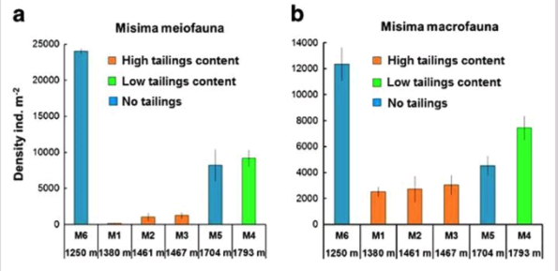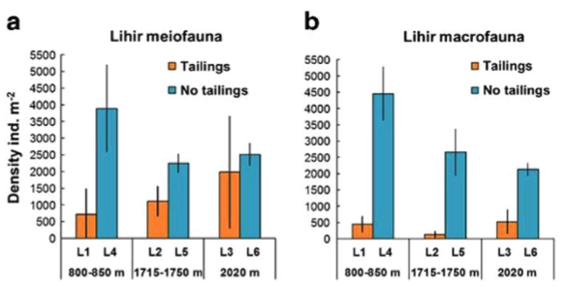
Abundance of metazoans (> 250 µm) at stations around Misima left and Lihir right (Hughes etal., 2015)

Impacts on meio and macrofauna were made at Misima and Lihir mines. At Misima DSTD (Deep Sea Tailings Disposal) took place for 15 years and ceased with its operation in 2004. Sediment samples shown in the graphs above in 2007 show sever impacts on deep sea faunal communities at a broad taxonomic scale. Lihir initiated DSTD in 1997 and is projected to continue out to 2030 but results indicate impact of this currently active disposal.

Acid Rock Drainage (ARD) where it occurs poses a potential long-term environmental hazard that could adversely impact the local ecology without preventative measures.

Mercury
There is extensive alluvial mining in PNG with some use of Mercury which requires regulation. The volume of its use and escape into the local environment is not known of monitored. PNG has not taken steps to determine whether to ratify the Minamata Convention.

Agro Industry
Oil palm estates across PNG use a fertilizer regime to maximize productivity from the palms. Within this they attempt to minimize leakage into the surrounding environment and hence minimize this cost. Companies which are RSPO certified maintain or reestablish vegetated buffers on rivers, the coast and settled areas, guided by the Logging Code of Practice (1996). Effluent that is generated from palm oil processing at mills is passed through a series of settling ponds before water overflow into the surrounding environment. Regular stream monitoring is a requirement of CEPA under the Conservation Act 2000.

Marine
The dumping of waste at sea by fishing fleets has been recorded by on-board observers. These incidents have been plotted and the nature of the waste recorded as per the below graphs.

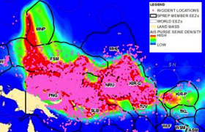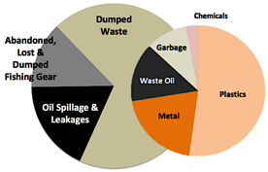
Incident locations (pink dots) & Types of Waste (graphs) from Purse Seine Fishing Vessels based on Observer Data 2004-2014 SPREP

Sea lanes, bilge water pollution and areas of potential grounding disaster
Papua New Guinea is on major shipping lanes between Australia, New Zealand and Asia.
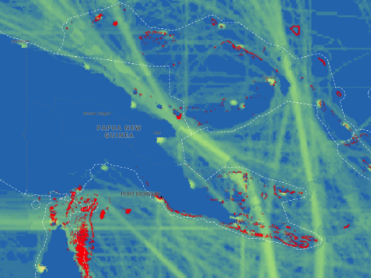
Shipping Lanes, Potential Ocean Pollution Reefs in red (UNBiodiversity Lab 2018)

Previously much traffic passed through the Torres Strait, however with an increased volume of ships with greater depth of draft the Jomard Entrance and route east of the Louisiades are anticipated to have increasing volumes of traffic. Of concern near 50% of these ships are flags of convenience.

Vessels have grounded within the PNG EEZ in this reporting period
.
The response capability of PNG to ship grounding and spillage on any of these routes is minimal with a >48 hour response time. Therefore any disastrous grounding would have a major impact on the immediate marine ecosystems.

Success
The capital of PNG, Port Moresby has decreased its pollution from solid waste through support from the J-PRISM (Japanese Technical Cooperation Project for Promotion of Regional Initiative on Solid Waste Management in Pacific Island Countries) through the improved management of the Baruni landfill site.
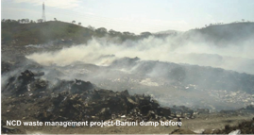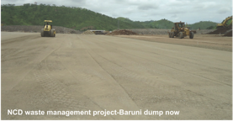
Baruni landfill site Port Moresby Previously and in 2014 JICA Pacific Business Review 2014
This is an example of a dramatic upgrade of waste disposal practice in Port Moresby for collected solid waste. Due to high costs however for this to be implemented in other growth centers will require political will and financial input.

Also a pilot compositing project for the Port Moresby Market of biodegradable waste to was trailed under J-PRISM.

There is a commercial waste management company that services the requirements of the mining and LNG sectors maintaining a high standard of non-tailings pollution management.

National Water, Sanitation and Hygiene (WaSH) Policy 2015-2030
The WaSH Policy (2015-2030) aims to prevent human waste pollution of the environment focused in urban, peri-urban, settlements and village communities. This policy however makes no further point on environmental pollution or ecological impact mitigation.

The National Water Supply and Sanitation Act (2016) aims to provide for coordinated water supply and sanitation services and for the planning, design, construction and management of water supply and sanitation systems in the country.

Marine
Mitigating against pollution in the marine environment has been strengthened through a series of complementary Marine Pollution Acts:

Marine Pollution (Ballast Water Control) Act (2013)
Marine Pollution (Ships and Installations) Act (2013)
Marine Pollution (Preparedness and Response) Act (2013)
Marine Pollution (Liability and Cost Recovery) Act (2013)

PSSA (Particularly Sensitive Sea Area) Designations
PNG has been proactive in reducing the risk of pollution from vessel grounding by establishing safer passage regulation through major shipping route channels.
In this reporting period the Jomard Entrance two-way route was approved by the IMO and came into effect on the 1st June 2015 as a PSSA (Particular Sensitive Sea Area).
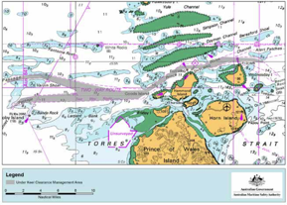
Joint Australia-PNG PSSA Torres Strait Jomard Passage PSSA Milne Bay, PNG
The Navigation Aids were upgraded across PNG by 2012 with assistance from the ADB with additional aids to be installed to increase shipping safety in an effort to decease potential vessel groundings.

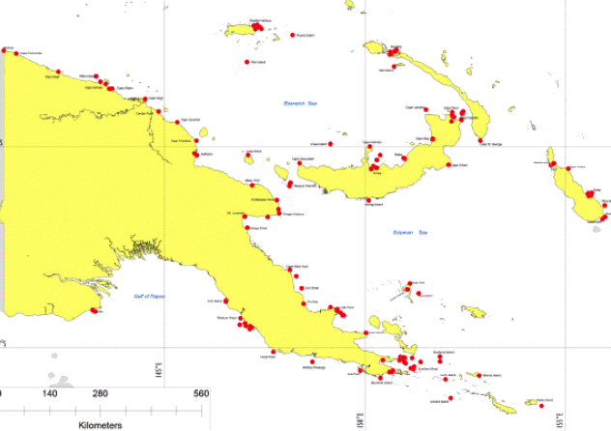
Locations of existing 214 International NavAids 2012

Constraints
The lack of data, especially trend data of all waste types across Papua New Guinea is a major constraint to the management of pollution point sources and the resultant extent of impacts.

There is a lack of capacity of designated agencies across PNG in urban and peri-urban populations to manage solid waste and sanitation. Implementation of the WaSH policy is a challenge in expanding urban centres especially where the required infrastructure for waste processing is not established. ‘Squatter’ settlements in urban centres are difficult to service by virtue of often being of unplanned, densely populated areas and remain a challenge in service delivery.

There is a lack of recycling business in the country with Aluminum and scrap metals being the exception.

E-waste is not currently segregated and is entering into landfill

Moving forward
Papua New Guinea needs to build on its successes but requires a concerted effort to collect, maintain and interpret data on waste sources and resultant pollution in order to develop law, policy, strategies and actions where gaps currently occur.

Papua New Guinea has agreed to many Conventions and Protocols which is an indication that it recognizes its obligations in this regard and Bilateral or Regional however priority is needed to take action to implement change.

Sustainable Development Goals
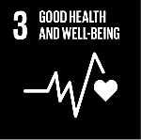
3.9 Currently reducing health risk from pollution and contamination requires concerted efforts in monitoring and directed action.

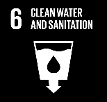
6.3 The National Water, Sanitation and Hygiene (WaSH) Policy 2015-2030 and the National Water Supply and Sanitation Act (2016) have set the framework and legal mechanism to improve water quality and reduce pollution and to increase sanitation coverage.
9.4 Through Environmental Permits industry, especially in the mining, LNG and plantation nucleus estate agriculture sectors are managing towards high environmental standards e.g. ISO and RSPO.

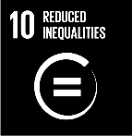
10.2 Reaching the rural towns and communities is a major challenge in the influencing of this Aichi Target and requires concerted education and awareness.

11.6 The development of a state of the art landfill at Baruni for the capital city of Port Moresby has improved NCDC municipal solid waste management and reduced air pollution from burning. Also the reduction of solid waste through a composting pilot can be assessed in its application in Provincial Towns.
12.2 The concept of Reduce, Reuse and Recycle needs further concerted effort.

14.1 A series of Marine Pollution Acts in 2013 and the establishment of a PSSA in 2015 at Jomard passage to decrease risk of accident at sea by large vessels have set mechanisms in place to reduce incidents of pollution at sea.
The EITI (Extractive Industries Transparency Initiative) has created a venue for discussion on environmental management concerns within this sector.

1  2  3
Invasive Alien Species Priority Species Measures in place to manage pathways

Aichi Biodiversity Target 9 Invasive alien species prevented and controlled

Status of the prevention and control of invasive alien species
On track to achieve target
Priority species targeted
Progress towards target but at an insufficient rate
Status on the measures in place to manage pathways of potential entry of alien species
On track to achieve target

Level of confidence of the above assessment
Based on partial evidence
Based on limited evidence

A number of introductions and control measures are reported.

Monitoring related to this target is partial (e.g. only covering part of the area or issue)

The Invasive Species List is progressively being uploaded into a database, and there are Environmental Reports in invasive species, mitigation and control measures being implemented by major developments.

Outline
Papua New Guinea is the eastern portion of the island of New Guinea and its associated satellite islands and is therefore isolated but threatened from many invasive species. The agency in Papua New Guinea with the responsibility for national biosecurity of the PNG border is NAQIA (National Agriculture Quarantine Inspection Authority

Main entry point surveillance
NAQIA concentrates on the main entry points into PNG across its international borders in vessel/wharf inspection and aircraft/airport (incoming passenger/cargo) inspection. There are strict requirements of items coming into the country such as meat, dairy, eggs, fresh fruit and vegetables, plant and soil, live animals and laboratory material along with some products derived from these.

The main points of maritime entry into PNG are the ports of Port Moresby and Lae and to a lesser degree other coastal marine ports. This is followed by cruise and expeditionary cruise vessels with varying voyages that currently take in Milne Bay, East New Britain and other provinces. Yachts also enter PNG waters such as within the Louisiade Archipelago.

There is localised coastal traffic between Western Province and Australia through the Torres Strait plus (land and sea) to Indonesia, between West Sepik Province and Indonesia (land and sea) and between the Autonomous Region of Bougainville and the Solomon Islands.

Entry by air is mainly through POM, Jacksons Airport Port Moresby, with near 200,000 passengers in 2015 and 2016 (TPA 2017) with 50% from Australia & NZ, 25% from Asia and 25% from other points of origin.

Border Inspection
NAQIA in Port Moresby has the capacity to inspect near 30% of incoming selected containers to this port. In 2015 a Container X-Ray Scanning facility at the Motukea Wharf in Port Moresby became operational, improving inspection capability.

The border between PNG and Indonesia in the Western Province is currently not well resourced. As a result there is movement of trade across this border especially deer and potentially Piku, Pig Nosed Turtle further outlined in ABT 11, that has a market in Indonesia and possibly making its way into illegal wildlife trade (Traffic 2014).

Invasive Species Register
The current number of invasive plant species in PNG is not known. There are those which interfere with agricultural, pastoral or horticultural activities and are found in subsistence gardens and commercial agriculture and those which invade natural plant ecosystems altering them. Henty and Pritchard (1975) treated 146 species as weeds in Weeds of New Guinea and their Control. This has not been revised systematically since. Currently with the assistance of SPREP (South Pacific Environment Program) NAQIA is establishing a database of Invasive Species in Papua New Guinea.

A pathway for invasive plant species in the rainforest is through the opening of the canopy by logging and access tracks. Theses species can be introduced by machinery that has not been inspected before entry into an area of operation. There are at least 39 invasive species in rainforest (Kiapranis & Banka n.d.), however the amount of change that these have caused in the rainforest ecology is not known.

Recent surveys of invasive species have been made on the Kokoda Track, a major trekking route made by groups coming mainly from Australia. In 2015 there was no evidence of any new-to-PNG exotic pest species having been introduced by trekkers along the track, but it is likely that the high volume of people walking along the track are assisting the spread of the 83 known exotic plant species along it.

Another survey was made of the Exotic Plants of the Kikori River Basin (2017) by NAQIA with the support of ExxonMobil-PNG. This survey assisted in the development of the Invasive Species program within the company’s Environment Program.

The total number of invasive plant species in PNG is therefore likely to be greater that 200 species.

Freshwater Fishery Invasive Species
Many inland subsistence communities in Papua New Guinea, face a lack of protein in their diet. As a result fish such as trout Oncorhynchus mykiss, carp Cyprinus carpio, tilapia Tilapia rendalli and T. mossambicus, and ‘super’ tilapia, have been introduced across Papua New Guinea by government agencies, church groups and others to improve the protein source of rural communities from the 1960s to the present. These have often invaded nearby waterways progressively altering the natural ecology, irreversibly. Within the Sepik River fish stocking projects of exotic fish were implemented in 1987–93 and 1993–97, through a Papua New Guinea Government and United Nations (UNDP/FAO) partnership. Although these species were selected on the basis of their potential to occupy ecological niches not filled by native fish (1984) the actual impact of these introductions is poorly documented, although there is preliminary evidence that there is a declines of some native species due to the spread of exotics (2006).

The other spread of fish is by fishers themselves who see species as potential protein. For example in the Fly River system it is thought that both climbing perch and walking catfish were introduced by villagers travelling from other parts of the country. Both species are valued as food fish since they can survive out of water for long periods. Villagers travel from village to village carrying fish wrapped in moist leaves, often throwing any excess fish in the nearest waterway. Both climbing perch and walking catfish are also likely to compete with native species for both food and space There are currently no management plans in force to halt the spread of either introduced species.

Invasive Species in Protected Areas

Level of threat caused by invasive and problematic species (METT 2017)

Invasive species are known to occur in the PNG Protected Area network with invasive species being perceived as high threat in 20% of protected areas. The impact of these invasives on species of concern or the integrity of the ecology is not known and there is currently no proactive management to control or eradicate these invasive species within PAs.

There are currently four known invasive bird species in Papua New Guinea; the rock pigeon Columba livia, which is generally restricted to urban areas; the starling Sturnella vulgaris, a European species that was recently sighted in Port Moresby; and two species of sparrow that have recently become established around Port Moresby, and beyond to provincial centres.

The common myna Acridotheres tristis, an Asian species was at Alotau near the main container wharf after 2000, but has not been reported as seen in the last decade (Mitchell). All of these invasive species are also found in neighboring Australia, a possible pathway for unintentional introduction through shipping.

There are no known introduced reptiles to Papua New Guinea. There is only one known introduced amphibian, the cane toad Rhinella marina.

The introduced mammals across much of Papua New Guinea are domestic cats Felis catus, dogs Canis lupus familiaris Rusa Deer are invasive along the Southern Coast of New Guinea and Ship Rats. Feral pigs Sus scrofa are active across the country.

The Giant African snail Lissachatina fulica, which invades food gardens and areas of commercial agriculture was introduced during the second world war and has progressively spread to many areas of the country.

Success
The Cartagena Protocol led to the development of a Papua New Guinea National Biosafety Framework (2005) through consultations guided by National Biosafety Biotechnology Committee (NBBC) over the two years 2003-2005 with stakeholder agencies led by the Department of Conservation (DEC now CEPA) assisted by the UNEP/GEF Biosafety Project. CEPA is the designated focal point as well as the Competent National Authority (CNA) administering and the secretariat to the NBBC making CEPA the primary agency for all activities elating to GMOs (Genetic Modified Organisms).

This led to the formulation of a draft Biosafety Policy Framework and of a draft Biosafety and Biotechnology legal framework with the Biosafety and Biotechnology Bill (2005) taking a preemptive, precautionary and regulatory approach towards GMOs.

Marine
Marine pollution: the Ballast Water Control Act (2013) was created to prevent, reduce and control the introduction of harmful aquatic organisms and pathogens to PNG waters via ships ballast and water sediments, incorporating PNG laws that are relevant to international conventions on the control and management of ships’ ballast water and sediments.

Constraints
The Biosafety and Biotechnology Bill was not endorsed by parliament and did therefore did not pass into legislation.

Also the only institution with the capacity for advanced biotechnology research is the Papua New Guinea University of Technology (PNGUT) Biotechnology Centre (UBC), Lae which became an independent entity as a Centre of the PNGUT on the 29th of November 2013. It has however faced many constraints to work effectively.

Moving forward
Maintaining the borders of PNG remains crucial.
Where eradications can be effective, i.e. rats from small islands or effective biological control measures taken, these need to be promoted and supported also.

Sustainable Development Goal
15.8 PNG has put in place regulatory, inspection and surveillance quarantine measures to protect the main points of entry into the country. The borders are however expansive with potential for incursion.

Aichi Biodiversity Target 10 Ecosystems vulnerable to climate change

Status of ecosystems vulnerable to climate change
Progress towards target but at an insufficient rate

Level of confidence of the above assessment
Based on limited evidence

Changes to ecosystems are often difficult to determine and a precautionary approach is needed in assessing these changes.

Monitoring related to this target is partial (e.g. only covering part of the area or issue) as both the ecosystems monitored and level of monitoring are selective.

There are scientific research papers on climate change both regional and in country, with some based on field based change monitoring and others on predictive modeling.

Outline
Anthropogenic and increasing Climate Change related Impacts
The natural environment throughout PNG is extremely fragile and highly vulnerable to both natural and human impacts. During the last 50 years, pressures on the environment in the use of resources are increasing and these are exacerbated by the intensification of extreme events, such as cyclones, rainfall and droughts. In addition to these threats and pressures on the environment it is expected that changes will arise from other aspects of climate change, such as steadily increasing temperatures, extended seasons, extreme unpredictable weather events and increasing climate variability. These threats will likely further exacerbate impacts and lead to loss of species and the erosion of the resilience of relatively stable ecosystems.

Elements of the natural environments of the country have developed in response to human activity and the changing climate, with a human presence of agriculture in PNG from 10,000 years before present. However, in the past few decades, the rapidly changing climate patterns, increasing population growth and intensity and levels of uses of natural ecosystems may have affected the ability of these systems to respond to such change. PNG has already been buffeted by extreme weather and climate events such as those brought about by the extreme El Niño drought of 1997/98 and extended subsequent La Niñas. With further changes in rising temperatures and sea level rise that are projected only out to 2100 (1 meter rise UNFCCC), the environmental domains of current ecosystems will change, along with low lying coastal inland and coastal areas that will be inundated. This will include the alteration and loss of sand cays, islets, atoll islands, river deltas such as the Fly and Sepik, mangrove forests and freshwater swamps. The coral reef association is likely to have greater incidences of bleaching from increased sea surface temperatures (degree heating weeks), and effects of acidification leading to a loss of coastal coral defences. All these changes will cumulatively and increasingly alter the resources of water, fisheries, forestry and agriculture sectors.

The Green House Gas of Carbon Dioxide has exceeded 400ppm and is currently at 415ppm, way above the 350ppm required for climate stabilization and it is consistently increasing at a rate of 2ppm annually. Surface air temperatures have increased by near half a degree Celsius since the mid 1970s in PNG, while rainfall patterns are variable (UNDP Climate Change Adaptation). With an increase of temperature, species with a low threshold tolerance to temperature change will become extinct and therefore ecosystem integrity of which they are a part is at risk.

Projected Climate Change in PNG
Currently the projections for future climate changes in PNG are broad with no confident refinement at a localised scale. The unpredictability of the seasonal weather patterns is evident and a shift in these is also becoming apparent, as customary biotic indicators in relation to seasonal calendar activities gained through experiential learning of our subsistence, hunting and gleaning societies, are no longer reliable.

The current broad projections for Papua New Guinea based on expert judgement by Pacific Climate Change Science Program (PCCSP) scientists are:

- Surface air temperature and sea-surface temperature are projected to continue to increase (very high confidence).
- Annual and seasonal mean rainfall is projected to increase (high confidence).
- The intensity and frequency of days of extreme heat are projected to increase (very high confidence).
- The intensity and frequency of days of extreme rainfall are projected to increase (high confidence).
- The incidence of drought is projected to decrease (moderate confidence).
- Tropical cyclone numbers are projected to decline in the south-west Pacific Ocean basin (0–40ºS, 130ºE –170ºE) (moderate confidence).
- Ocean acidification is projected to continue (very high confidence).
- Mean sea-level rise is projected to continue (very high confidence).

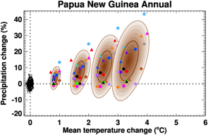
Temperature trend Pt. Moresby and projected percentage change of rainfall with temperature increase PNG .

Increasing temperatures are one of the most evident changes with a .11ºC increase every 10 years since 1950. With increasing temperatures due to climate change the projection is for increased rainfall across PNG. How increased rainfall affects flowering, fruiting in plant reproduction and food availability for species is not well known. The ecological systems in PNG are complex and are not well researched apart from intensive plant insect interactions by the Binatang Research Centre.
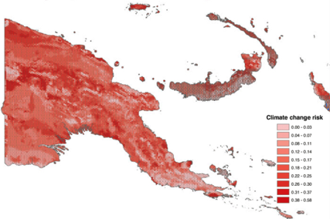
Projected Climate Change Risk (Saxon circa 2005)

Changes will vary across latitude, altitude and aspect in both the terrestrial realm shown here and in the marine realm. These are not yet known with any level of precision and compounding this is a lack of recent local weather recording stations across PNG that have a reliable series of records apart from at major airstrips around the country.

Despite the broad-scale projected weather changes for Papua New Guinea, the variability across the country is not clearly understood. The impacts of the El Niño and ENSO are an example of the variation projected to occur across different parts of the country.

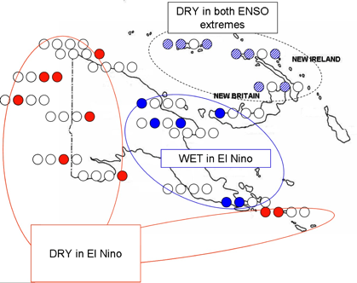
There is both an incremental increase of temperature and more recurrent extremes influencing the weather across PNG. It is these extremes of drought and long periods of rain with incidences of high intensity rainfall that are causing impact.

What these changes mean on a localized scale is also poorly understood. Different climatic domains, different weather patterns and extremes effect each species and hence the local ecology. Some of these are outlined in ABT 10 Ecosystems Vulnerable to Climate Change. Where a threshold is exceeded the impacts can be quite dramatic such as coral bleaching, were coral polyps evacuate at a degree heating weeks threshold or where animals die from heat stress.

Projected future ENSO climate extremes impact (Smith etal )

Sea Level Rise
Within PNGs initial communication in 2000 to the UNFCCC it was stated that the periodic or permanent inundation of low deltaic floodplains, swamp and low-lying areas including entire islands could affect 50% of the Papuan Coastline and 10% of northern shorelines with a 1 meter sea level rise with 4500 kilometers (20%) of the coastline moderately to severely inundated affecting 30% of the country’s population.

Actual Sea level rise (purple) from PNG Tide gauges and projections.

The projected sea level rise in the next generation 2050 based on the current CO₂ increases (415ppm 2019 + 2ppm annually) is in the order of 30-40cm.

Reefs
The tropical reef associations (14,535 km² of coral reefs, representing about 6% of the world’s total) are also impacted by sea surface temperature, sea level rise, rubbling and increased acidification, with reports of coral bleaching mostly at latitudes between the equator and 10 degrees south. The evolutionary capability to adapt to change of this system is not well known. Ecosystem studies by CSIRO Ocean Flagship expertise (2011) has put climate change as the dominant main risk of coral reefs in PNG beyond 2060, overtaking other anthropogenic impacts. Already many of Papua New Guinea’s reefs especially those proximal to populated areas, are at risk from these cumulative threats as per the figure below.
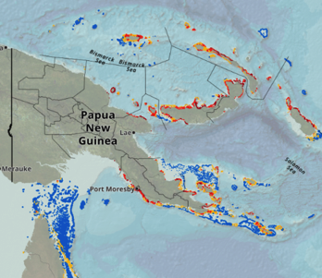
Reefs at Risk (UNEP 2011)

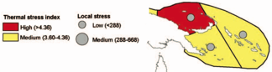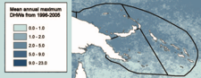
Left: Vulnerability to thermal Stress a combination of historical stress and projected thermal stress, Local Stress a combination of coastal development, marine based pollution, overexploitation of marine resources, inland pollution and erosion from Burke etal., 2002
Right: Mean Annual maximum DHW 1996-2025 from CoRTAD Macleod etal., 2010

Sand & Coral Cays
Small sand and coral cay environments are at risk of inundation due to sea level rise. Often isolated and distant from settled islands the loss of these will impact upon rookeries for turtles and sea birds.

Mangrove & Estuarine
Sandy beach, Mangrove (0.8% of PNG forest types UNFCCC), Coastal Freshwater Swamp (6.8% of PNG forest type UNFCCC 2017). Forest and Estuarine areas are also at risk of erosion and inundation due to sea level rise. Sea level rise near Papua New Guinea measured by satellite altimeters since 1993 is about 7mm per year (17.5cm in 25 years), higher than the global average of 3.2 ± 0.4 mm per year.

These marine environments are spawning and recruitment sites of many species, which will be impacted by a loss of their breeding grounds. This ranges from bivalve molluscs, crabs to fish and specialist bird species.

Alpine/Montane
The other at risk habitat is on the many mountain peaks across Papua New Guinea where endemic species with a narrow altitudinal range and temperature thresholds occur. The New Guinea Island, of which PNG alpine-subalpine zone is a part is the highest, largest, and wettest such region on any tropical island and it preserves great variations in biodiversity between the individual mountain areas (Hope 2014). Montane Forest makes up just over 1% of the forest types in PNG (UNFCCC 2017). This zone has been exposed to more extreme climatic shifts than at lower altitudes and may be threatened by creep of other plant communities as it warms.
Map showing alpine areas Picture Alpine Grassland and remnant sub alpine forest 3800m Mt Albert Edward (Hope 2014)

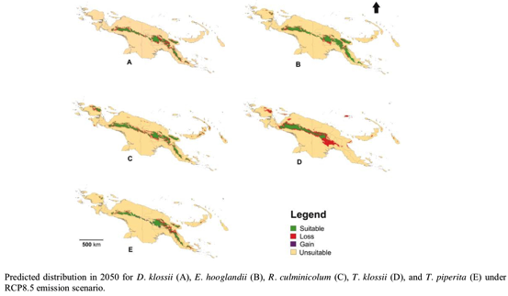
Another study (Robiansyah 2018) though looking at the change of subalpine and alpine plants is typical of much research in that it looks at specific taxa and not the overall changes of the more complex alpine ecology and the interaction and interdependence of species within it.

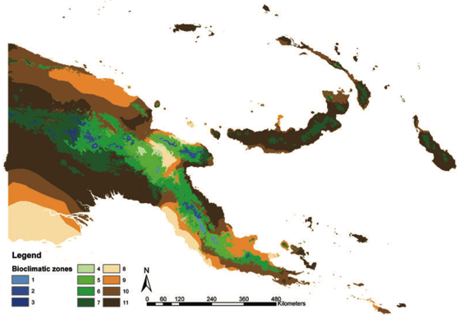
Bioclimatic zones Shearman & Bryan 2011

1 Upper Montane ML 4 Lower Montane L 8 Lowland L Rainfall Class
2 MH 5 ML 9 ML L Low
3 H 6 MH 10 MH M Moderate
7 H 11 H H High

Temperature anomaly September 2017 IFF 2018 source CHIRPS

All of the Alpine areas fall within higher September 2017 temperature anomaly areas. This in the early equinox transition period from the long nights of colder weather to long day hot weather.

Ecological changes are unknown
How such temperature, humidity, water availability changes (environmental domain changes) impact the ecology of all these at risk ecological associations of plant communities and interrelationships with associated fauna is not known. Yet this understanding is needed before we can begin to understand the impacts of climate changes on the resilience and stability of these species rich complexes. Such changes to the environment in the shift of seasons will effect the timing of food availability for migratory species such as birds, sea birds, turtles, fish and cetaceans.

Success:
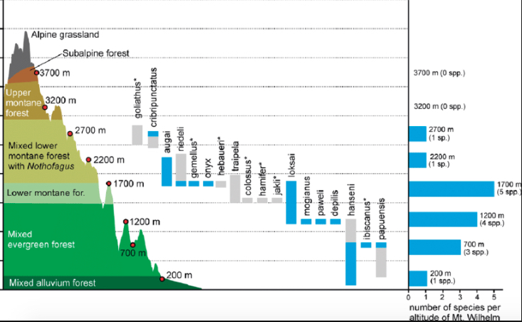
Mt Wilhelm Transect (Binatang Research Institute)

In an initiative to gain an understanding of change, initial baseline data for different taxa are being researched and collated with the inception of the Mt Wilhelm Transect, which has a series of stations at varying elevation. From these records future change and trends in species composition of various ecosystems such as those represented in the diagram from lowland mixed alluvium rainforest to subalpine forest will be deduced over time. This transect was established by the Binatang Research Institute based in Madang, with scientific papers from 2012.

Constraints
Delay of climate change alteration of the most vulnerable ecosystems is currently only through efforts to maintain the functionality of these ecosystems through the reduction of other impacting factors.

Where there is opportunity of ecosystems to creep across a changing environmental domain or contract to mirco-climate refugia, these projected areas need to be protected e.g. coral in areas of cold water upwelling, inland of mangroves, upslope plant communities.

Currently future climate domains can only be projected at a coarse scale.

There are no species translocation programs currently being developed for either environmental or agricultural biodiversity.

Moving forward
Having baseline biodiversity data in of the ecological complexes of PNG and determining indicator species within them is vital to the understanding of changes that are occurring. This is beyond the current capacity of the country with the result being that many ecological changes will occur that remain unrecorded.

Existing research such as the altitudinal mountain transects of Mt Wilhelm and within the YUS Conservation Area (CA) are examples of where such research can take place in the terrestrial realm. Other species surveys of terrestrial, freshwater and marine ecosystems also offer opportunities to investigate change with follow-up surveys.

Sustainable Development Goals
13.1 Determining with confidence the actual changes due to climate change at a scale that can inform adaptation is still coarse with wide variability. Awareness on natural disasters is ongoing however often populations occur in areas that are at risk. There are rainforest monitoring initiatives in place that will assist to inform what changes are occurring.
14.3 Papua New Guinea’s direct impact on ocean acidification is minimal. Research in country proximal to thermal hot springs in inshore waters has contributed to the understanding of increased acidification.

1 2 
Terrestrial Marine

Aichi Biodiversity Target 11 Protected areas

Status of terrestrial protected areas
Progress towards target but at an insufficient rate
Status of marine protected areas
No significant change

Level of confidence of the above assessment
Based on comprehensive evidence

CEPA in country has a record of all protected areas within a recently upgraded Protected Area Register that is updated half yearly.

Monitoring related to this target is adequate

Outline
Protected Areas of Papua New Guinea
Based on CEPA 2018 figures the area of Terrestrial designated Protected Areas as at March 2018 was 18,399.55km² which is 3.98% of the total land mass of Papua New Guinea. This is made up of 57 declared protect areas under national legislation. (The Torricelli Mountain range has also been submitted as a Conservation Area and if designated the percentage of Terrestrial PAs will increase to 4.38%).

Within the World Data Base on Protected Areas (UNEP-WCMC 2018) to be updated by PNG, most PAs are officially not reported against any IUCN Protected Areas category (IUCN 2018). (It is anticipated that many will be category VI: Protected Areas with Sustainable Use of Natural Resources)

Marine Protected Areas within LMMA (Local Managed Marine Areas) vary under adaptive customary local management with CEPA 2018 figures for Marine Areas designated under Protection being 0.21% of the EEZ. This is made up of 17 non- gazetted LMMAs.
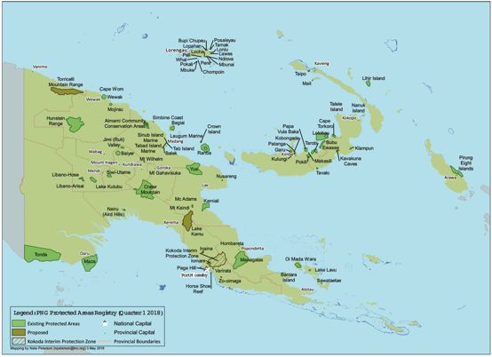
Protected Areas of PNG at March 2018 (CEPA 2018)

Success
Papua New Guinea Policy on Protected Areas (2014)
The Policy on Protected Areas (2014) has been developed by the Government of Papua New Guinea to support the development and management of a National Protected Area Network in Papua New Guinea. It will guide communities, organizations and agencies to harmonize their efforts in a structured and logical approach to the sustainability of existing protected areas and the development of new PAs. The Network will be established and governed to conserve the country’s outstanding biodiversity and provide benefits for local communities, customary landowners, and all people. At the same time, the network forms the cornerstone of an integrated approach to sustainably conserve nature and provide resilience to climate change on both land and sea. To this end, the policy is built on five pillars for an effective protected area network:
1. Protected Areas, Governance and Management;
2. Sustainable livelihoods for communities;
3. Effective and adaptive biodiversity management;
4. Managing the Protected Area network;
5. Sustainable and equitable financing for Protected Areas.

Efforts will be focused on establishing the legal and institutional framework for the management and governance of the PNG Protected Area Network with clear lines of responsibility and high standards of governance, accountability and reporting, and ensuring it has adequate funding and staff capacity, competent leadership structure, functioning policies, and operational systems. As 92% of PNG’s land and 90% of near-shore marine areas are either owned or used by customary landowners, the PNG Protected Area Network must be built with their full involvement, support and cooperation. All aspects of building the network will be in partnership with communities, thus ensuring that the network supports their natural resource sustainability and livelihoods.

Free prior informed consent of customary landowners and communities will be foundational in the register of the entire PA Network. Further, to support the development of sustainable environment and livelihoods efforts will focus on ensuring that local arrangements governing use of natural resources in Protected Areas are fair and sustainable and continue to support traditional livelihood and wellbeing.

Policy actions recommend training, supporting and empowering communities, customary landowners and Protected Area workers to sustainably manage Protected Areas.

Conservation and Benefit Sharing Agreements will also be developed with customary landowners and communities for all Protected Areas on the register to formalize the management arrangements and benefits. Policy actions will also work towards developing and applying biodiversity management planning, monitoring and reporting, natural and cultural resource management, and law enforcement of the Protected Area.

Pillar four and Pillar five of the policy suggest the development of a Biodiversity Trust Fund to support the Protected Area Network through mechanisms such as biodiversity and ecosystem services offsets, green contributions such as levies and taxes, and donations and philanthropic contributions; and will develop small grant programs to deliver funding directly to support local communities in the establishment and management of Protected Areas. Due to the fact that most lands and near-shore marine areas are owned by customary landowners, governance in the PNG Protected Area Network will recognise of customary leadership and how they and the community wish to engage with governments at all levels (FAO 2015)

Varirata National Park
This Protected area is found on the escarpment of the Astrolabe Range overlooking the capital city of Port Moresby. It was Papua New Guinea’s first National Park declared in 1969 on state land and officially opened in 1973. Once a premier attraction, though the local environment retained its biodiversity through this protection, the facilities had deteriorated. These were upgraded to reflect the times through a JICA supported initiative to encourage people to easily enjoy the local environment. Signage, track refurbishment and an information-interpretive centre are visible indicators of this change.
Landowner LLG, CEPA & JICA at VNP upgrade launch (JICA 2017) VNP extension & buffer

Also JICA expertise through stakeholder engagement with local Koiari Land Owners, the Koiari Local Level Government, the Conservation and Environment Protection Authority progressed this initiative with a management plan, mapping and engagement of local landowners on sustainable livelihood development alternatives. Developing opportunities through bird-watching and the development of a series of field guides that were informed by biodiversity monitoring and surveys that included camera trapping.
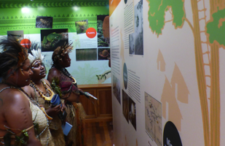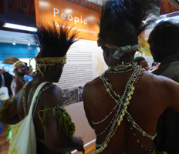
Local landowning Koiari of Warirata at the spiritual study tour of the Information Centre October 2018
Varirata National Park is in the limelight for change and its attractions feature on various web links.

Kokoda Memorial Park / ’Kokoda Track Reserve’ and IPZ
The Kokoda Memorial park was Gazetted in 1981 <1 hectare whilst the ‘Kokoda Track Reserve’ (1972 no Gazettal Notice) is 71ha, 96km in length and 20 metres wide, crossing the Owen Stanley Ranges from Owers’ Corner to Kokoda.
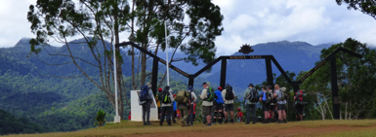
Aerial view Kokoda MP (PAA 2016-17) Owers’ Corner Trekkers.

The Track was long used as a means of throughway by Papua New Guineans, however it is the Track’s historical importance during the Kokoda Campaign (July – November 1942) of WWII that has facilitated its recognition and respect. The Track was used by the Japanese advance on Port Moresby and pitched battles were fought by the Australian retreat until the turning back of the invading force within sight of Port Moresby. The Track attracts about 4,000 fee paying trekkers each year (PGK350 per trekker, raising PGK1.2 million per annum) and who are supported by about 57 trekking companies from Australia and PNG. Kokoda Track Authority (KTA) was set up as a special purpose authority that provides oversight of activities undertaken on the track. It manages the track and the trekking industry and supports the two local level governments through which the track passes. The effectiveness of the KTA was subjected to review in 2018 and results are not yet released.

The Kokoda Initiative (KI) with financial and technical support from the government of Australia has from 2008 supported the establishment of a PNG model‐protected area through enabling ecological sustainable development, revenue generation and associated service and livelihood opportunities for communities along the Kokoda Track and surrounds. The PNG Government is interested in extending the spatial bounds of focus through the generation of a Sustainable Development Master Plan (SDMP) for the whole of the IPZ (Interim Protection Zone) through which the Track passes. The intent is for the Master Plan to provide the means to facilitate a model for integrated land use and conservation planning through a whole of government approach in collaboration with IPZ communities.
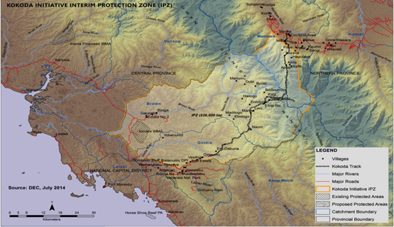
Kokoda Track and Interim Protection Zone IPZ. (Kokoda Iinitiative 2014)

The IPZ represents the core area for possible legal protection of the Brown River Catchment area and most of the Kokoda Track. The area incorporates the Brown, Naoro and Goldie Rivers, which are also the priority areas for future development of hydro-power and water supply for the capital city of Port Moresby. It extends into the Northern Province to protect the historic values of the Kokoda Track. The use of IUCN Protected Area Category IV (Habitat/Species Management Area) and V (Protected Landscape/Seascape) of for the IPZ was recommended.

The Kokoda Track Military Heritage Management Plan 2018 draft was produced by the PNG National Museum and Art Gallery, the mission of which is ‘to identify, protect, interpret, commemorate and promote the shared histories and heritage of the Kokoda Track’. This will increase the value of the Track building on the experiences of collation and publication of Voices from the war – Papua New Guinean stories of the Kokoda Campaign, World War II in 2017

A Road Map for Potential World Heritage Nomination: Kokoda Track and Owen Stanley Ranges (2015) was undertaken to assist the PNG Government to determine the arrangements, resources, information, consultation, operational context, and timeframe to attain the information required to make an informed decision on whether to pursue the option of World Heritage nomination, and the steps to be taken in the event that a nomination proceeds.

Managalas Conservation Area
The Managalas Conservation Area was declared in 2017, which at 3,600km² makes it the largest in PNG. The areas within this for conservation are yet to be defined in a land-use management plan. The biodiversity focus of this Conservation Area, is to conserve the Managalas Plateau sub-population of the Queen Alexandra Birdwing Butterfly Ornithoptera alexandrae and other wildlife of this area.

The idea of this protected area was first muted in 1984 during a literacy project by the students and lecturers from the University of Papua New Guinea (UPNG). This developed into a conservation and community development concept from 1996 as the area is remote with limited services and development opportunities. By 2011 the over-all objective of the Managalas Plateau Conservation Area Project was to preserve the biological resources of the Plateau and promote sustainable development (Maharu 2011). This was facilitated by the local PNG environmental NGO Partners with Melanesians with the support of donors, especially the Rainforest Foundation of Norway (RFN) through extensive consultation with communities of the Managalas Plateau.

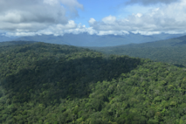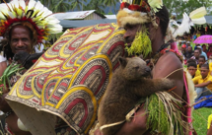
Part of Managalas CA plateau At the declaration with Vulturine Parrot and Doria’s Tree Kangaroo Mongabay 2017 Queen Alexandra Birdwing Butterfly pupa and newly emerged male adults

The Managalas CA extends from lowland tropical rain forest at 460m to mid montane forest and grassland at 2856m, within which 20,000+ community members of 150 clan groups and five languages subsist from their surrounding resources. This was a major community conservation achievement after many years of dedicated education, awareness, discussion and negotiation in order to gain a strong community and governance consensus.

Constraints
Protected Area Management Effectiveness
In 2006 a RAPPAM (Rapid Assessment and Prioritisation of Protected Area Management) study was researched of all the Protected Areas of PNG at that time. The final document and results however were not socialized and as a result few of the recommendations it contained were implemented. And several protected areas since have been fully or partially altered and have lost many of their values. A recommendation from this study subsequently adopted within the 2007 NBSAP was the National Target to develop a PNG Protected Area Policy, which after a consultative process led by CEPA was endorsed by the National Government in 2014.

In 2017 57 Protected Areas across PNG were evaluated using the METT (Management Effectiveness Tracking Tool) within which some questions were adjusted. It will therefore be referred to as the PNG-METT. The key changes to the PNG-METT were ensuring the appropriateness of the questionnaire and the workshops in the PNG context; adding questions about protected area benefits and values, and the condition and trend in these values over time; and recording participants’ views about how the situation on their protected areas could be improved (e.g. in relation to the values, threats and various management effectiveness themes).

With a few exceptions, most protected areas are highly valued by their customary landowners as places where nature and culture are relatively intact. People still perceive a close relationship between nature, culture and livelihoods. Where animals and plants are respected for their own value, but more often as important resources for food, medicines, building material and cultural practices. People are usually aware of the need for sustainability in their use.
PNG-METT Respondents perceptions of the level of importance/benefits provided by protected areas (PNG-METT 2018)

Percent of Protected Areas that experience threats (PNG-METT 2018)

The threat analysis in the PNG-METT was based on the IUCN standard threat classification adapted to the context of the PNG protected areas. This was defined as anything that causes damage or potential damage to the values of the protected area. As many protected areas in Papua New Guinea have villages and food gardens within them, with hunting and/or fishing. People’s responses to real general threats in their PAs are indicated in the table above.

It is perceived that climate changes experienced including temperature extremes, prolonged droughts, increasingly severe storms, flooding, shifts in habitat and changes in seasonal patterns. (PNG-METT 2018) are the main threat to PAs. Biological resource use in hunting and gathering along with collection of house building materials within the PA are essentially perceived to be threats at the same level.

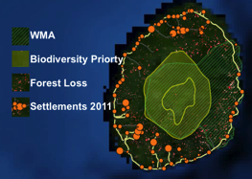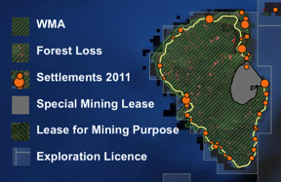
Left Bagiai WMA (PNGFA/CCDA Portal 2018) Right Lihir Island WMA (PNGFA/CCDA Portal 2018)

Alternative Use Impacts in PAs
Within some Protected Areas other uses are occurring. Within the Bagiai PA on Karkar Island there are coastal communities practicing rotational subsistence agriculture altering the forest, with a coastal road link. On Karkar is an 1839m active strato-volcano from which ash plumes have occurred in 2012, 2013, 2014 and 2017 making the dynamic upper reaches of the PA conservation by default.

Within the Lihir Island WMA there are coastal communities practicing rotational subsistence agriculture altering the forest, a coastal road link, a special mining lease, lease for mining, mining easements and an exploration licence all within or covering the entire WMA. The Lihir Gold Mine has been in operation since 1997 with a Deep Sea Tailing Placement (Disposal) of >5million tonnes of mine waste.

Other protected areas have Forest concessions over them whilst Paga Hill Scenic Reserve a 13ha National Park in Port Moresby is also altered in 2015 from road development for an urban development proposal (Paga Hill Estate) adjoining the CBD.

Despite many of the Protected Areas being declared in the period 1980-2000 management support has been lacking which has influenced the communities’ perception in the management effectiveness in the PAs. There has been little customary landowner input into the management of Protected Areas as protected areas with traditional law though having some effect locally are not seen to be strong against external threats or illegal entry which is of concern. The use of village courts or other legal options are very rarely used.
Overall progress of management effectiveness in PAs in PNG 2nd graph is benefits of PAs
(PNG-METT 2018)

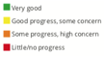
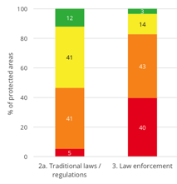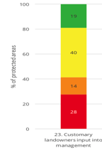
Customary management, law and enforcement in Protected Areas (PNG-METT 2018)

Conservation Planning: Priority Areas of Interest
In 2017 the PowPA (Plan of Work Protected Areas) analysis combined the Terrestrial PoWPA and Marine PoWPA. This is the most recent Government recognized set of conservation priority areas of interest to guide future conservation planning, since the CNA (Conservation Needs Assessment 1994).
Areas of Interest (AOI) Conservation priorities Land Sea Conservation Assessment for PNG 2017 CEPA

Moving forward
The Conservation and Environment Protection Authority, CEPA through the recent METT analysis is guided by a set of key recommendations that relate to each Protected Area across the country. CEPA is also guided by the Policy on Protected Areas (2014) and the Implementation plan of this policy (PAIP 2018) currently under funding consideration by the National Policy & Planning Department, in order to effect positive change across Papua New Guinea’s PA Network.
Summary of 3 key recommendations from each PA. (PNG-METT 2018)

There are other potential PAs that are currently being progressed with communities across the country.

Following the recent PoWPA (2017) the key priority areas of interest are also defined, both terrestrial and marine, and with the recent PNG Maritime Zones Act (2015) the application of a provision in regard to marine environment protection and underwater cultural heritage offers opportunity to develop marine PAs.

The Protected Areas Bill (2018) if passed will present a legal framework for PAs, both terrestrial and marine and for their formal recognition and placement on a National Protected Areas Register.

Sustainable Development Goals:
6.6 Though not the primary reason many large Protected Areas lead to water catchment protection. The IPZ of the Kokoda Initiative is an example where the Brown River water catchment is proposed for conservation which will also improve management of a proposed hydroelectric dam facility that will assist in the renewable electricity supply for the nation’s capital Port Moresby

11.4 The national Protected Area network is incrementally increasing the number and area of formally recognized PAs across the country. In doing so the cultural links of communities’ on whose customary lands the PAs are located are strengthened in the management planning of these areas.

15.1 Many of the PAs in PNG are in mountainous regions therefore the associated rivers are also with the PA management plans. There is one which is also a RAMSAR site of lake Kutubu and another wetland of Tonda which is on a migratory bird flyway.
15.4 A major signature of the PA network is of different types of tropical rainforest which are the dominant plant community type of the country.

Aichi Biodiversity Target 12 Reducing risk of extinction

Status of reducing the risk of extinction
Progress towards target but at an insufficient rate

Level of confidence of the above assessment
Based on partial evidence

Few species in PNG are evaluated for threatened status as per the IUCN Red List of Threatened Species.

There is monitoring in place for a limited number of key species. No comprehensive species monitoring system is in place.

Assessments are usually through local species survey for key species and through contribution of status through the IUCN Red List of Threatened Species, Herbarium Data, Global Mammal Assessment, Global, Amphibian Assessment and project monitoring data (CEPA database).

Outline
Papua New Guinea is a high biodiversity tropical country with high levels of both species richness and irreplaceable endemic species both terrestrial and marine being within the Coral Triangle. As an indication of this, the species richness of some highly visible genera are shown here.

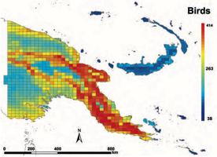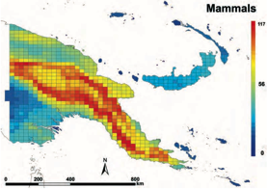
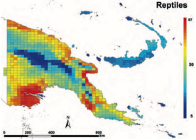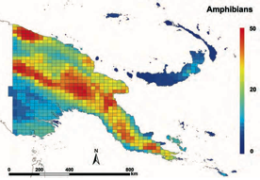
Species richness 25 x 25 km grid Bishop Museum

There remain however gaps in our biodiversity knowledge. Rapid Biodiversity Surveys reported in 2015 that had been led by WCS in the Hindenburg Wall region supported by PNGSDP, where new species of several genera were found including 23 new plants, 2 rodents, 1 bat, 10 herpetofauna, 26 ants, 5 butterflies and 16 odonates Manus and Musau Islands supported by CEPF where a six new species of plants, and at least 3 frogs and a lizard were new species. With potential mining/hydrocarbon developments these companies also invest in biodiversity survey work. Many new species also continue to be described by other past collecting expeditions that have been done by other research taxonomists. These serve to show that there are many new species yet to be uncovered and scientifically described.

However the current capability of PNG to prevent the risk of extinction of species is hampered by a lack of information. A centralised NBIS (National Biodiversity Information System) database is currently being put in place within CEPA that can be populated with data that though currently available, is scattered across many sources both in country and overseas.

There are many species within Papua New Guinea on the IUCN Red List of Threatened Species 2018 that are listed as
Critically Endangered Animals 19, Plants 17
Endangered Animals 49, Plants 27
Vulnerable Animals 275, Plants 135
Near Threatened Animals 256, Plants 57
Least Concern Animals 3291, Plants 645

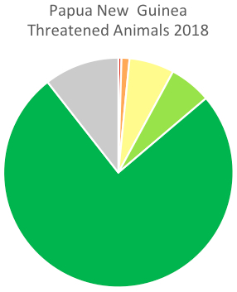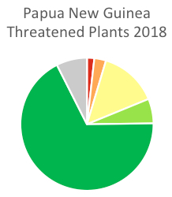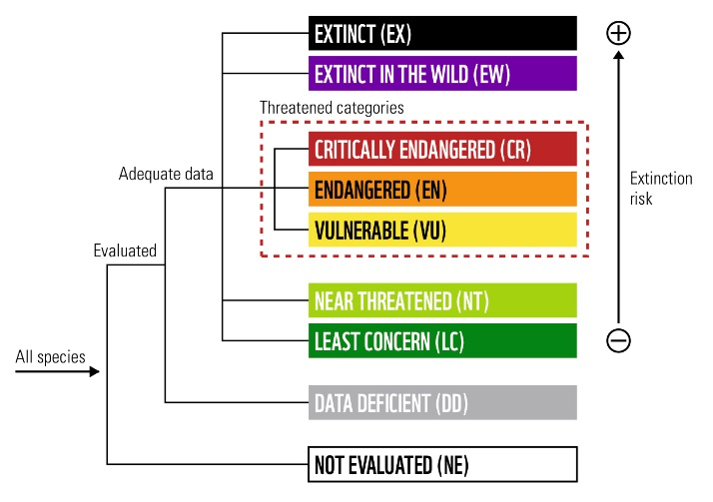

Of these there are only a few species, which have featured in conservation initiatives.

Changes of status of Species within PNG and its EEZ
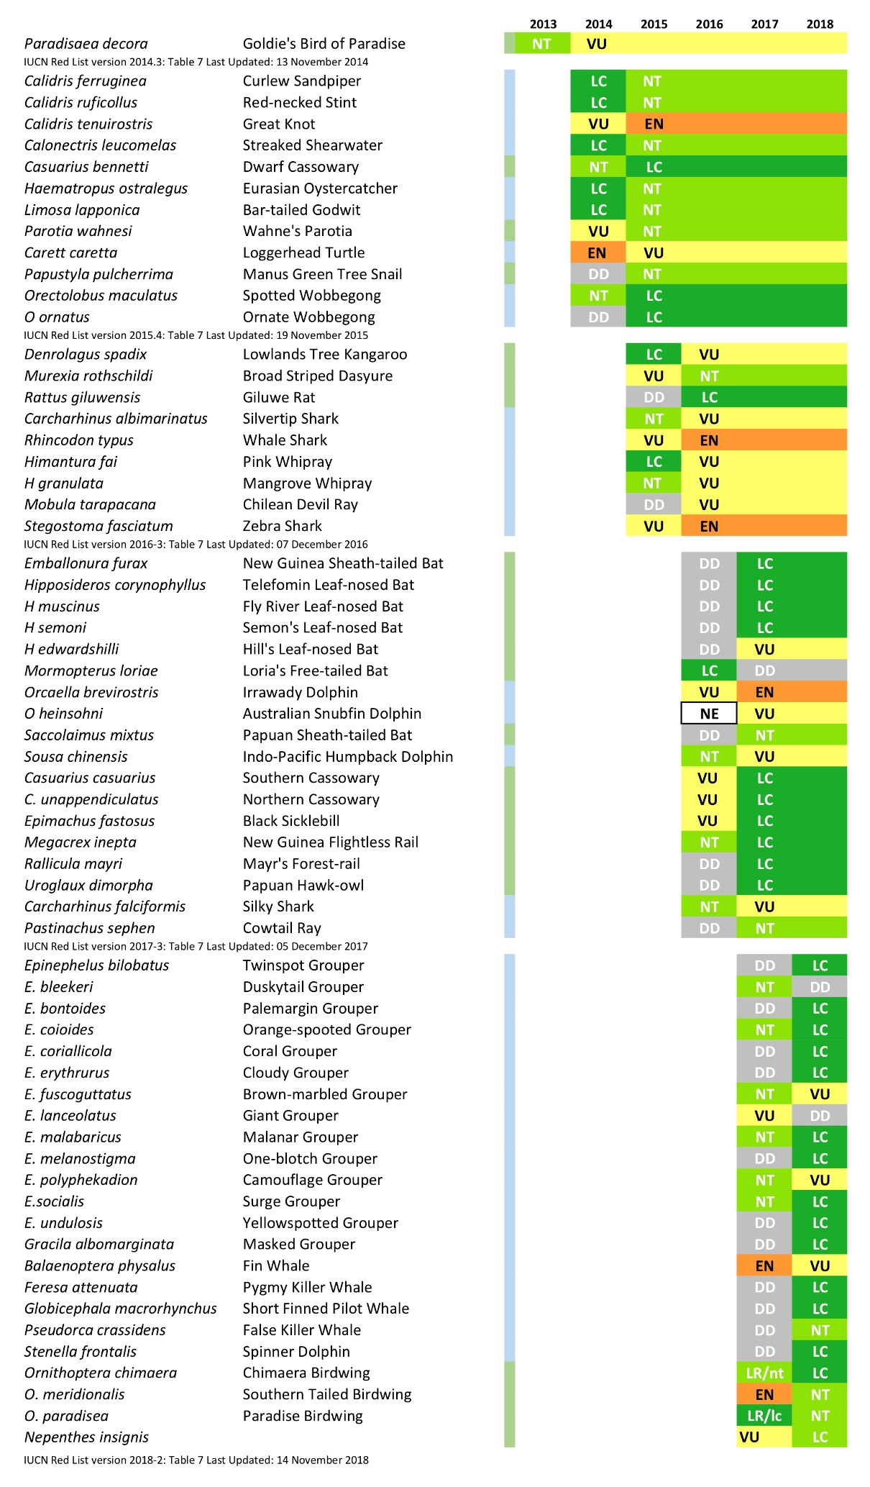

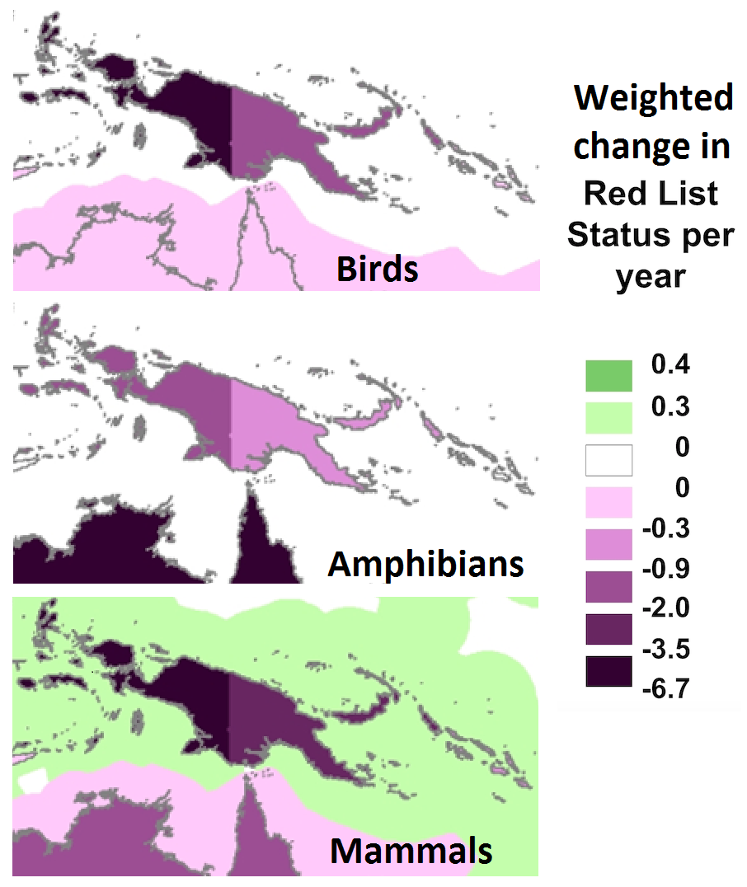
There has been a trend of an increased level of threat of species on the IUCN Red List of Threatened Species. This threat is in the asceding order of amphibians, birds and mammals, whilst there has been an improvement of marine mammals in the EEZ of PNG, the Solomon Islands and Indonesia.

Matchie’s (Huon) Tree Kangaroo Dendrolagus matschiei YUS Conservation Area and ex situ Woodland Park Zoo population.
The Matschie’s (Huon) Tree Kangaroo Dendrolagus matschiei is a narrow endemic species of the Huon Penninsula on the PNG central north coast that became a focal species of community-based conservation that became a Conservation Area. This intervention was initiated by Lisa Dabek of the Woodland Park Zoo in 1996 after the threats of habitat loss and hunting raised the status of this species from VU (Vulnerable) to EN (Endangered) with an estimated population of less than 2500. It still remains EN C2 a(ii) (IUCN v 3.1 2016).

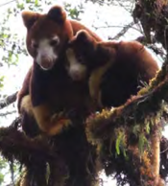
Junior ‘ranger’ program YUS (TKCP 2017) Karau Kuna Whitley Award 2016 Tree Kangaroos

Tree Kangaroos are difficult to locate, living in difficult terrain with a sparse distribution. In early discussions on how to save the tree kangaroo one possibility that resonated with local hunters was setting aside portions of hunting land to allow wildlife to reproduce and ensure the sustainability of hunted species. The concept of setting aside a portion of one’s hunting land for a protected area was described as a “wildlife bank.” The protected area would serve as a safe place for tree kangaroos and other wildlife to reproduce, and when the young dispersed from the protected lands into the buffer areas the hunters would be able to harvest them sustainably. Through these discussions it became clear that there had been a similar practice of culturally-based tambu/taboo areas in the past. Communities in YUS continued to express interest in conservation and from the early stages of partnership, This developed into the efforts to save the species led by the YUS Tree Kangaroo Conservation Program (TKCP). Early on TKCP took the approach of community-based conservation (Beehler & Kirkman 2011).

The main species management action is to have a hunting moratorium and to protect the habitat. In return communities received support in the social services of education and health that were not being provided by the government, and later links with conservation coffee and cocoa. It was only recently in 2013 with improved technology that satellite tracking has been possible in applied research to determine the home range and some of the life history and requirements of the species. This is seen as a model for establishing large PAs in PNG that have a globally important significance.

As a ‘Strategy 2’ the Woodland Park Zoo has an ex situ breeding program for the Matschie’s Tree Kangaroo as part of an AZA (Alliance of Zero Extinction) Tree Kangaroo Species Survival Plan (TKCP 2014).

TKCP won the UNDP Equator Prize in 2014 and the Whitley Fund for Nature Award in 2016.

Costing this model from 1996-2016 is not straightforward with inputs from WCS 2001 and 2003 in Biodiversity Surveys, BMU/KfW (German Development Bank) Euros 2 million + in extension and landscape management plans by JCU and others; and infrastructure, Conservation International GCF (Global Conservation Fund) in the sourcing of USD2 million as initial capitalisation of the Trust Fund (CI 2012) that continued be capitalised. TCKP is supported through the PNG GEF 5 Project to further develop its Conservation Coffee and Cocoa initiatives.

The 2016 budget income is USD500,000+ (TKCP 2016)

Tenkile (Scott’s) Tree Kangaroo Dendrolagus scottae other Red listed species and the proposed Torricelli Protected Area.
The Tenkile (Scott’s) Tree Kangaroo Dendrolagus scottae CR A4cd (EN 1994 and last assessed at CR in 2008 and this needs to be updated by TKP) is an endemic species found in the Torricelli Mountains of north-west of PNG that was regarded to be the most threatened Tree Kangaroo in PNG. This intervention and is also seen as a model for species and habitat conservation in Papua New Guinea.

Hunstein Mountains Tenkile (Scott’s) Tree Kangaroo TCA 2017

This program of conservation set aside areas of habitat with a hunting moratorium first put in place in 1999 with 13 villages after initial scoping and awareness with communities. In 2000 a species recovery plan was written and in 2001 the Tenkile Conservation Alliance (TCA) became a PNG registered NGO and the hunting moratorium resigned in 2002 (14 villages). Jim and Jean Thomas from Zoos Victoria managed the project intervention from 2003

Hunting Moratoriums are central to conservation of this and other species being renegotiated, expanded and resigned in 2004 (18 Villages), 2006 (21 Villages), 2008 (39 villages), 2010 (42 villages), 2012 (50 villages + Grizzled Tree Kangaroo), 2014, 2016 (50 villages + black Spotted Cuscus & Northern Glider).

The status of the other species that were progressively included in these moratoriums are the;

Grizzled Tree Kangaroo D. inustus VU A4cd since 1994 (IUCN 2016);
Black Spotted Cuscus Spilocuscus rufoniger CR (IUCN 2015) (Rare 1982, VU 1994, EN 1996, CR 2008)
Northern Glider Petaurus abidi CR B1ab(iii,v) (IUCN 2016) (VU 1994, CR 2008)

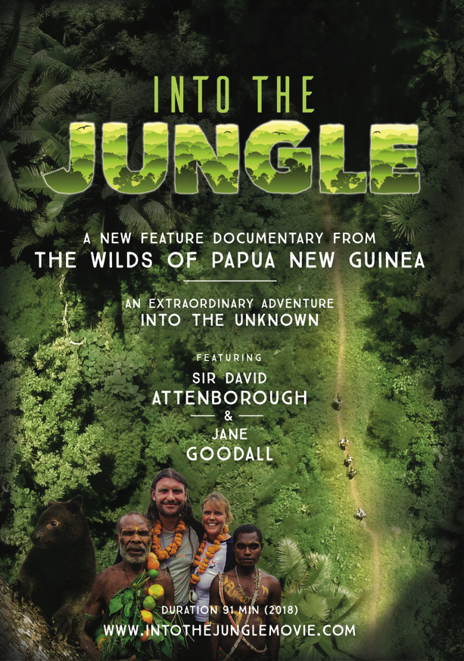
Due to the moratoriums, alternative protein sources of rabbits, chicken and fish farming of Tilapia (a potential invasive species of rivers) were introduced. A monitoring program of the Tree Kangaroo is to learn its life history and population trends of the species of focus supported in 2011 to date increasing by camera trapping. TCA has also sourced assistance for health and education, and poverty alleviation. A WaSH Program of water tanks, sanitation and family planning.

Tenkile Conservation Alliance Company Limited, with charitable status was established in Australia in 2015.

Through their leadership efforts Jim and Jean Thomas have been awarded the Australian Geographic Conservationists of the year award Jean Thomas Future for Nature Award (The Netherlands) and Telstra Business Women Award for Social and Purpose Enterprise and Mathew Akon wins Whitley Fund for Nature Award (UK). A feature length documentary on this work Into the Jungle was released in 2018.

This program is a NGO IUCN member for PNG (TCP 2016)

This program has invested USD5 million. With a budget income of USD650,000 in 2016 (80% of which is from GEF5 funds).

Queen Alexandra Birdwing Butterfly Ornithoptera alexandrae, the Managalas Conservation Area and Higaturu Breeding Facility.
Improving the security of the Queen Alexandra Birdwing Butterfly Ornithoptera alexandrae EN B2ab(iii) (2018) CITES I, has been attempted several times over the last 30 years, but remains endangered since 1983. The Oro Conservation Project funded by AusAID ran from 1979 to 1982 and after surveys by Michael Parsons for CI in 1991 discussion of a Queen Alexander Birdwing Butterfly Conservation project were initiated which subsequently ran from 1995-1999 without any significant outcome apart from gaining some knowledge in situ and within a flight cage and awareness. This included setting aside habitat in WMAs and enrichment planting in the forest of the larval food plant of Aristolochia.
There remain two sub-populations of this species, one on the Popondetta Plain were the species was first scientifically found and on the Managalas Plateau were it was found subsequently. After some 30 years the Managalas Plateau has been set aside by communities as a CA through recent guidance with the local NGO, Partners with Melanesians. A management plan for the CA that will take into consideration the butterfly will be made.

The other subpopulation on the Popondetta Plain has been impacted by the mosaic of land-uses in its habitat with large areas of oil-palm plantings that impede its ability to recolonize across the landscape, logging and subsistence agriculture. Following on from a the release of book on the species as a literature in review and conservation proposal in 2016, interest grew with the establishment of the UK NGO Swallowtail Trust and support from the Sime-Darby Foundation, Malaysia. (New Britain Palm Oil Ltd (NBPOL) is a subsidiary of Sime Darby and has plantations at Higaturu, Popondetta). From 2018-20 an entomologist was taken on and the establishment of a laboratory breeding facility, flight cages and Aristolochia vine nursery has been established at the estate. This is with the aim of maintaining a backup lowland founder population and to centre research on the species with possible reintroduction to known areas of forest where the species was previously known to occur. (Sime-Darby 2017)

Pig nosed Turtle Carettcohelys insculpta and potential wildlife trade
The Pig nosed Turtle Carettochelys insculpta VU A1bd (2000) is one the species that potentially enters into to illegal wildlife trade (Traffic 2015).

It has a distribution in northern Australia and the Trans-Fly area of PNG and Papua Province, Indonesia the border of which is very rugged and isolated. Previously Merauke in Papua Province was reported is an important trade hub for wild fauna and flora including cross-border trade of Pig-nosed Turtles (Rhodin and Genorupa 2000). Villagers living close to the southern PNG-Papua border have been reported to stockpile Pig-nosed Turtles for trade along the coast with traders from Merauke (Rhodin and Genorupa, 2000). It is not known what is the current situation but the sparse population on the PNG side of the border are closer to and access goods and services in Papua Province and in 2018 PNG made plans to improve roads and Customs Surveillance which will hopefully lessen the opportunity for movement of this and other species across the border. There is also potential for illegal wildlife trade on logging ships. Illegal trade of species from PNG is currently poorly reported and understood.
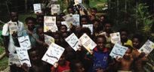
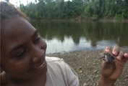
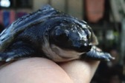
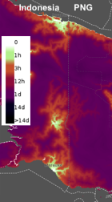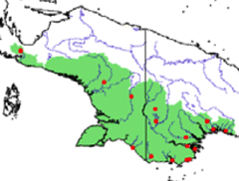
Accessibility to urban centre (UNBiodiversity Lab 2018) Distribution of Pig Nosed Turtle New Guinea (Traffic 2015). Awareness, Piku hatchling & Piku ExxonMobil 2012

Migrations Green Turtle Chelonia mydas and Hawksbill Turtle Eretmochelys imbricata
In the 2017-18 nesting season female turtles were tracked using satellite tags on both (4) Green, Chelonia mydas EN A2bd (2004) and (3) Hawksbill, Eretmochelys imbricata CR A2bd (2008) were tagged from Anchorage Reef on the edge of the Coral Sea, Milne Bay by ECA Eco Custodian Advocates (maps below) and Hawksbill turtles were tagged at the Conflict Islands in the Louisiade Archipelago Milne Bay by (CICI) Conflict Islands Conservation Initiative. This is the first time these species have been satellite tagged in PNG and has resulted in new data on the movements of these species that compliments the many years of metal tagging and recovery programs of Australia and PNG.

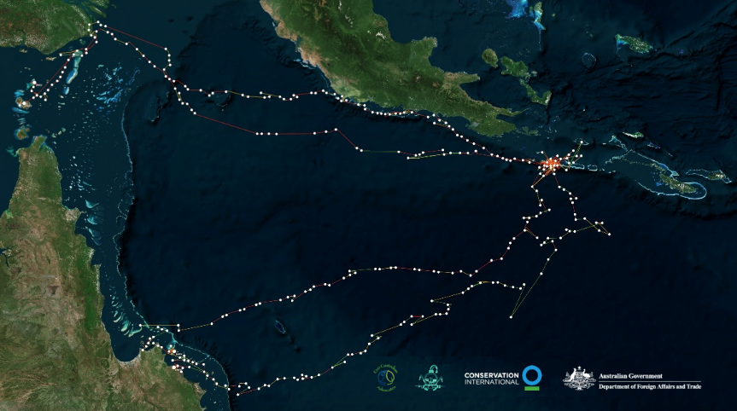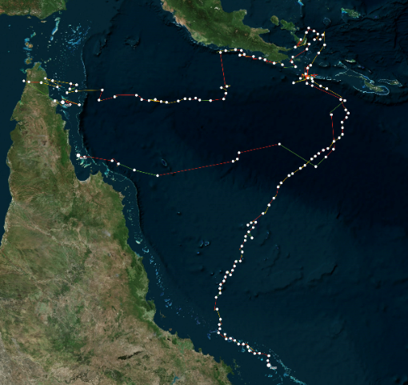
Left; Green Turtle migration and Right; Hawksbill Turtle migration from Anchorage Reef, Milne Bay (ECA 2018)

Reducing Tuna Fishery Bycatch of Species of special interest
A range of conservation and management measures have been introduced by WCPFC to reduce impacts of fisheries on species of special interest, including whale sharks, silky and oceanic white tip sharks, sea turtles, cetaceans and seabirds. Spatially and temporally disaggregated summaries of observer bycatch data are publicly available, including observed long-line and purse seine effort and interaction rates for species of special interest.

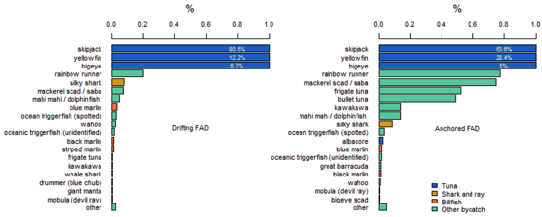
Catches from Purse Seine Tuna Fishery from Observer Reports SPC 2018

The bi-catch from Purse Seine fishery includes untargeted fin-fish, sharks, whale shark, giant manta and Mobula (devil ray)

Success
Despite general decline of species as per the IUCN Red List of threatened species, through targeted species programs such as with the tree kangaroos featured, though the status remains the same, the actual numbers of individuals has increased, based on ongoing surveys. Many programs across PNG are building on this success and applying many of the approaches used in the process in the development of new proposals and in their ongoing work.

Constraints
The loss of habitat to logging is a major concern for many of the tropical rainforest species. An example of this is given for the island of New Britain where some of the most dramatic alteration of rainforest has occurred with much forest rapidly destroyed in recent years, with some to clear-fell for conversion of forest to oil palm plantations. This has led to rapid population declines for many restricted-range and endemic bird species found on the island.

In Papua New Guinea, the island of New Britain is of high global conservation importance because it supports a large number of endemic and restricted-range birds: 37 species are found only on the island or have global ranges of less than 50,000 km². Using remotely sensed data from satellite imagery, it has been estimated that 12% (3,000 km²) of the island’s forest was cleared between 1989 and 2000, equating to a rate of forest loss of c.1.1% per year. Lowland forest has been hardest hit, with nearly a quarter of the forest below 100m disappearing over the same period. If these rates of deforestation continue, all forest below 200 m will have been cleared by 2060 (Buchanan et al. 2008).

Birds are undoubtedly suffering as a result of this extensive habitat loss, especially those species largely restricted to lowland forest. Four species are now suspected to be declining at rates exceeding 30% over three generations (Black Honey-buzzard Henicopernis infuscatus VU A2c;C1+2a(ii) (2016) Blue-eyed Cockatoo Cacatua ophthalmica VU A2cd (2016), Russet Hawk-owl Ninox odiosa VU A2c (2016) and Bismarck Kingfisher Alcedo websteri VU A2c;C1+2a(ii) (2016)) and five more are thought to be declining at rates approaching this threshold. The total number of endemic or restricted-range species classified as globally threatened or Near Threatened on New Britain as a result of population declines from forest clearance has increased from 12 to 21 (Buchanan et al. 2008).
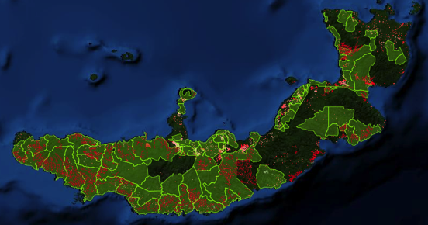
Logging concessions, Logging tracks, forest change, New Britain Island (PNG REDD+ & Forest Monitoring Portal 2018)

Even early on high localized rates of deforestation on New Britain appeared to be driven largely by clearance for large commercial oil palm plantations. Satellite images show that c.320 km² (11%) of the total land cleared of forest had been converted to oil palm plantations by 2000, with ongoing conversion planned. Forest-dependent species generally cannot survive in oil palm monocultures. On New Britain monocultures of oil palm trees over short grass are known to support none of the island’s 37 restricted-range or endemic species (LeCroy and Peckover 1983). The loss of forest continued from 2010 but with the RSPO this was no longer the case, however with a recent SABL clearance of forest on the south coast the future on this is uncertain.

Moving forward
Papua New Guinea is developing a National Biodiversity Information System that will include IUCN Red List and CITES listed species from which Species Recovery Plans can be developed. Currently PNG does not have the institutional capacity to drive such an initiative in a systematic manner but is working towards this.

Following on from the Protected Areas Bill if it becomes an act, it will guide the process of establishing, listing and adaptively managing Protected Areas. Its passing will also require revision of the long-standing Fauna (Protection and Control) Act 1966 and a Species Bill to be drafted.
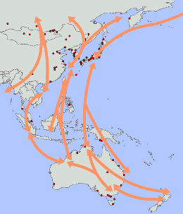
Further applied research on the migratory species and their habitat requirements within PNG is a challenge that would benefit from increased bilateral support. These are sea-bird migrations (as per the map), cetaceans, turtles, manta rays and fin-fish.

Being a high biodiversity country the volume of effort required to reduce the threat of extinction of its endemic species is huge. To achieve this under the policy and guidance that developed by CEPA the support of partners in achieving this is an even greater challenge.

Western Pacific Bird flyway

Sustainable Development Goals

14.4 The introduction of best practices in the tuna catch has led to a reduction of bi-catch.

15.5 The habitats of some key endemic species has been secured in the PNG Protected Area network while other areas are in preparation for designation. A review of all PA Management has also informed future plans moving forward.

Aichi Biodiversity Target 13 Safeguarding genetic diversity

Status of safeguarding genetic diversity
Progress towards target but at an insufficient rate

Level of confidence of the above assessment
Based on partial evidence

Genetic diversity in situ is poorly known an indication that this ABT is not being reached.

Monitoring related to this target is partial (e.g. only covering part of the area or issue)

There is no proactive ongoing systematic data collected to monitor the status of in situ genetic material in the subsistence sector in PNG.

PNG reports to FAO (ITPGRFA) International Treaty on Plant Genetic Resources for Food and Agriculture first report) and internally in the NARI (National Agriculture Research Institute) annual reports on ex situ collected genetic material held in its various research facilities around the country and on its research programs.

Outline
PNG Centre of Origin and Diversity
Papua New Guinea is the Centre of Origin for banana Musa species (Australimusa series), sugar cane Saccharum officinarum, sago Metroxylon species, highland Setaria palmifolia and lowland pitpit Saccharum edule, Rungia; the centre of diversity for yams Dioscorea species, taro Colocasia esculenta, sweet potato Ipomea batatas, aibika Abelmoschus manihot, winged bean Psophocarpus tetragonolobus. There are also tulip Gnetum gnemon, galip Canarium indicum, okari Terminalia kaernbachii, karuka Pandanus julianetti among others.

Genetic Material Collection
In the mid 1980’s Papua New Guinea participated in the collection of genetic material of Musa and set up a germplasm collection at Laloki. The banana germplasm that was collected by IPGRI/QDPI/DAL (International Plant Genetic Resources Institute/Queensland Department of Primary Industry and (PNG) Department of Agriculture) in the PNG are held under in vitro storage at Maroochy Research Station, Nambour, Australia and some promising materials are conserved in field gene-bank at the South Johnston Research Station, North Queensland also in Australia. Other recent exchanges of material occurred in 2015-2019 with Biodiversity International/ITC (Banana International Transit Centre). Yet despite PNG being the centre of origin of Musa of the 35 IMTP (International Musa Testing Programme) trial sites and 5 participating breeding centres in 2005 for banana across the world none were in PNG. This is a contentious injustice especially as many banana varieties are a staple drought food for many communities across PNG that will likely gain importance as material for subsistence agricultural societies that need to find ways to cope with climate change impacts.

The number of banana types grown by subsistence farmers across PNG is not known. Additionally there are wild banana types which grow in lowland forest and with large areas of forest loss from logging and conversion to oil-palm there is a greater risk of the loss of these wild types of Musa.

Apart from banana well over 7,000 accessions of 42 crop plant species were initially collected and were maintained in ex situ field collections. In a report by Kambuou (1995) on field collections she reported that this had dwindled to 1,474 accessions of 41 crop plant species being maintained, with the rest of the collected germplasm lost because of funding constraints. This trend appears to be continuing.

The option of traditional agricultural/horticulturalists encouraged to maintain their own collections of varieties and to record their own traditional knowledge of them and agronomic practices used, is vital for the in situ conservation of agricultural/utilized species that needs to be funded and well coordinated. It is not funded however, due to a lack of due recognition of the value of the subsistence sector and research that concentrates on developing farming systems.

Success
The majority of agricultural plant diversity is maintained through custom in the diversity of subsistence agriculture farming systems across Papua New Guinea by village households on their customary owned lands. Plant genetic diversity is mainstreamed within the 80% of the country’s population with most of this species and plant variety knowledge of name, form, agronomic requirements and preferred use held orally by the clan or family unit of production. Though the status of this is not known, not having been systematically recorded by the majority of Papua New Guineans who are agrarian rural farmers, maintaining their livelihood and wellbeing from their agricultural/horticultural production.

National Germplasm Collections
The PNG government agricultural research organization NARI has a program to conserve some of this genetic diversity of sweet potato, taro, banana, yam, cassava, aibika, traditional vegetables and fruits and nuts. Their collections are conserved and maintained in National Germplasm Collections in field gene-banks at four NARI Research Centres in the country at NARI Southern Region Research Centre, at Laloki 28km outside Port Moresby, the national taro germplasm collection is at the NARI Momase Region Research Centre, Bubia outside Lae, while the highlands sweet potato collection is maintained at NARI Highlands Regional Research Centre, Aiyura outside Kainantu and the lowlands collection is held at the Islands Regional Research Centre, Keravat in East New Britain Province where the collection of traditional and exotic fruits and nuts species and traditional vegetables are also maintained.

The staple food crop diversity in PNG is mostly from subsistence agriculturalists’ cultivars or land races collected originally from their gardens. The diversity of sweet potato (857 accessions), taro (330 accessions), banana (241 accessions), yam (70 accessions), cassava (147 accessions) and aibika (49 accessions) were collected from farmers’ subsistence gardens and conserved under ex situ collections in field gene-banks and duplicate collections maintained under in vitro slow growth storage by PNG NARI (2009). The numbers of accessions held apart from banana and cassava have declined over the last 10 years.

In vitro storage
Some cultivars of staple food crops of sweet potato and taro and introduced crop varieties of banana and potato are maintained under in vitro slow growth storage at NARI Keravat and Aiyura. The germplasm conserved under tissue-culture storage in PNG are sub-cultured every six months and the seed crops are re-generated every two years for viability. Germplasm stored in tissue culture and in seed storage conditions are working collections except for the taro ‘core’ collection (20%) that is maintained by the Biotechnology Centre at University of Technology, in Lae.

PNG NARI handles the plant genetic resources for food and agriculture while the commodity institutes are responsible for their own commodity crops. The Coffee Industry Cooperation (CIC) through their Institute, the Coffee Research Institute (CRI) is responsible for conservation, management and utilization of coffee germplasm and all research and development (R&D) activities carried out in the country on coffee. The Cocoa-Coconut Institute (CCI) undertakes the cocoa and coconut research and development activities, it being a Research Institute owned by the Cocoa Board and the Kokonas Indastri Koporesen (KIK) of PNG. These entities are maintaining germplasm of cocoa and coconuts.

There are 55 accessions (41 tall and 14 dwarf) held at the KIK Research station out of Madang which is part of the International Coconut Germplasm for the South Pacific Region (ICG-SP).
However this is under threat from 2014 with Bogia Coconut Syndrome (BCS) and the collection is planned to be relocated to Punipuni in Milne Bay Province with the first phase of this relocation funded in 2016.

The Coconut Embryo Culture Unit (Laboratory) at Stewart Research Station in Madang is responsible for importation of varieties for conservation at the ICG-SP gene-bank.

The New Britain Palm Oil Ltd has a modern biotechnology laboratory where they are conserving some elite and selected palm oil materials for their research purposes and also multiplying quality clonal materials for their own plantings and for export to other countries.

Constraints
Loss of plant varieties due to El Niño Droughts 1997-98, 2014-15
In farmers’ subsistence gardens, the diversity of foods crops is being lost at an alarming rate. The intense droughts that are occurring in the country are causing ‘genetic erosion’ to food crop diversity in the subsistence sector. Farmers are able to maintain only the crop varieties that are hardier and can withstand dry spells, such as the triploid ABB cultivars/landraces of bananas are hardier than diploid AA cultivars. Following drought there are often extended periods of La Niña with many months of rain, conditions which favor other cultivars, whilst drought tolerant varieties may decrease in these conditions.

As a result genetic diversity is lost, not only under in situ conditions, but also under ex situ establishments due to effects of climate change, inadequate resources, and in the latter case ongoing inconsistent funding.

Strengthening the Protection of Intellectual Property Rights Required
There is no national legislation administrating subsistence farmers Intellectual Property Rights in PNG and therefore the rights of the farmers, both men and women, are most often not considered when decisions are made on the access and use of their valuable PGRFAs. This has created a lot of issues between the resource owners and the users of the germ-plasm. The rights of the subsistence farmers’ over their genetic resources, experiential and applied knowledge, needs to be formally recognised and supported by policy, legislation and harsh penalties for breaches where required.

Lack of Wild Crop Data
Like the under-utilized crop species, the wild plant diversity of PNG is not officially recorded with no extensive and exhaustive surveys or inventory taken on these wild food plant resources. All these plant species are growing in the wild habitats, especially in rainforest habitats, which should be a concern for the country because of habitat destruction by human interventions including mining operations, large agricultural developments, urbanization and limbering and logging activities. (FAO 2009)

PNG has no cryopreservation facility. In the South Pacific Region the cryopreservation activity is only undertaken by the Secretariat of the Pacific Community (SPC) at the Regional Centre for the Pacific Crops and Forestry (CePaCT) in Fiji.

Moving forward
There is an urgent need to give recognition to and record all aspects of localised Papua New Guineans’ knowledge of the plant varieties within a framework that ensures intellectual property rights remain with the customary custodians of this information. This means in local languages and in other Papua New Guinea lingua franca.

Whilst ex situ repositories of genetic material need consistent long-term support an innovative program is urgently needed to facilitate in situ maintenance of the diversity of heritage crops across the country.

Sustainable Development Goals

2.2 The Galip nut which is a protein source has been developed which though destined for export has led to research that will have application in local nut production.
2.5 A basic number of plant varieties of main staple crops are maintained in genetic collections.

REDD+ PES
Aichi Biodiversity Target 14 Ecosystem services

Status of REDD+ ecosystem services
Progress towards target but at an insufficient rate
Status of payment for ecosystem services
No significant change

Level of confidence of the above assessment
Based on partial evidence
Based on limited evidence

There is much information in the public domain with REDD+ and less in all aspects of PES.

There is monitoring of forest change but no monitoring system in place that is directly related to REDD+. Ecosystem services by type are not mapped across PNG and there is no monitoring of payment that is correlated to these services.

There is limited information on ecosystem service management beyond the PA system. In many instances this is customary management at a localised level.

Outline
Ecosystem Services and Wellbeing
The complex mosaic of environments across Papua New Guinea provide ecosystem services to the people who are reliant upon them for their wellbeing. The majority of the population who live on their own customarily owned land and subsist from it for food are essentially reliant upon ecosystem services for their survival; supporting services of soil formation and nutrient cycling for gardening and food security, provisioning services for food, water, materials, firewood, regulating services of water and cultural services of identification with place, customs and heritage.

Much of each day by women and girls is spent in work that is heavily reliant on the services provided by ecosystems. The carriage of water, food and fuelwood to the household, the tending of gardens and feeding of livestock is in many parts of the country, or is seen as, the role of women and girls. The values of these services are not known, is not disaggregated by gender or the vulnerable, nor spatially mapped. However the concept of payment for these Ecosystem Services by developers to custodians of the land is seen as attractive because it follows straightforward logic and uses market forces to prevent environmental degradation.

Taking the lead in 2005, PNG and Costa Rica as tropical forested countries established the Coalition for Rainforest Nations (CfN) to collaboratively reconcile forest stewardship with economic development, such as carbon trade based on the rainforests supporting services of carbon sequestration.

From this point, efforts to determine the value of carbon sequestration dominated ecosystem system discussion. Early research from 2000 determined the carbon sequestration of PNG rainforest species along with measuring and extrapolating the carbon value of PNG forests, however the government has been working in readiness towards a compliance market in carbon. The PNG Forest Authority has utilized a UNFCCC protocol and developed survey techniques to determine the carbon values and biodiversity values of forest through a series of research plots located in different plant community types. This work is ongoing to refine this knowledge and to inform values for future carbon trade.

Papua New Guinea has been investigating proposals for the Payment for Ecosystem Services as an economic option to maintain the integrity of Protected Areas where appropriate. Following several years of discussion by an Expert Consultation Group a proposed PES system for PNG (2011) was set out. This however was not initiated through a formalized system, or trading mechanism, nor outlined in legislation. With REDD+ this element of PES based on the provisioning service of carbon equivalent is being developed in PNG with the aim of future trade in a compliance market based on the Paris Agreement (UNFCC COP21 Paris 2015) which offers a PES system.

Success
Valuing Species
Communities place value on species based on the attributes that they have and their utilitarian value, such as medicinal plants, plants used in magic or perfume, as food, building materials, soil enrichment (nitrogen fixing species), plants which attract animals that are then hunted for food (protein source) or used for decoration in ceremonies such as dances or ceremonial exchange. These species require the greater ecology to be maintained.

At the species level the Department of Lands, Valuer General has a Compensation Schedule for Trees and Plants (2013) (that also includes sacred sites and ceremonial grounds) determined by a committee that is dominated by extractive and development agencies. Though a list exists it does not reflect the potential market or replacement value of many of the species listed. Also there is no value offered for soil.

Ecological Understanding of Rainforest
The Binatang Research Centre in Madang has been doing ongoing cutting edge research that offers opportunity to look at changes in ecosystems within PNG. It is intensive research that is helping to gain an understanding of the complex ecology of the rainforest and other plant community types.

Initially a 50 hectare (1km x 0.5km) permanent rainforest dynamic plot was established at Wanang in the lower Ramu within a community conservation area of 10,000ha held under a conservation deed from 2000 by 8 clans coming together against the threat of a logging concession. This is a member of the Centre for Tropical Forest Science consortium plant plot that consists of 2884 plant stems of greater than a centimeter diameter and accessed at the Swire Research Station Wanang with links to University of Minnesota, Smithsonian Institute, the Czech Academy of Sciences and the University of South Bohemia. The tagging of each tree took three years by six field researchers. Within this plot the growth patterns of rainforest trees are being recorded again from 2016. The Wanang initiative was recognised by the UNDP Equator Prize in 2015.
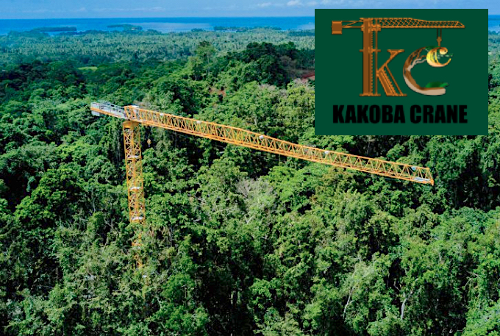
Binatang Research Centre Kakoba Crane commissioned in 2018

A rainforest monitoring crane was launched by the Binatang Research Centre in late 2018 from which intensive research can be done for a 1 hectare area. This lowland rainforest plot will complement the Wanang plot with in depth applied research. The nearest other crane is in the Wet Tropics of Queensland, Australia.

Together these are providing information on rainforest ecosystem change primarily from normal growth and climate change.

National Forest Inventory.
Part of Papua New Guinea REDD+ readiness is determining the (NFI) National Forest Inventory. A monitoring protocol was developed that included measurement of upper and lower plants, soil, birds, ants, fruit fly and moths. These are a stratified sample of clusters across different plant community types found in the country. This is still in process in 2019 and when completed will better inform current knowledge of the biodiversity occurrence across these plant community types.
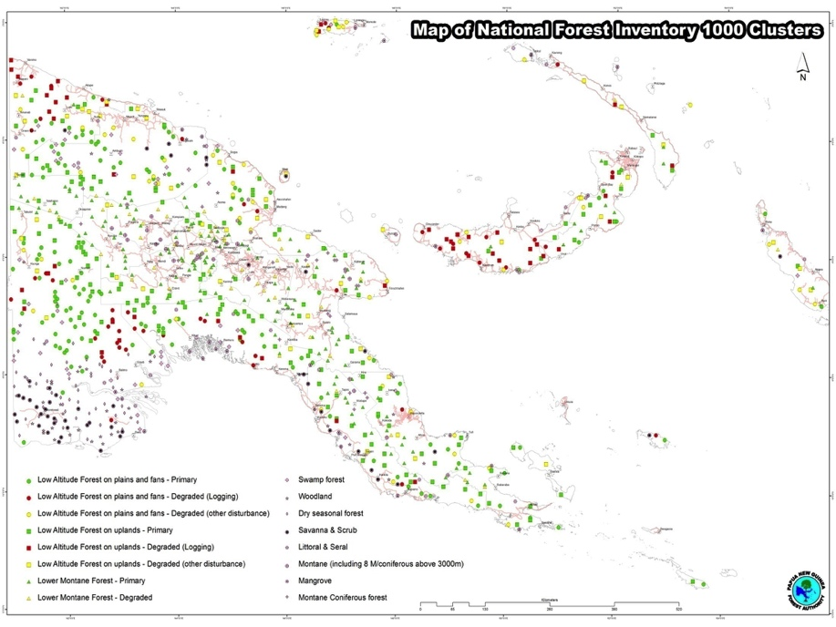
National Forest Inventory Clusters (PNGFA 2018)

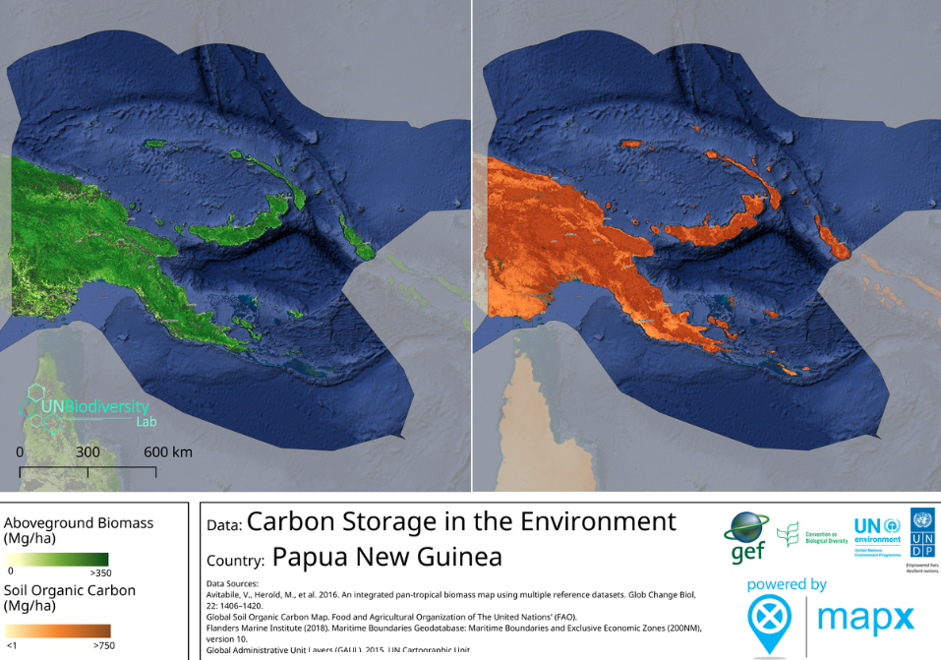

Payments for Ecosystem Services
An ecosystem service is a process or activity that occurs in nature and that benefits people. A participatory study on PES was done for New Britain Island in 2015 within which it was concluded that Payment for Ecosystem Services (PES) is an innovative resource management tool that can use economic incentives to promote conservation, while providing livelihoods and reducing poverty for rural landowners. In PNG ecosystem services occur most often on customary land and the owners may destroy that service in an effort to gain income from this resource through farming, logging, mining, hunting or other extractive activities. With PES landowners receive a payment to stop any usually destructive activities that would prevent the ecosystem service from continuing, thus offering an alternative use of the resource.

Through stakeholder consultations across New Britain with businesses, government officials and non-government organizations (NGOs) the ecosystem service payment options identified fell into three major market categories: Biodiversity or carbon offset credits, Watershed protection or land management schemes, and aesthetic beauty or ecotourism schemes. However this has not yet progressed to a changed paradigm to that of New Britain shown in the map ABT 12.

The gap between concept, policy and the forces of production and management i.e. household and clan needs to be addressed to develop PES as a real option.

Communities in Wide Bay East New Britain made the decision to not log, but to establish a WMA (Wildlife Management Area) to maintain the Ecosystem Services that they have been relying on. This decision was based on what they saw from nearby logging (2003), an analysis based on weighing up the losses and valuing the services that the intact forest provided them. The value of the ecosystem services or the replacement cost was seen as of sufficient value to maintain the forest rather than the option to allow commercial logging with its cash benefits and associated environmental degradation.

Also with the progression of the ADB supported Noaro-Brown Hydropower development out of Port Moresby the PES of water catchment management for hydro-power is currently being investigated.

Constraints
Currently there is limited capacity to determine the ecosystem services values of the environments across PNG that would give government and landowners alike a sense of the cost-benefits of development options.

The ecosystem service of localized water provision to communities by maintaining the environment of watersheds has been neglected. Even the role of water in maintaining ecosystems types is also poorly researched, understood, valued or promoted.

The ecosystem provisioning service of forest in maintaining the soil for current and future forest or agriculture, is also neglected and its true value is poorly researched and known.

Moving forward
Under REDD+ there is opportunity from a PNG developed protocol and extensive field surveys to evaluate the value of the environment and ecosystems services in determining premiums additional to carbon values.

The current Noaro-Brown hydo-power initiative can inform the process and calculations of the ecosystem values of this water catchment to maintain the integrity of the dam. This applied research can inform the application of these PES principles for existing and future hydo-power schemes across PNG.

In determining the ecosystem value of PNG environments the fundamental aspects needed in environmental accounting will inform discussion on the cost-benefits of Papua New Guinea’s future ecologically sustainable development.

Sustainable Development Goals
1.5 Disaster awareness is reaching those who have access to media but other remote rural communities is a major challenge. Ecosystem service awareness remains unknown across most of rural PNG. Progress is required.

3.9 Hazardous substances are not monitored beyond economic development projects and remains a major gap. Progress is required.

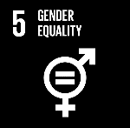
5.1 Women and girls play a major part in subsisting and maintaining the environment but remain poorly heard. There are programs which are addressing this gap often led by development partners within their project initiatives than have gender training of staff and build in gender milestones they aim to achieve.
5.5 Opportunity and representativeness based on capability remains an ongoing ideal however achieving this for women and girls varies by culture and workplace across the country.
6.4 Policy (WaSH) intent promotes access to safe, convenient and sustainable water supply across the country and is informing programs to be implemented however does not take into account sustainable ecosystem management to maintain localized water provisioning.
6.6 The protection of water in PA placement and management occurs passively usually unintentionally.
7.1 Currently additional hydro-energy projects are muted but these will have localized environmental impact whilst decreasing the environmental footprint of greenhouse gas emissions.

8.4 PNG economic growth that is decoupled from environmental degradation is occurring through environmental certification of agricultural products.
8.9 Eco-tourism is promoted but numbers of tourists remain currently static

9.1 Major infrastructure projects are taking place in transport, communication and electricity. These however all have environmental impacts.
9.4 Power by hydro, LNG are in development to replace the dominant fuel source of diesel in growth centres.
13.1 Factoring climate change impacts is neglected.

14.7 Maintaining sustainable fisheries remains a challenge/

15.9 Factoring the environment in development plans has occurred in planning at different scales of government though is uncoordinated, thereby missing opportunity.

Aichi Biodiversity Target 15 Climate resilience

Status of climate resilience
Progress towards target but at an insufficient rate

Level of confidence of the above assessment
Based on limited evidence

Loss of resilience is often incremental so determining the state of this is difficult. Local and political efforts that enhance resilience are easier to measure.

It is often complex to monitor incremental change until an ecosystem reaches a tipping point and flips from one association to another. Resilience is enhanced by maintaining ecosystems in robust environmental health, which is through strict maintenance of natural ecosystems or rehabilitation efforts in an attempt to reach this state.

There is ongoing measurement within PNG of physical parameters that show trends i.e. temperature and sea level rise whilst there are biotic measurements within ecosystems that are more complex or of the status of indicator species, which is currently not well developed to determine the effectiveness of interventions.

Outline
There have been concerted efforts in the development of large-scale Conservation Areas driven by communities with flagship species ABT11 & 12 and in the initial Biodiversity Offset ABT5 that also contribute to the resilience of these ecosystems. The intertidal zone of mangrove and to the reefs have also seen localized action by communities with supporting partners. And NARI in the development of farming systems through food variety and agronomic research in building the resilience of the planted subsistence ecological system, ABT13.

Though these have seen positive change towards achieving this Aichi Biodiversity Target there is still a huge effort required across the country.

Success
Mangrove rehabilitation.
With sea-level rise the estuarine area is dynamic. The mangrove ecosystem has been exploited and often cleared previously but with education and advocacy this is being turned around. Within Central Province of the country there are ongoing mangrove rehabilitation and replanting projects with many different communities. With the support of USAID PACAM the PNGCLMA together in partnership with local communities engaged with the women mud crab harvesters to initiate mangrove rehabilitation with the support of their village chiefs.
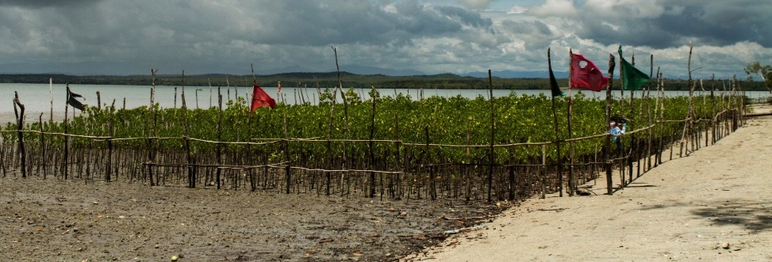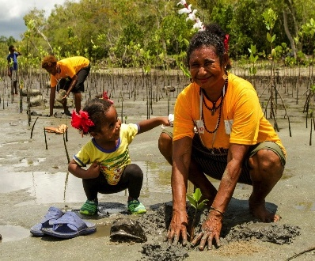
Mangrove Nursery and planting out Hall Sound, Central Province (PNGCLMA 2018)
The NFA National Fisheries Authority has an established nursery that also assists in the planting out of seedlings along coastal systems to the east and west of the capital Port Moresby.

These built upon the USAID supported MARSH (Mangrove) Project worked with these partners plus the then OCCD now CCDA, UPNG, PNGADP (PNG Assembly Disabled Persons) and PwM (Partners with Melanesians) and had an extent of NCD, Central, Manus, New Britain and New Ireland Provinces and ran from 2012-2017 with the aim of building resilience in communities and to reduce forest degradation.

Promotion of customary closure

Short film poster (CI& ECA 2018)
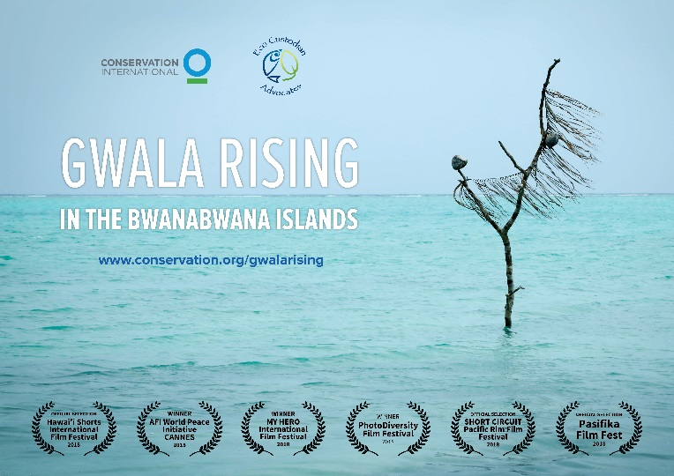
The inner marine environment like the mangroves has often seen overuse that has been exacerbated by climate change impacts. Ecosystem based management builds the resilience of this environment and approaches in achieving this are being promoted by the government and NGOs across the country, notably Manus, West New Britain, New Ireland and Milne Bay Provinces. Communities have used customary closures, no-take zones in their efforts towards natural resource management. A film short was produced where island communities in Milne Bay Province have adapted ‘gwala’ customary closure in the dynamic socio-economic context of the present. In building the local resilience of the reef the resultant increase of marine resources in adjoining fishing zones has also been enhanced, providing catch that has improved the livelihoods of the community, including the young, women and elderly. As a short film it can be shared on e-media and smart phones across the country and with other small island states to support future extension efforts in building on customary practices.

Policy & Strategy
The National Climate-Compatible Development Management Policy (2014) was endorsed by the PNG national government, followed closely by the Climate Change (Management) Act (2015). On the 30th of September 2015 PNG became the first country to have formally submitted its National Climate Action Plan 2015 as a Nationally Determined Contribution (NDC) under the Paris Agreement.

Papua New Guinea National Climate Compatible Development Management Policy (2014)
This is a cross-sectoral national policy prepared with the objective of building a climate resilient and carbon neutral pathway for climate compatible development in Papua New Guinea. This strategy combines economic development with mitigation and adaptation through sustainable development whilst increasing livelihood resilience to climate change. The key policy themes relate to natural resources, land-use, hazards management, green development, public health, public infrastructure, transport and energy.

The Conservation and Environment Protection Authority, the PNG Forest Authority, Department of Lands, Department of Agriculture, and Department of National Planning in collaboration with OCCD will support actions that preserve and manage natural assets, including natural ecosystems, forestry lands and agricultural land in such a way that the natural assets can be sustained despite climate change impacts and that the natural assets help reduce greenhouse gas emissions.

The Department of National Planning in consultation with OCCD will also support the development of plans, strategies, and standards to better anticipate and prepare for the hazards impacts of climate change. Whilst the Department of Health in consultation with OCCD will support efforts to effectively manage public health impacts resulting from climate change, including customization of efforts to address particularly vulnerable populations. Efforts to address climate resilience and reduce greenhouse gas emission related to design, construction and installation, and operation of public infrastructure will also be supported.

Climate Change (Management) Act 2015
In recognizing the implications of climate change and the country’s obligation PNG responded with the development of this guiding legislation. This provides a regulatory framework to promote and manage climate compatible development through climate change mitigation and adaptation activities. Also the measuring, reporting and verification of a National reference level and targets of GHG of PNG along with mitigation and adaptation standards and performance levels. It was recognized that data is vital in informing all these aspects of the act.

Paris Agreement
Papua New Guinea signed the Paris Agreement on the 22nd of April 2016 and through the National Parliament ratified the Climate Change Paris Agreement with the instrument of ratification deposited with the United Nations General Secretariat on the 21st September 2016. Papua New Guinea actively supported the inclusion of Article 5 on REDD+ in the agreement. PNG Parliament also passed the United Nations Paris Agreement (Implementation) Act 2016 to enable in-country implementation of the agreement.

A Privileges and Immunities Agreement was signed between PNG and the Green Climate Fund (GCF) to support the accessibility of climate finance to build capacity, strengthen resilience, mitigate and adapt to climate change.

Many actions led to this stand by PNG.

CCDA has initiated the development of a policy for the implementation of REDD+ and an emissions trading mechanism.

National REDD+ Strategy of Papua New Guinea for the period 2017-2027
Papua New Guinea has been at the forefront of REDD+ negotiations globally since 2005 when PNG and Costa Rica introduced the concept of reduced emissions from deforestation to the UNFCCC. PNG’s early efforts on climate change were formalised in 2008 with the establishment of the Office of Climate Change and Environment Sustainability (OCCES), which was re-established as the Office of Climate Change and Development (OCCD) in 2010 and, following the passing of the Climate Change Management Act (2015), has now become the Climate Change Development Authority (CCDA). Applied research has assessed the drivers of forest cover change through a partnership between CCDA and PNGFA as well as UNDP and FAO and developing the four key components of REDD+ namely the;
- National REDD+ Strategy (NRS),
- Safeguards Information System (SIS),
- National Forest Monitoring System (NFMS) and
- Forest Reference Level (FRL).

PNG’s vision for REDD+ states that forests are central to the country’s formal and informal economy and the diverse cultures of its people. These provide a critical role in regulating environmental services locally including river catchments and weather systems, regionally through influencing rainfall patterns and globally through their contribution to the removal of GHG (Green House Gas) from the atmosphere thus helping to mitigate climate change. It is anticipated that by supporting community based land-use and development planning, that this will provide a critical basis for enhancing forest conservation.

National Forest Monitoring System
This work shows significant progress with the NFMS becoming operational and publically available in 2016. Similarly, actions proposed within the NRS will work directly with key sector and cross cutting strategies such as those on nutrition, food security, land use planning and climate compatible development as well as the specific sector strategies for forestry, environment, agriculture, land and land use planning.

Forest Reference Level
In its submission to FCCC (Framework Convention on Climate Change), Papua New Guinea has developed a national FRL (Forest Reference Level) for the period 2014–2018 with values as per the graph below/

The assessment team noted that the data and information used by Papua New Guinea in constructing its FRL were mostly transparent and complete and in overall accordance with the guidelines contained in the annex to decision 12/CP.17. T (CCDA 2018)

A number of small, geographically discrete projects may deliver local benefits but are not able to address broader trends in forest cover change that are driven by national level challenges.

Constraints
Understanding the true extent of global warming and resultant climate change that impacts on localized weather patterns is still a developing science. All policy, supporting law, strategy and implementation programs are informed by current information that is best available but that is still generalized. Currently PNG does not have the capacity to invest in biodiversity translocation initiatives so must therefore wherever climate-smart its Protected Areas with ecologically sound principles and to wherever possible incorporate a range of altitudes.

Moving forward
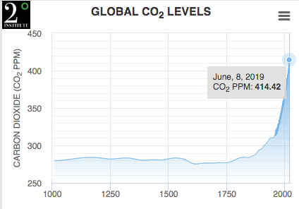
Based on the consistent increase in atmospheric CO₂ equivalent values, the future has a high probability of matching at least the A2 emission scenario. This can be used to inform communities that will have to translocate to other locations on their clan land or as climate change refugees onto other lands, where possible indicating at what date. Maintaining the quality of life for these communities through this time and post translocation is important. As 75-80% of the population rely directly upon their local environment for their wellbeing maintaining ecosystem resilience through local action that is supported by the government and development partners is crucial. There is a need to build on local knowledge that is value added with applied science and extension, and with conservation and rehabilitation as a part of sustainable natural resource use, that builds resilience across all clan/tribal lands/seas. Actions that are critical.

Localised Mapping of 0.5 & 1m sea level rise on small islands in PNG (Kimagl 2016)

Over millennia our local communities have been resilient, such that self-reliance is recognized within the 3rd goal of the PNG National Constitution and through the progressive recognition of this the National Government is main-steaming and refining its responses to climate change with crosscutting measures across all sectors. The international community has recognized this, however we need to exponentially build upon these efforts to keep pace with climate change.

Sustainable Development Goals
6.6 Areas of predominantly rainforest have been added to the Protected Area network in this reporting period with others in process of formal recognition. These core conserved areas will likely build resilience within the conservation estate.

9.1 Major road infrastructure is being developed in the country.
9.4 The hotel accommodation sector in Port Moresby is embracing environmentally friendly practice such as water reduction which also has financial cost cutting benefits.,,

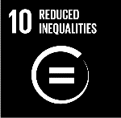
10.2 Inclusion of opportunity across PNG society classes in climate resilience is occurring through education programs on climate change and adaptation initiatives.

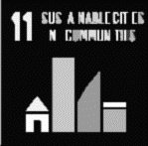
11.3 Disaster awareness is an ongoing activity across the country with variable risks based on location.

13.1 Based on awareness in 10.2 and 11.3 is follow-up actions to take to cope/ adapt or respond to hazards and disasters.
13.2 Climate change measures have been taken up by the PNG Institute of Engineers in revision of standards, and within policies of Forestry and National Policy.
14.2 CMMAs and LMMAs at clan/community level are strengthening local marine ecosystem resilience through areas of tambu no-take.

15.2 Forests are under customary management that is negotiated in subsistence and economic development with variable impacts.
15.4 Areas of mountain ecosystems has been added to the Protected Areas Network under formal conservation.

Aichi Biodiversity Target 16 Nagoya Protocol on access and benefit-sharing

Status of the Nagoya Protocol on access and benefit-sharing
Progress towards target but at an insufficient rate

Level of confidence of the above assessment
Based on comprehensive evidence

ABS Access Benefit Sharing has been discussed but has not progressed to Nagoya Protocol discussion

No monitoring system in place

Outline
Papua New Guinea has not ratified or acceded to the Nagoya Protocol.

The government has however, recognized the importance of biotechnology in the past by issuing permits to several international research and development institutions to conduct bio-discovery activities in PNG with the primary aim of finding new drugs to fight diseases. In the area of biosafety, the development of new medicines to control TB, cancer, HIV/AIDS and other sexually transmitted infections will be significant.

Papua New Guinea has also continued to share food crop germplasm material with internationally recognized institutions.

However, the protection of Intellectual Property Rights of the customary custodians with the knowledge associated with this material must be recognized and legally protected.

There are some aspects of Access Benefit Sharing (ABS) within the PNG legal system and agencies which have attempted to address this however this is difficult in the absence of a national guiding framework. Designing the best ABS framework within the complex, intricate cultural, social and political systems of Papua New Guinea is a challenge. This will require in depth of analysis that also looks at the broader international situation and includes Intellectual Property Rights (IPR).

Success
Through collaboration with other in-country agencies CEPA will gain from the country’s experience in its participation in the International Treaty on Plant Genetic Resources for Food and Agriculture (ITPGRFA) that can be drawn upon to inform the discussions on the Protocol.

Papua New Guinea has already in place policy frameworks and institutional arrangements that can assist to facilitate the discussion and intent of the Nagoya Protocol. The key sectors and organizations in the areas of agriculture, research, academia, business and community development, have in place strategies and frameworks that relate to ABS.

Although agencies have included ABS in their plans this has not been mainstreamed through implementation. These include sections within the Vision 2050, StaRS, the Development Strategic Plan 2030 and the MTDP3 (Medium Term Development Plan 3).

Constraints
Under the Convention on Biological Diversity, the rights of biodiversity are the sovereign rights of the nation states (Article 3). These rights can only exist if they are built on the rights of communities that have conserved and protected biodiversity within national territories for many decades. The people of Papua New Guinea lead a communal life in close relationship with nature and the environment that surrounds them. It is of utmost importance that the government stands behind the people in protecting biodiversity, especially the rich diversity in plant genetic resources. (Kambuou 2013)

The attributes and potential of virtually all of Papua New Guinea’s biodiversity is yet to researched. This includes the biochemical aspects and where species are utilized by local people the socio-cultural aspects

Papua New Guinea took significant steps towards having in place an ABS system through the development of a White Paper on PNG ABS (2006) and a PINBIO Bill (2008) which however was not endorsed or enacted by parliament.

Moving forward
It is important for PNG to proactively work towards the ratification of the protocol to fulfill its obligations under the UNCBD.

The ABS white paper and PINBio Bill can be revisited to determine their relevance in moving towards the protocol and where ABS is mentioned in development documents this can be extracted to guide discussion.

Papua New Guinea in 2019 will participate in a SPREP led ABS (Access Benefit Sharing) Regional Project which aims to assist countries in the Pacific region to ratify and implement the protocol. This will focus on capacity-building based on a self-assessment of national needs and priorities. This will include the preparation of a baseline analysis of traditional knowledge, and a road map towards the ratification of the Protocol that will include; a scoping of national laws, determining the implications of ratification and creating an enabling environment for the basic provisions of the Protocol such as by developing supportive institutional frameworks for protecting traditional knowledge, innovations and practices and customary uses of biological and genetic resources.

Also CEPA through a Memorandum of Agreement (MoA) with the GIZ ABS Initiative Project from 2019 to 2021 will develop and support institutional capacity in ABS policy, legal and administrative frameworks, analysis of potentials for bio-trade and associated value chains. In order to achieve this a competent National Authority will be supported, with a focus on human resource capacity to facilitate in the sharing of information with the ABS Clearing-House managed by the Secretariat of the Convention of Biological Diversity (SCBD).

It will also value add to the SPREP components relating to the rights of local individuals/families/communities and their traditional knowledge and genetic resources through supporting them and local community-based organisations to record, protect, register and store this knowledge through ethical protocols.

Currently there is an initial study led by UNSW (University New South Wales) on the patents held over Papua New Guinea genetic material that have already been taken from the country to inform the above projects in their implementation. As is evident in ABT 18 there is significant traditional environmental and ecological knowledge in Papua New Guinea and substantial agricultural genetic resources are held in gene banks overseas taken prior to this convention as per ABT13. The results of this will inform to potential which exists within PNG.

GEF 7 will support national and regional implementation (and facilitate ratification if required) of the Nagoya Protocol and contributing to the achievement of the to and beyond 2020.

Sustainable Development Goals
Nagoya Protocol encourages reinvestment of benefits in to conservation, sustainable management of biodiversity and ecosystems. Within Rio Conventions, from their outset, ABS is the only mechanism that rests on fostering fair international partnerships and explicitly encompasses not only ecological, but also social and economic aspects. Relevance of ABS for achieving the SDGs and Aichi targets: poverty alleviation, food security, health, economic growth, innovation, oceans and governance. Contributing to national (sustainable) development agendas

8.3 Access benefit sharing is a component ad mechanism for inclusive sustainable development

15.6 Discussion in ABS has developed an existing basis apart from the ABT16 to support equitable benefit sharing from agreed access to resources by local communities. However mechanisms are not currently in place and need to be developed to fully protect the rights of individuals and clans/tribes.

Aichi Biodiversity Target 17 National biodiversity strategies and action plans

Status of the NBSAP National biodiversity strategies and action plans
No significant change

Level of confidence of the above assessment
Based on comprehensive evidence

No draft revised NBSAP is available (June 2019)

This is monitored through the PNG 5th National Report to the CBD.

Outline
Papua New Guinea prepared a NBSAP that was launched at the 8th Pacific Island Conference on Nature Conservation and Protected Areas in October 2007 at Alotau, Milne Bay Province, PNG. Progress against the PNG NBSAP (2007) objectives was evaluated in the PNG 5th National Report to the CBD with a mixed scorecard. However this NBSAP was not reviewed to factor in the Aichi Biodiversity Targets from 2010 resulting in this document not being proactively utilized as a guideline to achieve the Aichi Biodiversity Targets, many of which nonetheless have been coincidentally addressed.

The PNG NBSAP (2007) is the version, which therefore currently remains in place through this reporting period and hence failing to reach the revision target of 2015.

Success
Through a consultative process lead by CEPA, the first PNG Policy on Protected Areas was formulated and recognized by the country’s National Government in 2014. Within this policy many of the categories of Protected Areas as found in Papua New Guinea were more clearly defined and five pillars outlining how to achieve conservation through Protected Areas were set out. In line with the policy the Protected Areas Bill 2018 and associated Regulations have been drafted reflecting the policy.

Also a Protected Areas Implementation Plan PAIP (2018) was subsequently developed by the then newly established Conservation and Environment Protection Authority (CEPA) through a consultative process, to guide and cost out the implementation of the Policy on Protected Areas (2014). This has just been formally recognized by the National Department of Policy & Planning in 2018 and will come into effect in 2019.

Constraints
By not having a revised contemporary NBSAP that factored in changes of the CBD, CEPA faced a disconnect with the Aichi Biodiversity Targets within the Convention and the Sustainable Development Goals during this reporting period.

Moving forward
Papua New Guinea is however now getting back on track with the PNG NBSAP (2007) in the process of being reviewed from mid 2018, through a series of regional consultations, which involve the participation of a range of stakeholders. It is anticipated that by 2019 a new version of the NBSAP will be in place for PNG that takes into account the Aichi Targets, the Sustainable Development Goals, that is guided by the aspirations and contemporary context of biodiversity conservation across the country.

This process will also, enable our country PNG to meaningfully contribute to discussions on the future direction of the CBD and post Aichi Biodiversity Targets 2020.

Aichi Biodiversity Target 18 Traditional knowledge

Status of Traditional knowledge
Progress towards target but at an insufficient rate

Level of confidence of the above assessment
Based on limited evidence

Oral knowledge is rarely in other mediums of communication being held by custodians.

No monitoring system in place

With so many languages this is extremely complex and overwhelming challenge to record all aspects of traditional knowledge across the entire country.

Outline
Papua New Guinea apart from being a high biodiversity country also has a high level of linguistic and cultural diversity with 852 distinct indigenous languages of which 12 are now extinct (Ethnologue 2018) plus an unknown number of associated dialects.

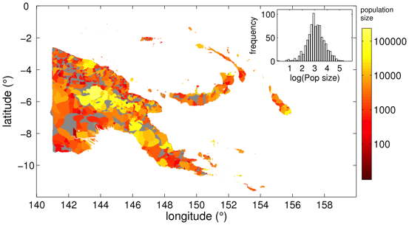
Index of Linguistic Diversity of Papua New Guinea & log population size histogram
(Ethnologue Database v15)

In this generation the majority of people are orally literate in their own language although there are signs that this will decrease in the next generation. As language is integrally linked to culture and customs these are also being lost. Despite this the linguistic and cultural ties between communities and their surrounding environment upon which they depend remains functionally strong. It is however different in the major cities where young people growing up in this urban environment are disconnected from their ancestral lands and this is a growing concern.
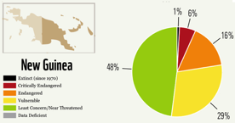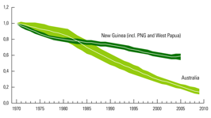
Threatened Languages in Papua New Guinea Index of Linguistic Diversity 1970-2010

The importance of language and culture in the process of development of our country is enshrined within the 5th goal of the PNG Constitution on Papua New Guinean Ways which in part calls for the recognition that the cultural, commercial and ethnic diversity of our people is a positive strength, and for the fostering of a respect for, and appreciation of, traditional ways of life and culture, including language, in all their richness and variety, as well as for a willingness to apply these ways dynamically and creatively for the tasks of development.

Nowadays, Papua New Guineans also tend to identify with larger territorial groupings of traditional political communities, such as those united by a common language or culture, and hence by a shared understanding of their natural environment (Filer 2015). Essentially these language/cultural groups though not currently recognized as such, could represent ‘nations’ across Papua New Guinea. Efforts of recognising leadership, values, TEK in sustainable development could occur at a nation level.

Level of threat within PAs relating to loss of culture (PNG METT 2017)

Traditional Environmental/Ecological Knowledge gained through experiential learning over many generation has led to various management practices of terrestrial and marine areas some of which a ‘tambu’ sacred/forbidden areas. These have been incorporated into the Protected Areas Bill 2018 as they often have high conservation value.

Success
In PNG there is empirical evidence showing that development agencies and NGOs that comply with the traditional decision and leadership processes of the community increase the receptivity of the people, encourage equal gender participation, and increase the chance of success of the proposed project or work (Jerome 2015).

In Port Moresby 2018, a Biodiversity Conservation Seminar was held of 100+ conservationists with the focus on customary conservation practice as a way of mainstreaming conservation across the clans and tribes of PNG. Stories from communities and lessons from the field informed discussion on conservation strategy, that potentially compliments the formalised PA network that is now being developed and guided by the Policy on Protected Areas (2014). The last time such a focus had taken place was at a Conference led by the then Office of Environment and Conservation on Traditional Conservation in Papua New Guinea: Implications for today in 1980.

Constraints
Customary Law derived from the traditions of the various peoples of Papua New Guinea is recognized within the Constitution and given statutory recognition in the Underlying Law Act 2000.

Although Customary law is recognised there is also a need for law on customary intellectual property rights and in maintaining ethical standards of prior informed consent to protect the rights of the custodians of this information. In the meantime indigenous languages, culture and oral traditional environmental/ecological knowledge is being lost. There is knowledge that it held by one clan or tribe or even by an individual; rituals, rites of passage, sensitive sacred and tambu/taboo intellectual property and it is for the owners of this information to decide if and how they pass it on. The information that is hidden in the forest and in the minds of people (Majanep 1982). Although Environmental Anthropology is a potential major in studies at UPNG or other PNG universities there is little emphasis or available support to enable the systematic recording of applied customary knowledge, apart from individual dissertations or ethno-botanical publications.

Moving forward
There is an urgent need to record Traditional-Customary Environmental/Ecological Knowledge especially in its application, in both local language and a lingua franca in a medium that is reliable. Although not formally recognized the language/customary groups form nations across Papua New Guinea which offer a strong customary management structure under which information collection can inform localized development.

There is an urgent need to value this Traditional-Customary Environmental/Ecological Knowledge and invest in in situ community-led programs that utilize these records to educate and advocate in its ongoing application in the changing social contexts of village societies across the mosaic of cultures within the Nation State of PNG.

There is an urgent need to invest in the registration of aspects of this knowledge in tangible (sacred sites) and intangible heritage (cultural practice) so that the social landscape that links people to their land and environment is recognized, strengthened and promoted.

Sustainable Development Goals
2.5 The many language/cultures across the country have subsisted based on their traditional knowledge of the environment which though encouraged is not proactively supported in a strategic countrywide effort.

5.5 The call for women’s participation in leadership beyond customary restrictions is actively promoted in PNG.

10.1 Income within the informal sector is promoted through SME (Small Medium Enterprise) support such that it is now a major sector in the country.
10.2 Social inclusion of all is the 2nd Goal and Directive Principle of the PNG National Constitution.

Aichi Biodiversity Target 19 Sharing information and knowledge

Status of sharing of information and knowledge
Progress towards target but at an insufficient rate

Level of confidence of the above assessment
Based on limited evidence

Data sharing is an ongoing issue over the last 40 years and there is little evidence of this changing.

No monitoring system in place

There is no monitoring of the volume extent and nature of data that exists on the biodiversity of PNG.

Outline
The challenge of having publically available information on the state of the environment and its entire biodiversity in a tropical biodiversity rich country such as Papua New Guinea is great. With high species richness and high levels of endemism combined with high cultural and linguistic diversity associated with this, it makes the task of recording and disseminating this information a major challenge.

Currently the majority of biodiversity data as it relates to the peoples of PNG is not disaggregated based on gender, age group or minority groups.

Success
Papua New Guinea is a highly complex nation and in recognizing the power of data and the many gaps that currently exist, the Department of National Planning and Monitoring has put in place a Strategy for the Development of Statistics 2018-2027. In doing so recognizing the importance of developing a reliable statistical system for the country that will integrate and manage all valuable statistics for evidence-based planning and decision-making to guide ecologically sustainable development.

This is to include statistics on productivity of the agriculture, fisheries exports and income, timber value of exports quarterly and to have satellite accounts of statistics on the environment, climate change, on land-use and access. Also statistics in relation to determining the HDI (Human Development Index) and the GDI (Gender Development Index) to be updated on an annual basis.

Data Portals
The PNG Herbarium through an agreement with herbaria in Australia has uploaded 5-10% of the 350,000+ (2335+ type specimens) held specimens into the searchable pubic PNG Plant Database that is hosted by the collaborating partner of the NSW Herbaria.

There have been various insect orders digitised from the scattered National Agriculture Insect Collection (formerly National Insect Collection), the New Guinea Binatang Research Institute and others that includes 1393 Ants (BRI).

png-nfms.org/portal/
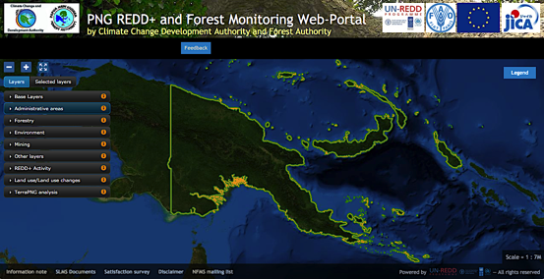
http://png-nfms.org/portal/static/loc/en/documents/PNG_REDD+_Web_portal_doc.pdf

The CCDA, Climate Change Development Authority in partnership with the PNGFA, Forest Authority have developed a PNG REDD+ and Forest Monitoring Web-Portal that has spatial layers of terrestrial habitat launched in 2016. This Web-portal was established for the purpose of publically disseminating forest and land use information to ensure the transparency of PNG REDD+ process. The data behind the spatial layers can only be viewed on line and are downloadable due to data restrictions being in place. The specific environment layers currently in the portal are limited to; the primary layers of Forestry; forest loss, tenements, Environment; PAs, Biological Rapid Appraisal Project (BioRAP) of 2000 CNA (Conservation Needs Assessment 1994), but not PoWPA the CEPA 2018 standard), Mining; mining leases, exploration licences, Landuse/landuse change

This portal was developed by the Remote Sensing Centre of UPNG with funding from the European Union.
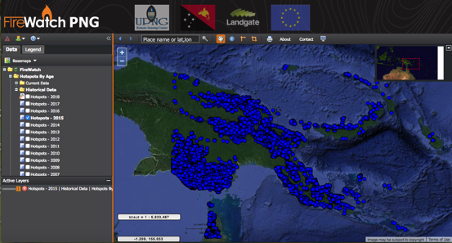
fire.pngsdf.com

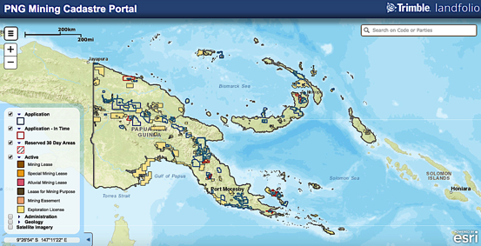
portal/mra.gov.pg/Map/

The MRA (Minerals Resources Authority) Portal contains data by and for the extractive industry, government and stakeholders. The portal has a PA layer as is current with CEPA, which indicates when an Exploration License Application polygon overlaps a formally protected area.

Information sharing in Papua New Guinea through Information Technology has been affected by variable internal internet connectivity that has been relatively expensive. Information on websites has increasingly become available on a Government Department/Authority basis, which also vary in approach and in maintaining up to date information.

The Conservation and Environment Authority initiated a website in 2018 and is under development with information being progressively uploaded.
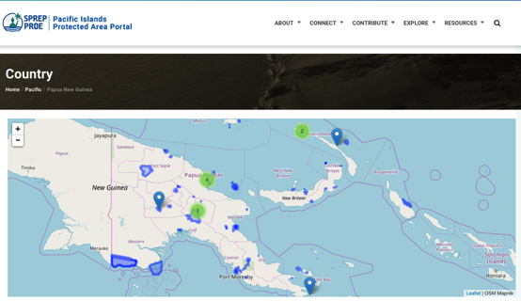
http://pipap.sprep.org/country/PG

PNG contributed to and participated in the PBIF (Pacific Biodiversity Information Forum) which has the aim to develop a complete, scientifically sound, and electronically accessible Pacific biological knowledge-base and make it widely available to local, national, regional and global users for decision-making. Within this administered by SPREP is the Pacific Islands Protected Areas Portal (PIPAP). This portal has data on Protected areas and the percentage of Aichi Target achieved and remaining. It has not been maintained up to date with recent PAs.

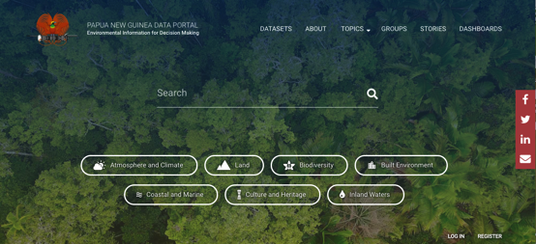
https://png-data.sprep.org/

Papua New Guinea led by CEPA is participating in the Inform (Environmental Information for Decision Making) Project 2017-2021 that is executed by SPREP, with financial support from GEF and through implementation by UNEP. CEPA has initiated in 2018 the uploading of reports, papers and shape files into the Data Portal. The other aspects of this initiative yet to be initiated are the Reporting Tool, Data Analysis and the process of Data Sharing. The Reporting Tool is the assist PNG to report against future UNCBD and SDG reporting requirements and includes State of the Environment (SOE) reporting which PNG will be preparing in 2019. The Data Analysis will assist in the use of environmental data in national planning and in ‘ecological’ sustainable development. This portal has been socialized within CEPA and is progressively being populated notably through 2018.

Constraints
The overall Statistical Capacity of Papua New Guinea has declined in the period from 2005-2013 as can be seen from the graph below as determined by the World Bank.
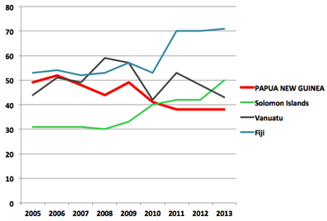
Environmental Statistics are a subset of this and are linked to many other parameters such as population, education, and the HDI (Human Development Index).

Statistical Capacity of PNG NSS (National Statistical System) with comparison other Melanesian Countries WB

The strengthening of a National Biodiversity Information System (NBIS) database by CEPA can inform other agencies of biodiversity and conservation priorities as determined by CEPA and through its use, open their dialogue with the Authority, in making development decisions that factor in environmental opportunities and concerns. It will also strengthen CEPAs internal capability in the planning and monitoring of the Protected Area Network, and to inform its regulatory functions in the evaluation of Environmental Impact Assessments, issuance of Environmental Permits and ongoing Environmental Reports by economic development projects and others. It will also play a key function in informing reports such as to the government and agencies such as CITES, RAMSAR, UNESCO and CBD.

To digitise the plant specimens of Lae Herbarium at the current rate would take 20+ years as the process faces funding, capacity and e-constraints.

Moving forward
A new fibre optic cable between Papua New Guinea and Sydney Australia that is scheduled for completion in 2019 will upgrade the capacity in PNG to at least 20 Tb/s dramatically increasing this capability of a reliable system that will enable capacity and connectivity enhancement for end-users. This cable has been laid and connected to Port Moresby and is being connected by cable to other coastal towns. This will offer the potential for more cost effective high speed connectivity that will facilitate the development of the current and future data portals along with data collection and dissemination opportunities.

There is a need to have the National Biodiversity Information System NBIS in place that is linked to databases and portals such as those already mentioned and others such as museums around the world where specimens from PNG are held. Data sharing and access agreements will need to be negotiated and the NBIS to be populated. A dedicated concerted effort in the collation, digitization and input of biodiversity and ecological data will be needed in order to better understand the biodiversity of Papua New Guinea in the future.

Sustainable Development Goals
4.7 The formal education system in PNG is guided by curriculum that is locally relevant to the future of the country and its place in the region.

7.1 There are plans in country to extend rural electrification by grid to 70% of the country’s population.
7.2 This is progressing towards increased hydo and locally produced LPG generated power.

9.4 PNG is currently investing in major infrastructure in roads, ports and airports. The efficiency of housing is good however of office developments is poor.

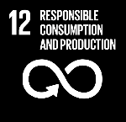
12.2 Natural resource use by the rural subsistence sector is variable losing, highly sustainable to a point where population demands become over exploitive.
12.8 Intergenerational fishery customary knowledge is still regarded as important. Most lifestyles in country have a relatively small footprint apart from the minority of high end urbanites. This though is impacted by the need to fly to many parts of the country due to the lack of road and shipping links.
14.4 For the Tuna to combat IUU fishing the development of a new tuna management plan; developing a coherent scheme for fisheries monitoring, control and surveillance; a new, more transparent vessel licensing system are in being developed.
17.6 There are tertiary institutions links and scholarship opportunities for PNG undergraduate and post graduate students.
17.7 in urban centres use of efficient lighting and solar hot water generation is becoming the standard whilst in remote locations solar electricity use is increasing

Aichi Biodiversity Target 20 Mobilization of resources (Financial)

Status of financial resource mobilization
Progress towards target but at an insufficient rate

Level of confidence of the above assessment
Based on partial evidence

Much funding is difficult to determine

Monitoring related to this target is partial (e.g. only covering part of the area or issue)

Outline
The National Government allocates a recurrent budget yearly for the National agency of DEC now the Conservation and Environment Protection Authority. In 2016 the actuals were PGK9.5 million with appropriations of PGK11.2 million for 2017 and PGK17.4 for 2018 million. There are actuals and appropriations that contribute to the ABTs as part of the budgets of other line agencies i.e., Climate Change Development Authority, PNG Forest Authority, National Fishery Authority, National Maritime Safety Authority, National Agriculture and Inspection Authority, the Departments of Agriculture and Livestock, Education, Lands and Physical Planning, Foreign Affairs and Trade, the National Agriculture Research Institute, Universities and agriculture commodity corporations. Also the provinces of which there are now 22, allocate funds towards environmental initiatives based on their approved 5 year plans. Determining this diverse investment accurately is difficult with actuals often at variance with budget allocation.

There is also significant funding for biodiversity conservation effort from the international donor community. This often requires counterpart funding from the government and use of staffing capacity from within CEPA which is often limited. The cumulative total of these funds is far in excess of the recurrent government funding allocation to CEPA and therefore has the power to focus effort in certain directions.

Success
A target within the 2007 NBSAP Theme of Financial & Technical Resource was to obtain necessary financial support of biodiversity initiatives. In achieving this both Government, Non Government and others have actively sourced funding from overseas.

The Government through development of Project Documents has secured funds and is currently implementing through;

GEF 4 Community-based Forest and Coastal Conservation and Resource management October 2011-September 2018 UNDP- (DEC) CEPA The project to assist the Government of Papua New Guinea through CEPA to establish its national system on protected area in the country with a geographic focus on New Britain Island and the Owen Stanley Range USD11.9 million.

GEF 5 Strengthening the Management Effectiveness of the National System of Protected Areas July 2015-July 2020 UNDP- (DEC) CEPA Building on GEF4 This project supports CEPA’s capacity for the effective management of a Protected Area system as showcased in 3 sites, namely the Varirata National Park and Sogeri Plateau, YUS Conservation Area and the Torricelli Mountain Range Total Project Funds USD49.9 million

Implementation of the Arafura and Timor Seas Regional and National Strategic Action Programs. 2011- Ecosystem health improved as a result of implementing the ecosystem approach to fisheries management, both regionally, on a large marine ecosystem scale, and locally, for fisheries in Indonesia, Papua New Guinea, and Timor-Leste. Total USD69.9million, GEF USD9.7 million.

R2R Strengthening the Management Effectiveness of the National System of Protected Areas. 2017

R2R- Pacific Islands Ridge-to-Reef National Priorities – Integrated Water, Land, Forest and Coastal Management to Preserve Biodiversity, Ecosystem Services, Store Carbon, Improve Climate Resilience and Sustain Livelihoods To maintain and enhance Pacific Island countries including PNG’s ecosystem goods and services through integrated approaches to land, water, forest, biodiversity and coastal resource management that contribute to poverty reduction, sustainable livelihoods and climate resilience. USD1.3 Million across Pacific nations.

Ratification and Implementation of the Nagoya Protocol in the Countries of the Pacific Region. 2014-

GEF 6 Sustainable Financing of Papua New Guinea’s Protected Area Network. 2016- To support through financing the management of protected areas and other aspects of oversight and management of the network of protected areas. Total USD61 million, GEF USD11.3 million.

Strengthening capacity in the agriculture and land-use sectors for enhanced transparency in implementation and monitoring of Nationally Determined Contributions (NDCs) under the Paris Agreement in Papua New Guinea. Total USD3.5million, GEF USD0.8 million.

Development of Minamata Initial Assessment in Papua New Guinea. 2015- GEF USD0.3 million.

GEF Small Grants 1994-2020 Providing financial and technical support to projects that conserve and restore the environment while enhancing people's well-being and livelihoods, In PNG SGP continues to support vulnerable and isolated communities across PNG in their efforts to protect and manage their natural resource while building their resilience against climate change. This is a facility that was negotiated by CEPA that is managed by the UNDP in the screening and disbursement of small grants to USD50,000 to community based organisations that need support in their conservation initiatives.

WB Productive Partnerships in Agriculture Project (PPAP) 2019. funded by a World Bank loan
http://www.projects.worldbank.org/P110959/png-productive-partnerships-agriculture?lang=en

ADB in Agriculture, Natural Resources and Rural Development, to date USD202 million

Maritime and Waterways Safety Project 2012. Sovereign (Public) Project. To enhance maritime safety and efficiency by upgrading the country’s navigational aids network, make maritime safety information more readily available, and help develop maritime safety communities of practice. These improvements are expected to benefit remote, rural populations and boost local and international shipping and trade. USD41.5 million loan.

Regional: Strengthening Coastal and Marine Resources Management in the Coral Triangle of the Pacific (Phase 2) Sovereign (Public) Project. 2010- To address issues on coral reefs, fisheries and food security that continuously threaten coastal communities. The subproject in Papua New Guinea is to strengthen local capacity of 10 vulnerable island communities for an ecosystem-based approach to resource management covering FADs, gillnet exchange and diversification to climate resilient gardening practices.

FAO Technical support to the Department of Agriculture and Livestock (DAL) for the preparation of Policy Partnership on Food Security (PPFS) Action Plans. 2018. To enable all Papua New Guineans to access and consume sufficient, safe, affordable and nutritious food at all times.

Country gender assessment of the national agriculture and rural development sector in Papua New Guinea. 2016-2018. To conduct an assessment of the institutional capacity of the ‘Women in Agriculture Development’ desks at the national, provincial, and district levels of the Department of Agriculture and Livestock. The assumption is when equality is recognised at the wider level, then the levels in equal participation improves in the agriculture productivity and; natural resources being managed fairly; household economy could also be increased and nutrition levels rise. Gender equality will increase the impact on various national and subnational government policy interventions and at the same time contribute towards the overall achievement of the sustainable development goals (SDGs) and the millennium development goals (MDGs) nationally.

Strengthening Capacity for Data Processing, Analysis and Management in PNG. 2018. To improve agricultural statistical capacity in Papua New Guinea

Databasing and Documentation of PNG National Herbarium Plant Collection

EU, Aust, NZ Joint Pacific Initiative for biodiversity, climate change and resilience.

EU UNREDD Technical support to the PNG Forest Authority to Implement a multi-purpose National Forest Inventory 2014-2019. To support the Papua New Guinea Forest Authority to implement a continuous and multi-purpose National Forest Inventory

CEPF 2013-2022 East Melanesian Hotspot of PNG New Guinea Islands, Solomon Islands, Vanuatu, focuses on globally important biodiversity with a large grants > USD20,000 and small grants < USD20,000 mechanism. USD9 million

DFAT (Department of Foreign Affairs and Trade) Kokoda Initiative

Australia’s collaboration with UNDP helped build the capacity of Papua New Guinea’s Climate Change Development Authority (CCDA).

Governance expenditure related to climate change is estimated at USD4.1 million in 2016-17. This includes UNDP1.5 million to the UNDP to help build the capacity of Papua New Guinea’s Climate Change Development Authority (CCDA), and USD0.3 million to strengthen the disaster risk management capacity of the Papua New Guinea National Disaster Centre. It also includes USD2.3 million of estimated climate change expenditure through the Church Partnerships Program, which implemented drought response measures focused on disaster risk reduction and capacity building in Highland communities.

Australia 2015 -2018. AUD118.5 million in climate change support to Papua New Guinea

USAID Green Climate Fund Readiness Support Project

PACAM (Pacific American Climate Fund)
- Papua New Guinea Centre for Locally Managed Areas Inc. will implement the Scaling Up Women’s Participation in Mangrove Management project.
- Mahonia Na Dari Research, Education and Conservation Centre will implement the Youth as Agents of Change: Marine Environmental Awareness in Kimbe Bay project.
- The Institute for Sustainable Futures-University of Technology Sydney will implement the Engaging Communities and Government in Biodiversity Conservation and Climate Adaptation project.
- Live and Learn Environmental Education will implement the Managing Fire to Conserve Biodiversity and Reduce Climate Vulnerability project.

USAID Papua New Guinea (PNG) Biodiversity. 2019. Seeks to reduce the primary drivers and threats to biodiversity in the country by strengthening management of customary lands and waters that include exceptional areas of terrestrial and marine biodiversity. To support this goal, the Program will work at the national and local levels to strengthen the policies and build the capacity needed to implement systems that support improved customary management of lands and waters. It will also implement activities that reduce significant threats to biodiversity in priority places. USD19 million

JICA
Project for Biodiversity Conservation through Implementation of the PNG Policy on Protected Areas. 2015-2020. The goal is to set up effective management of the Protected Areas Network by applying the models of protected areas management. To achieve this goal, the project aims to achieve four outcomes; (1) to strengthen institutional framework including formulation of PPA Action Plan and establishment of the National Conservation Council; (2) to enhance the terrestrial PA management model at Varirata National Park and the surrounding Koiari area; (3) to develop a model of establishing a new marine PA; and (4) to raise awareness of the people about biodiversity conservation.

Capacity Development Project for Operationalization of PNG- FRIMS [Forest Resource Information Management System] for Addressing Climate Change: Forestry database projects. 2014-2019

The Japanese Technical Cooperation Project for Promotion of Regional Initiative on Solid Waste Management in Pacific Island Countries: NCD waste Management project, 2011-2016. J-PRISM

Port Moresby Sewerage System Upgrading Project. 2010-2018. Loan PGK206.5 million.

Constraints
Funding secured by large international Environmental NGOs (WWF, TNC, WCS) and small local environmental NGOs (which can be quite substantial) is not known. Much funding drives the direction of conservation effort that these agents concentrate on.

Moving forward
Programs and Projects that secure funding must come under government policy.

SECTION 6 Contribution of Local Communities to ABT Achievement

Rural Communities and in some situations communities in proximity to cities and towns own the land through the customary rights of the clan/tribe. This gives them ownership rights of the biodiversity on their lands or seas, with some people given user rights to hunt, gather, fish or glean from these resources.

Within the 840 living languages few include a word or the concept of conservation, the closest being tambu/tabu/sacred or the word for respect/law. Surviving on subsistence has led to a utilitarian perspective of the environment and the services that they receive from it. There are some practices that support the sustaining of the environment so that it produces for community needs.

In nearly all situations area based conservation and species/biodiversity conservation is on customary land and clans/tribes must give permission for this to occur. To maintain this, both recognition of leadership and consensus is often required to ensure that conservation decisions are followed and complied with in order to avert dissent or sabotage of a conservation initiative. It is this process that entails a long community participatory process in order for conservation to be accepted and to have the chance to remain viable in the short and long term.

Spatial Mapping
Determination of clan boundaries is often fraught with dispute however in community-driven customarily recognised initiatives this can be negotiated and determined internally. In formalised Protected Area delineation an open transparent participatory process that allows for mapping on paper, the ground or by field GPS must be allowed to happen when the community is confident in the process.

Sacred Sites
Sacred Sites though known by community or individuals are poorly formally recorded or registered with the National Museum and Art Gallery. The Protected Areas Bill recognised Sacred Sites as a from of Conservation and has a Schedule for the recording of a sacred site. If passed into legislation it is anticipated that this Bill will assist to generate the recording and recognition of sacred sites and open the discussion on the protocols, strategies, support/programs needed to effect this.

Customary Review
Within the review of the ABT the Professor of Anthropology at the UPNG Linus Digim’rina and other academics, Colin Filer and Luke Petai made comment from a critical viewpoint. Other key persons who commented grew up in village communities during their formative years and are now often sought for advice in village developments. They are of a generation that knows the language and many of the customs as taught by their parents and grandparents and as such are custodians of knowledge that can inform the local perspective.

The 6NR does directly refer to community-based conservation however community-driven conservation also is occurring where communities see that there are benefits directly derived from their environment or secondarily by participating in a conservation initiative with links outside of the community. The latter can be tenuous as when benefits no longer flow other alternative livelihood strategies may be entered into.

Knowledge
Within this report the METT (Management Effectiveness Tracking Tool) was used to evaluate with communities the situation of their Protected Area. This is a rigorous transparent interview process often at the site of a Protected Area with the customary land owners. Within this a series of questions were asked in relation to the PA and explanatory notes in reference to answers were added.

The use of local language and custom, its promotion and record as an approach to mainstreaming conservation within communities has not been advocated by government.

Funding Support
The UNDP overseas a SGP Small Grant Program which is a competitive bid through a process of submission in a set format, for funds by a community group or local NGO to implement a conservation intervention. (Refer ABT 20)

SECTION 7 Updated Biodiversity Country Profile

Status and trends of biodiversity, including benefits from biodiversity and ecosystem services and functions:
Papua New Guinea consists of the eastern half of the island of New Guinea, the largest tropical island in the world along with its associated satellite islands which range from large orographic islands, archipelagos, to coralline islands, atolls and cays. Papua New Guinea is dominated by a central cordillera of mountains with Mt Wilhelm at 4510m and two major rivers, which flow through extensive lowland plains, the Sepik River in the north-west and the Fly River in the south-west of the country. This dynamic landscape continues to be formed by the tectonic collision of the Australian Plate and a raft of micro-plates to the north, and some 67 active volcanoes. The land area of the PNG half of the island of New Guinea is 398,127 km² and the satellite islands 65,636 km² (59,263 km² in the New Guinea Islands and 6,373 km² in the East Papuan Islands) and an Exclusive Economic Zone (EEZ) of an expansive 1,673,759 km² or 3.6 times its land area.

Papua New Guinea is a high biodiversity tropical country with extensive areas of diverse forest communities and its associated endemic flora and fauna. Closed forest 278,767km² covers near 60% of the country and in 2014 these were being cleared or degraded at a rate of 0.49% annually. The rainforests of Papua New Guinea are East Malesian with a combination of Asian and Australian elements. The lowland rainforest is floristically rich, especially of tree species with 80 genera and upwards of 2000 species with some of its forests equivalent to the richest rainforest of Kalimantan and peninsula Malaysia to the west. The other major types of forest (dry evergreen forest, swamp forest, mangroves) have remained relatively stable. Papua New Guinea has 143 genera and over 2,700 species of orchids, which is over 10% of the currently known species. Biodiversity endemism likely exceeds 30% for Papua New Guinea and is well over 70% within Papuasia. For nearly all taxa the number of species is not yet known with new endemic species being uncovered, some awaiting description.

There are extensive areas of mangrove forest 0.8%, containing the highest known diversity of 33 mangrove tree species. The mangroves are often associated with coastal fresh water swamps of 6.8% of PNG forest type, in extensive estuarine systems, which are spawning and recruitment sites of many taxa ranging from bivalve molluscs, crabs, holothurians fish and specialist bird species.
Papua New Guinea harbors a rich array of animals, including an estimated 150,000 species of insects, 314 species of freshwater fishes (82 endemic), 641+ species of amphibians and reptiles (328+ endemic), 740 species of birds (77 endemic), and 276 species of mammals (69 endemic). The current status of evaluated species in Papua New Guinea includes; 36 critically endangered, 76 endangered, 410 vulnerable, and 313 near threatened.
Papua New Guinea lies within the Coral Triangle and has the highest marine biodiversity richness of the Pacific Ocean. Its extensive fringing and barrier reefs of 14,535 km² together with other marine associations contain over 2,800 fish species. Papua New Guinea lies on the West Pacific flyway of seabirds and its waters are on migratory paths for cetaceans, turtles and tuna.

Papua New Guinea has had continuous agricultural cultivation over the last 8000 years at Kuk in the highlands which is the only UNESCO World Heritage listed site within the country. There are high levels of agricultural biodiversity, and it is the centre of origin for banana and sugar cane and the centre of diversity for yam, taro and sweet potato. There are over 250 defined agriculture systems which have varying staple crop diversity and cultural agronomic practices. Numerous plant species have traditionally been cultivated, including more than 30 root crops, 21 legume species, 40 leafy green vegetables, 60 other vegetables and roots, 43 varieties of nuts, 102 fruits, and 89 other plants used for food or seasonings. Agriculture diversity and traditional agronomic knowledge lies predominantly in situ with subsistence farmers. This is tenuous with loss of cultivars through influence or natural selection from climate change and a corresponding loss of customary knowledge. There are ex situ collections held by the National Agricultural Research Institute and overseas which despite preserving genetic material represents a loss of customary property rights.

Hunted and traded wildlife plays an important part in custom for exchange in celebration and within traditional diets, supplying the primary intake of proteins and fats in many highland areas and other isolated areas of the country. In coastal areas, a wide variety of seafood, including fish and molluscs are fished and gleaned.

Domesticated and to a lesser extent wild pigs are an important animal for exchange and feasting. Wildlife is an important part of all communities with value in customary practice and as a protein source.

In coastal areas there is a reliance on seafood as a protein source, and importantly coconut.

Main pressures on and drivers of change to biodiversity (direct and indirect):
Papua New Guinea has a high population growth rate of near 3.0% and as 75-80% of the population is in the subsistence sector this has an increasing footprint on the natural environment due to their reliance upon it. This sector is responsible for near half the current loss of forest annually through its successional loss from a shortening garden forest fallow. Industrial logging within forest sector however is the cause of forest degradation (25,000 km² 2001-2015) which is ten times higher than the total forest loss of 2,500 km² in the same period. Forest clearance and degradation has altered this ecosystem especially in areas of intensive or repeat logging. Previously near 100% Oil Palm plantings were RSPO (Round table Sustainable Palm Oil) compliant, however there is an emerging trend to convert forest to non-compliant monoculture oil palm.

Also with increasing population and urbanization is the increasing volume and concentration of waste and pollution associated with development. PNG is also on a major shipping route between Australasia and Asia which presents other risks.

Papua New Guinea is heavily reliant on its mineral wealth and many of these mines have a large environmental impact with riverine or deep-sea disposal of tailings.

Increasingly impacts of climate change are altering the country’s natural environments from unpredictable extremes of weather, El Niño /La Niña events, sea level rise, higher than the world average at 1.8mm per year and a gradual increase in temperature. Increasing temperatures will also alter the composition of all ecological communities at a rate and extent that is not yet clearly understood.

Measures to enhance implementation of the Convention
Implementation of the NBSAP
Although Papua New Guinea put in place a NBSAP (2007), this however was not resourced sufficiently enough for it to be extensively socialised across government agencies and stakeholders. As a result, its implementation was incidental rather than by design. Also this NBSAP did not undergo revision to reflect the Aichi Biodiversity Targets, in part due to the drawn out process of DEC the Department of Environment and Conservation, transitioning to an authority. The NBSAP therefore did not directly reflect the Strategic Plan for Biodiversity 2010-2020 or the Aichi Biodiversity Targets that came into effect in 2010. The PNG-NBSAP is under review 2018-19.

As with the PNG-NBSAP the Aichi Biodiversity Targets were not extensively socialised by the Conservation and Environment Protection Authority (CEPA) in consultation with line agencies and stakeholders as there was no section dedicated to this task. However Papua New Guinea has progressed in the implementation of many of the ABTs, despite the enormity of the challenges they present in their aspirational implementation.

Also through the NBSAP revision process and the 6th National Report, the country is now better placed to be on track and in a position to meaningfully contribute to discussions on the Aichi Biodiversity Targets (ABTs) towards and beyond 2020.

Overall actions taken to contribute to the implementation of the Strategic Plan for Biodiversity 2011-2020
The Papua New Guinea Development Strategic Plan (2010-2030) sets a new direction and parameters for development planning in the country. This has set a significant course in integrated, ecosystem-based initiatives, the development and additions to Papua New Guinea’s network of protected areas, in addressing climate change issues, restoration of degraded ecosystems, legislation for the protection of species at risk, habitat stewardship programs, sustainable resource management and a variety of ecosystem, species and genetic research and assessment initiatives. Customary landowners in the country own the land and sea and are an integral part of the landscapes and seascapes of the nation. Consideration is given to customary landowners when identifying priorities for protection and management.
Papua New Guinea has strengthened its core environmental agencies by transitioning them into the Conservation and Environment Protection Authority and the Climate Change Development Authority. They are under a single National Government Ministry and are now located in the same building.

Support mechanisms for national implementation
Within Papua New Guinea there has been concerted effort in the development of many policy and legislative documents that have given direction in environmental management. The overarching policy is a long-term Vision 2050 Policy (2009) which transcends the five-year parliamentary terms of its elected leaders. Within this is a new development paradigm of the National Strategy for Responsible Sustainable Development (2013/14) which is complimented by the National Population Policy (2015-2024), the National Climate Compatible Development Management Policy (2014), the National Energy Policy (2018-2028), the Policy on Protected Areas (2014) and the Water Sanitation and Health Policy (WaSH) (2015).

Other key policies in development are the National Sustainable Land Use Policy, the Environmental Bond Policy, the National Food Security Policy, the National Policy for Sustainable Palm Oil (2016) the Biodiversity Offsets Policy and a Biosafety Policy Framework are currently under discussion.

Papua New Guinea recognises underlying customary law as foundational in its society within the Underlying Law Act (2000). Also, in recognising its international obligations the Climate Change (Management) Act (2015) and United Nations Paris Agreement (Implementation) Act (2016) were also enacted.

Papua New Guinea’s marine sovereignty was redefined within the Maritime Zones Act (2015) and in pollution restriction and preparedness within its waters through a series of Marine Pollution Acts; Marine Pollution (Ballast Water Control) Act (2013), Marine Pollution (Ships and Installations) Act (2013), Marine Pollution (Preparedness and Response) Act (2013) and the Marine Pollution (Liability and Cost Recovery) Act (2013).

All main staple food crop species and fruits and nut species of the country are represented with selected varieties conserved within planted gene-banks at various Research Programme Centers of the National Agricultural Research Institute (NARI) located throughout the country. With some accessions of this diversity held in gene-banks in overseas collections.

Mechanisms for monitoring and reviewing implementation
With ongoing biodiversity surveys across PNG the gaps in biodiversity knowledge are slowly being filled. However, there is still much to be uncovered to science. A National Biodiversity Information System NBIS is being established within CEPA and will link to country interfaces on regional portals.

With a range of policies now in place a series of strategies and implementation plans are also being implemented and these are tracked through annual reports. Within the Conservation and Environment Protection Authority this is outlined in part through the Protected Areas Implementation Plan (2018-2028) and the authority’s overall implementation plan.

ACRONYMS

6NR | Sixth National Report
AA | (Diploid Banana) genome group
ABB | (Triploid Banana) genome group
ABM | Asbestos containing materials
ABS | Access Benefit Sharing
ABT | Aichi Biodiversity Target
ADB | Asian Development Bank
ANU | Australian National University
AOI | Area of Interest
APEC | Asia Pacific Economic Cooperation
ARD | Acid Rock Drainage
ASM | Artisanal and Small-Scale Mining
AusAID | Australian Agency for International Development
AZE | Alliance for Zero Extinction
BCS | Bogia Coconut Syndrome
BDM | bêche-de-mer
BioRAP | Biological Rapid Appraisal Project
BMU/KfW | German Development Bank
BOPPL | Bewani Oil Palm Plantation Ltd
BRI | Binatang Research Institute
BSc | Bachelor of Science
BSP | Bank of South Pacific
CA | Conservation Area
CAN | Competent National Authority
CAB | Conformity Assessment Body
CB | Cocoa Board
CBD | Convention on Biological Diversity
CBD | Central Business District
CCA | Community Conservation Area
CCDA | (PNG) Climate Change Development Authority
CCI | (PNG) Cocoa-Coconut Institute
CEDAW | Convention on the Elimination of All Forms of Discrimination against Women
CEPA | (PNG) Conservation and Environment Protection Authority
CePaCT | Centre for the Pacific Crops and Forestry
CEPF | Critical Ecosystem Partnership Fund
CfN | Coalition for Rainforest Nations
CI | Conservation International
CIC | (PNG) Coffee Industry Cooperation
CICI | Conflict Islands Conservation Initiative
CITES | Convention on International Trade in Endangered Species of Wild Fauna and Flora
CLC | Civil Liability Convention
COP | Conference of Parties
CoRTAD | Coral Reef Temperature Anomaly Database
CPC | Constitutional Planning Committee
CR | Critically Endangered
CRI | (PNG) Coffee Research Institute
CSIRO | Commonwealth Scientific and Industrial Research Organisation
DAL | (PNG) Department of Agriculture and Livestock
DEC | (PNG) Department of Environment and Conservation
DNA | Deoxyribonucleic acid
DNP&M | (PNG) Department of Planning and Monitoring
DOL | (PNG) Department of Lands
DSTD | Deep Sea Tailings Disposal
DSTP | Deep Sea Tailings Placement
ECA | Eco Custodian Advocates
EEZ | Exclusive Economic Zone
EIA | Environmental Impact Assessment
EMPNG | ExxonMobil PNG
EN | Endangered
ENSO | El Niño Southern Oscillation
EPA | (EU) Economic Partnership Agreement
EU | European Union
EVSL | Early Voluntary Sector Liberalisation
FAD | Fish Aggregating Device
FAO | Food and Agriculture Organisation
FCA | Forest Clearance Authority
FCCC | Framework Convention on Climate Change
FIA | (PNG) Fishing Industry Association
FIES | Food Insecurity Experience Scale
FRI | (PNG) Forest Research Institute
FRL | Forest Reference Level
FUND | International Oil Pollution Compensation Fund
GCF | Global Conservation Fund
GCF | Green Climate Fund
GDI | Gender Development Index
GDP | Gross Domestic Product
GEF | Global Environment Facility
GHG | Green House Gas
GIZ | (Deutsche) Gesellschaft für Internationale Zusammenarbeit
GovPNG | Government of Papua New Guinea
HCW | Health Care Waste
HDI | Human Development Index
HDR | Human Development Report
HIV/AIDS | Human immunodeficiency virus infection and acquired immune deficiency syndrome
HLPDAB | High Level Policy Dialogue on Agricultural Biotechnology
ICBG | International Cooperative Biodiversity Group
ICG-SP | International Coconut Germplasm for the South Pacific Region
IFC | International Finance Corporation
IMTP | International Musa Testing Programme
IPGRI | International Plant Genetic Resources Institute
IPR | Intellectual Property Rights
IPZ | Interim Protection Zone
ISO | International Organisation for Standardisation
ITC | (Banana) International Transit Centre
ITPGRFA | International Treaty on Plant Genetic Resources for Food and Agriculture
ITTO | International Tropical Timber Organization
IUCN | International Union for Conservation of Nature
IUU | Illegal Unreported and Unregulated
JICA | Japan International Cooperation Agency
J-PRISM | Japanese (Technical Cooperation Project for) Promotion of Regional Initiative on Solid Waste Management (in Pacific Island Countries)
KfW | (Kreditanstalt für Wiederaufbau)
KI | Kokoda Initiative
KIK | (PNG) Kokonas Indastri Koporesen
KTA | Kokoda Track Authority
LMMA | Locally Managed Marine Area
LNG | Liquid Natural Gas
LULUCF | Land use, land-use change
MARPOL | International Convention for the Prevention of Pollution from Ships
MARSH | Mangrove Rehabilitation for Sustainably managed healthy forests
MASP | Mapping Agricultural Systems Project
METT | Management Effectiveness Tracking Tool
MoA | Memorandum of Agreement
MRV | Monitoring & Measurement, Reporting and Verification
MSc | Master of Science
MSC | Marine Stewardship Council
MSGTA | Melanesian Spearhead Group Trade Agreement
MTDP2 | (PNG) Medium Term Development Plan 2
MTDP3 | (PNG) Medium Term Development Plan 3
NAQIA | (PNG) National Agriculture Quarantine Inspection Authority
NARI | (PNG) National Agriculture Research Institute
NASAA | National Association of Sustainable Agriculture, Australia
NBBC | National Biosafety Biotechnology Committee
NBIS | National Biodiversity Information System
NBPOL | New Britain Palm Oil Ltd
NBSAP | National Biodiversity Strategy and Action Plan
NDC | Nationally Determined Contribution
NDOE | (PNG) National Department of Education
NFI | (PNG) National Forest Institute
NFMS | National Forest Monitoring System
NGO | Non Government Organisation
NMAC | National Management Advisory Committee
NMSA | (PNG) National Maritime Safety Authority
NPP | National Population Policy
NRS | (PNG) National REDD+ Strategy
NSS | (PNG) National Statistical System
NSW | New South Wales
NZ | New Zealand
OBG | Oxford Business Group
OCCD | (PNG) Office of Climate Change and Development
OCCES | (PNG) Office of Climate Change and Environment Sustainability
PA | Protected Area(s)
PACAM | Pacific American Climate Fund
PAIP | Protected Area Implementation Plan
PAU | Pacific Adventist University
PBIF | Pacific Biodiversity Information Forum
PCCSP | Pacific Climate Change Science Program
PES | Payment for Ecosystem Services
PGK | Papua New Guinea Kina
PhD | Doctor of Philosophy
PIC | Prior Informed Consent
PICTA | Pacific Island Countries’ Trade Agreement
PINBio | (PNG BioNET PNG Biodiversity Network)
PIPAP | Pacific Islands Protected Areas Portal
PMAC | Provincial Management Advisory Committee
PNG | Papua New Guinea
PNG CLMA | Papua New Guinea Centre for Locally Managed Marine Areas
PNG-NDO | Papua New Guinea National Disaster Office
PNG-NSO | Papua New Guinea National Statistics Office
PNGADP | PNG Assembly Disabled Persons
PNGFA | Papua New Guinea Forest Authority
PNGPoP | Papua New Guinea Palm Oil Platform
PNGRIS | Papua New Guinea Resource Information System
PNGSDP | Papua New Guinea Sustainable Development Program
PNGUT | Papua New Guinea University of Technology
POM | Port Moresby
PoWPA | Plan of Work Protected Areas
PPA | Policy on Protected Areas
PPAP | Productive Partnerships in Agriculture Project
PS6 | (IFC) Performance Standard 6
PSSA | Particularly Sensitive Sea Area
PwM | Partners with Melanesians
QC/QA | Quality Control and Quality Assurance
QDPI | Queensland Department of Primary Industry
R2R | Ridge to Reef
R&D | Research and Development
RAMSAR | Ramsar Convention on Wetlands of International Importance
RAPPAM | Rapid Assessment and Prioritisation of Protected Area Management
REDD | Reducing emissions from deforestation and forest degradation
REDD+ | Reducing emissions from deforestation and forest degradation and the role of conservation, sustainable management of forests and enhancement of forest carbon stocks in developing countries
RFN | Rainforest Foundation of Norway
RPSC | Regional Project Steering Committee
RSPO | Round Table Sustainable Palm Oil
SABL | Special Agriculture Business Lease
SAN | Sustainable Agriculture Network
SCBD | Secretariat to the Convention on Biological Diversity
SDG | Sustainable Development Goal
SDMP | Sustainable Development Management Plan
SEEA | System of Environmental-Economic Accounting
SIS | Safeguards Information System
SOE | State of the Environment
SPARTECA | South Pacific Agreement on Trade and Economic Cooperation
SPC | Secretariat for the Pacific Community
SPREP | Secretariat of the Pacific Regional Environment Programme
StaRS | Strategy for Responsible Sustainable Development
STD | Submarine Tailings Disposal
TAC | Total Allowable Catch
TB | Tuberculosis
TCA | Tenkile Conservation Alliance
TEK | Traditional Environmental/ Ecological Knowledge
TI-PNG | Transparency International Papua New Guinea
TKCP | Tree Kangaroo Conservation Program
TPA | (PNG) Tourism Promotion Authority
UBC | University Biotechnology Centre
UN | United Nations
UNCLOS | United Nations Convention on the Law of the Sea
UNCTAD | United Nations Conference on Trade and Development
UNDP | United Nation Development Progam
UNEP | United Nations Environment Program
UNESCO | United Nations Educational, Scientific and Cultural Organization
UNFCCC | United Nations Framework Convention on Climate Change
UNRE | University of Natural Resources and Environment
UNSW | University New South Wales
UNWFP | United Nations World Food Program
UoG | University of Goroka
UPNG | University of Papua New Guinea
UPNG RSC | University of Papua New Guinea Remote Sensing Centre
US | United States
USD | United States Dollar
UTZ | (Utz Kapeh)
VDS | Vessel Day Scheme
VNP | Varirata National Park
VU | Vulnerable
mVAM | monitoring Vulnerability Analysis and Mapping
WaSH | Water Sanitation and Health
WB | World Bank
WCPFC | Western and Central Pacific Fisheries Commission
WCPO | Western and Central Pacific Ocean
WCS | Wildlife Conservation Society
WED | World Environment Day
WMA | Wildlife Management Area
WTO | World Trade Organisation
YUS | Yopno, Uruwa and Som

